Oregon Deafblind Project

Building Effective Programs

Lyn Ayer, Ph.D., Grant Project Director • Summer (1) 2017
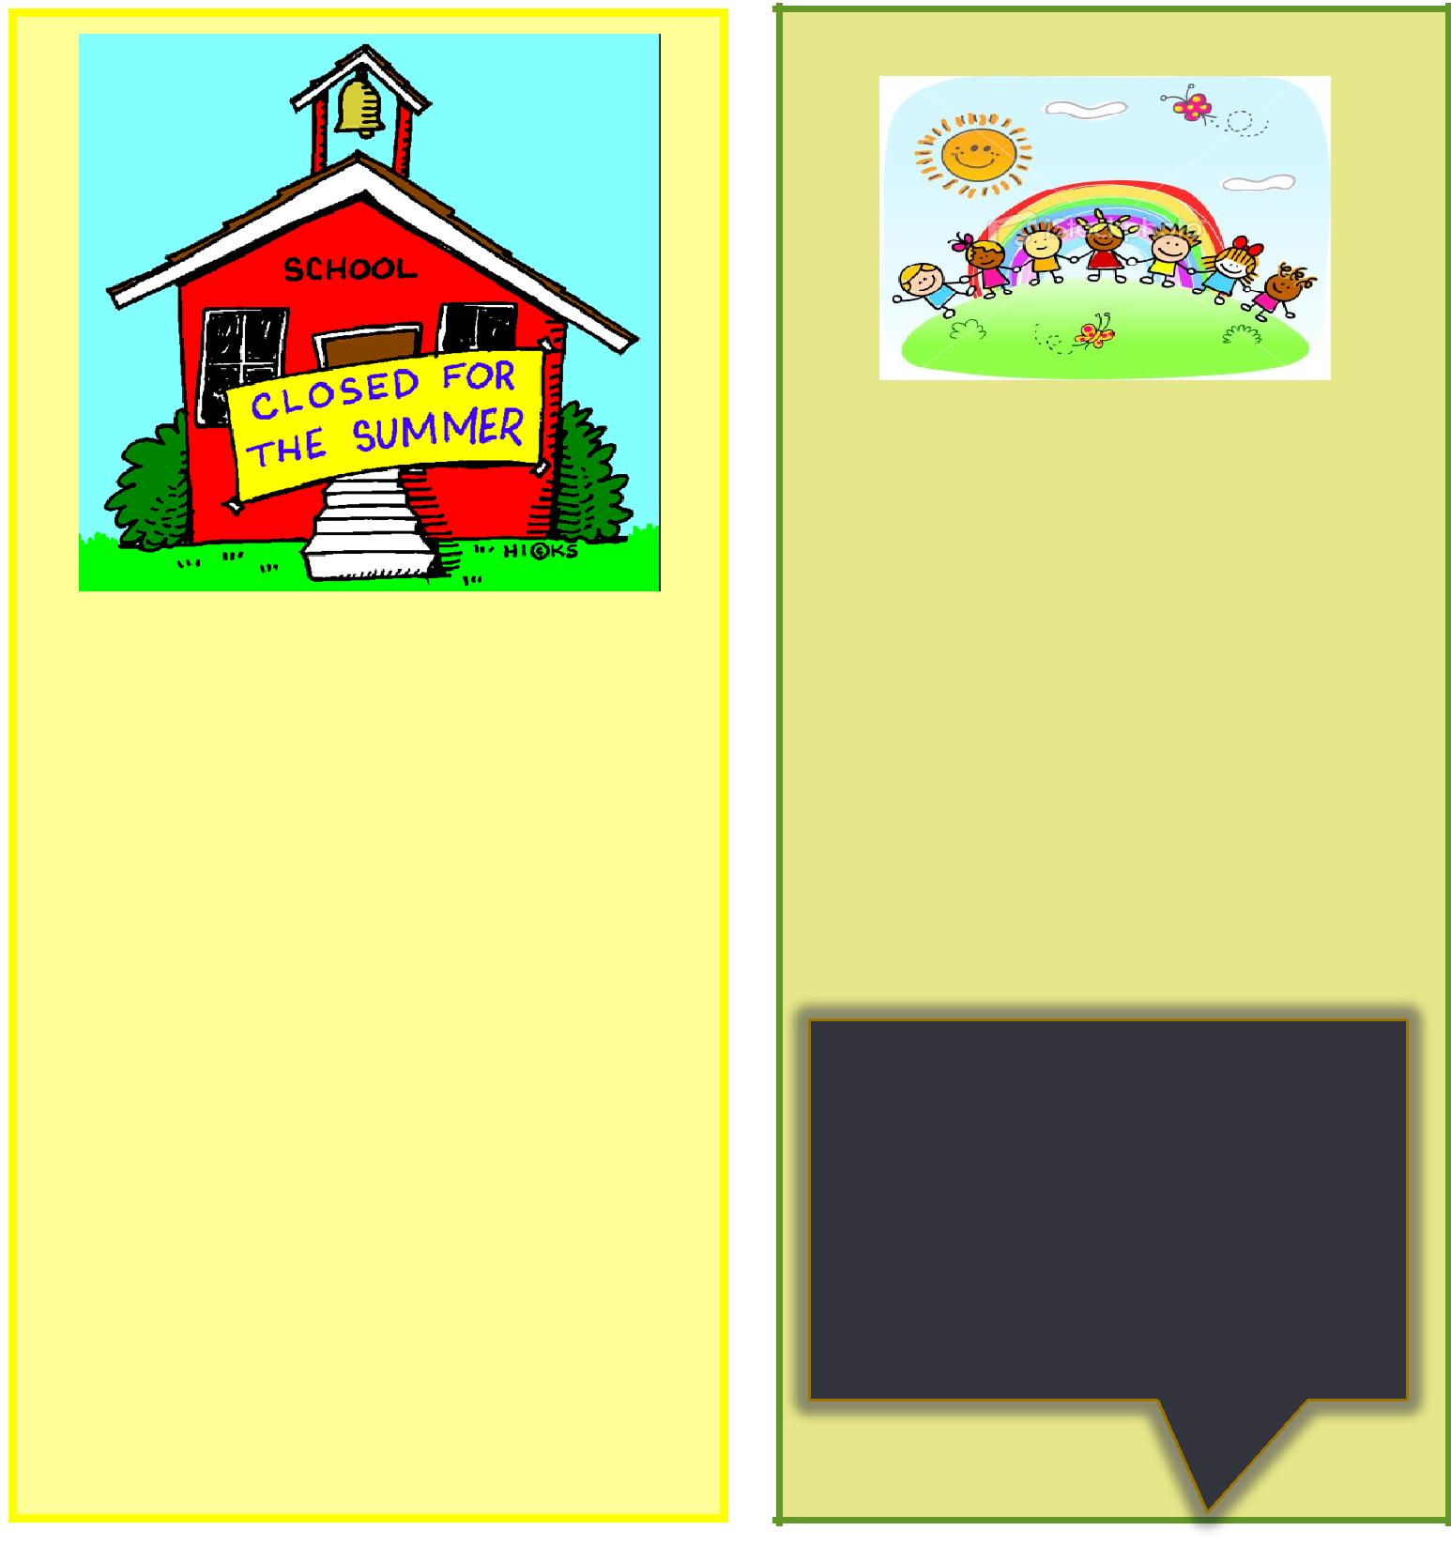

Hello all:

Schools are closing and everyone is heading out this week — for sum-mer vacation! Hurray!

So — this is the first of your sum-mer newsletters. Hope to send out at least one more. Have a great vaca-tion — or staycation. Either will be fun after a busy school year!

Lyn

CONTENTS

Director’s Greeting | 1

Usher Syndrome and Genetic Testing 2

Visual Motor Checklists | 4
Book Nook (Potty Training) | 6
Facebook Share | 7
Oregon Deafblind Workgroup | 8
Oregon Deafblind Project info | 8

Nothing is more memorable than a smell. One scent can be unex-pected, momentary and fleeting, yet conjure up a childhood summer beside a lake in the mountains.”
Diane Ackerman

1

Genetic Testing for Usher Syndrome: Is this Important?

Parents -- Do you know if your child has Usher Syndrome?

If know your child is Deaf/HH, but you are not sure if there is vision loss, or if you are not sure of the answer to this question, take a look at these one-page questionnaires on our website. They are titled Parents Visual-

Motor Checklist, and Students Visual-Motor Checklist. http://oregondb.org/ You do not have to submit these anywhere unless you want to share them with your child’s teacher, doctor, or someone else – but these are checklists that might help you decide whether or not you need to go back to your ophthalmologist or a ge-neticist to ask questions. There are two questionnaires because your child might want to fill out one for himself independently. This would be a “plus” because, if you choose to, you can then compare notes.

If your child was born Deaf/hard of hearing, and is beginning to show several of the signs in the checklist, it indi-cates he/she may be developing an eye condition called retinitis pigmentosa. The most well-recognized indica-tors are poor night-vision, or poor vision in dull areas, appearing “klutzy”, tripping on steps, disliking contact sports, and pulling back/stepping back in order to see something or someone better. Another sign of Usher Syn-drome is poor balance – but not for all forms of the syndrome. These are some, but not all the possible signs you may see. There are more documented in the checklists. So take a look at our website, under “Resources” in the left column: http://oregondb.org/ - or look at a side-by-side list of questions on pages 4-5.

IF you check-marked all or almost all areas on the checklist, and even though this may be difficult to do, it would be good for you and your child to share information with the IEP team. They can help in many ways and make sure your child can adjust to changes that will occur. Be aware that the changes are often so slow that you may not have noticed them.

If your child gets a diagnosis of Usher Syndrome from a medical team, it is good to make quite sure that it is Ushers. The following link states that genetic testing is the only way to get a “definitive” diagnosis of this syn-drome: https://www.usher-syndrome.org/take-action/get-genetic-testing.html Not many persons get this testing done – usually because it is too expensive, or it takes too long to get results, or they feel it is not useful. If you are thinking of the cost involved, there may be a way to get insurance coverage, or find a donation or par-tial coverage from an agency. Scroll down on the same page and you will find information about Unravelling USH, the Usher Syndrome Coalition – and their collaboration with Project Usher at the Wynn Institute for Vi-sion Research to help everyone with a diagnosis to be able to have genetic testing done.

Here are the steps to helping your child, gaining information about the latest research and possible treatments, and to get genetic testing done:

Have a physician document diagnosis of Usher Syndrome – even if genetic testing has not been done

Enroll in the online registry: https://www.usher-registry.org/en/users/sign_up

If you want, you can also join the USH blue book – which helps you to connect with others via e-mail:

https://www.usher-registry.org/en/network_members/new Please be aware that this is a secure site: https://www.usher-registry.org/en/registry_faq

Preferably, work with your child’s physician(s) to have them order the test: https://www.carverlab.org/ request/physician (John and Marcia Carver Nonprofit Genetic Testing Laboratory).

2

However, you can order this too. This page has information on how to order a test – if you are someone who might have Ushers, your physician, or another lab: https://www.carverlab.org/request

Patient information on how to order a test: https://www.carverlab.org/request/patient

Physician information on how to order a test: https://www.carverlab.org/request/physician

Send-out laboratory information on how to order a test: https://www.carverlab.org/request/lab

If you have questions, check this page on the site to see if your question may already have been answered: https://www.carverlab.org/faqs/ordering

If you feel you need to take along more information, download and print out the “information sheet” indi-cated and share it with your physician.

Also take this letter from the Wynn Institute for Vision Research which documents why insurance should

cover genetic testing: http://wivr.uiowa.edu/sites/default/files/documents/ Insurance_carrier_letter_Usher_2.pdf There is also a form that you can download: http://wivr.uiowa.edu/ Project%20Usher%20Instructions

For your information, here are the codes for insurance purposes that your physician might be able to use:

Genetic test codes for Usher syndrome genetic testing at the University of Iowa Carver testing lab:

81400, 81407, 81408, 81479

Diagnosis codes:

Retinitis pigmentosa: ICD9: 362.74/ ICD10: H35.52 Bilateral Hearing Loss: ICD9: 389.9/ ICD10: H91.93

The Carver Lab may be able to assist financially through the Project Usher Fund - if you need this assistance. You can contact them: usher-lab@uiowa.edu.

Other Information:

Here’s the site’s page on what Usher Syndrome is: https://www.usher-syndrome.org/what-is-usher-syndrome/

Join the mailing list – so you get information promptly: https://www.usher-syndrome.org/

Connect to the USH talks page – so you can inform yourself about the latest information on Ushers research and genetic testing: https://www.usher-syndrome.org/what-is-usher-syndrome/presentations/ush-talks- library.html

Explore the blogs from this site: https://www.usher-syndrome.org/our-story/ush-blog.html

Take a look at the Yellow Book — of experts (worldwide!) on Usher Syndrome: https://www.usher- syndrome.org/what-is-usher-syndrome/find-an-expert.html

Campaign to raise funds to develop treatments for all types of Usher Syndrome: http://www.wivr.uiowa.edu/ UsherChallenge

Read about Project Usher: http://www.wivr.uiowa.edu/Project%20Usher

3

Visual-Motor Checklists

Take a look at these sets of questions, and respond YES NO or UNSURE to each of them. Note: Many of the questions are “parallel” questions in the two columns.

 | Parents: Has your child experienced any |  |  | Student (son/daughter): Have you noticed, or
 | of these visual and/or motor concerns? |  |  | been concerned about any of the following?
Is your child afraid of the dark, or nervous to go out |  |  | Are you unsure of your movements when it is dark?
 | at night? |  | Are you nervous of going out at night, especially alone?
Does he/she have a night-light in his/her bedroom? |  |  | Do you feel the need for a night-light in your bedroom?
Does it bother him/her if the light goes out unex- |  |  | Do you have difficulty moving around in a movie theater
 | pectedly? |  |  | when it is dark?
Does your child struggle with closed captioning? |  |  | Have you found yourself having difficulties following ASL?
Does he/she have to step back or push his/her |  |  | Have you had issues with seeing or following closed cap-
 | chair back to watch TV? |  |  | tioning?
 |  |  | Do you find you can follow ASL or CC better from further
 |  |  |  | back?
Does your child tend to bump into people acci- |  |  | Do you tend to bump into people accidentally?
 | dentally? |  | Do you frequently stub your toe on objects or fall over
Does he/she run into pieces of furniture? |  |  |  | low furniture?
When crossing a street, is he/she over-cautious |  |  | Does crossing a street make you anxious and uncertain?
 | and uncertain?
Does your child sometimes appear to have a bal- |  |  | Do you think you have poor balance?
 | ance problem? |  | Have you been told – or do you feel you are a “klutz”?
Do you think your child is “klutzy”? |  |  | When you drop an object, do you have trouble finding it/
When your child drops something, does he/she |  |  |  | picking it up?
 | fumble to pick it up? |  | Are you able to walk on a balance beam – or a line on the
 |  |  |  | floor?
Does your child act startled to see someone who |  |  | Are you often surprised to see someone who entered a
 | they didn’t realize was in the room? |  |  | room silently?
In an “unknown” hallway, is your child aware of |  |  | In an “unknown” hallway, are you aware of what is on
 | what is on the wall? |  |  | the walls?
Does he/she turn his/her head, rather than eyes, to
 | find something?
Does your child stumble on stairs going up? |  |  | Do you stumble or trip on stairs?
Does he/she stumble on stairs going down? |  |  | Do you step off a curb that you didn’t notice was there?
Does your child reach for something and knock it |  |  | Do you reach for something (e.g., on a table) and knock it
 | over? |  |  | over?

A few more questions on the next page…...

4

Visual-Motor Checklists (cont.)

Parents: Has your child experienced any | Student (son/daughter): Have you noticed, or
of these visual and/or motor concerns? | been concerned about any of the following?
Does your child have issues with “glare” during the | During the day, does bright sunlight blur your vision?
day? | At night, are car headlights “blinding” to you?
Does he/she find car headlights etc cause “glare” | In class, is it easier to see if you sit with your back to the
problems at night? | windows?
Does your child sit with his/her back to windows/ | Do you have to pause when going from a dark area to a
light sources? | bright one?
Does your child avoid contact sports? | Do you dislike playing contact sports?
Does your child struggle with a sport that requires | Do your struggle with a sport that requires following a
following a ball? | ball?
Does your child have trouble catching a ball (e.g. | Do you have trouble catching a ball?
tennis, baseball)?
Has your child discussed any of the | Have you talked to your parents, your doc-
above with you? | tor, or any adult about these?

Please be aware that these questions are just indicators that there may be Usher Syndrome related “red flags”. Answering “Yes” is not conclusive — but it may help you decide to see an ophthalmolo-gist or a geneticist to find out more.

You can download and print two separate forms from http://oregondb.org/

Here is a link to a page of Usher Syndrome Resources:
http://oregondb.org/forms/usherresources.pdf

And another page for teachers who may need to know what to do next:
http://oregondb.org/forms/ushersteps.pdf

What’s the point in genetic testing? Here are some thoughts…..

You will know FOR SURE whether you or your child has Usher Syndrome. There are other conditions that may look like Usher Syndrome and are not.

You have a better chance of being notified if you can become involved in a research project that is looking for a cure — or to stall the progress of retinitis pigmentosa.

You can estimate what to expect with retinitis pigmentosa and not be surprised with diminish-ing vision.
You can learn how to cope with diminishing vision—and not just guess what you need to do.

You can contact appropriate service personnel — e.g., an orientation and mobility specialist, a rehabilitation specialist who specializes in vision loss, housing personnel, counseling

You will be able to move ahead with your life and what you want to do.

5

BOOK NOOK

The universal challenge: Toilet Training

I think this topic will get the attention of many parents and educational teams. It is often a challenge for children with special needs, including children who are deafblind.

If we think about it, we actually train our children to use their diapers or pull-ups for toileting. And then we ex-pect them to convert to sitting on a potty – without regard for their previous experience and prior routine. Using a potty is an entirely different routine. It uses different tools and includes a whole set of new expectations. This is diffi-cult enough for a child who does not have any obvious disa-bilities, or who can see – because he can watch what an adult does and can imitate – and learn the “new” way to do things. What of our children who are deafblind? Do you see the issue here? Here is what it might look like from the child’s perspective:

I have to learn a whole new routine for something I al-ready know how to do!

The new routine now has an actual “place” – whereas before I could do this anywhere.

This new routine has new objects to contend with (bathroom, new floor type, sink, faucet, soap, water, toilet paper and toilet paper rack – and of course, the inevitable potty! And did I mention the flush tank with the handle or button….or the echo in the bathroom – especially at school.)

Those objects and the new place produce different sen-sations than my previous routine. I think I’ll just stick with this wet diaper!

It has new actions that are “work” (take the pants down, pull them up, use toilet paper, wash your hands, etc). All that happened before was I lay down and someone took the “wet” away.

You expect ME to do all this? It’s a whole different level of independence we are looking at.

Words, words, words! It has a whole new vocabulary that someone is going to throw my way.

Darn it! The old routine was so much easier!!! SO—now we need to consider that this is not toilet

training – but it must be thought of as toileting RE-training. In our field of work, we know a lot about routines and how important it is for our children who are deafblind. We also know that once a routine is established, it might be difficult to change – or may take some expert management to make the switch. However, once we have this mind-set, it might be a little easier.

What are some of the things we might do/think about to change from one routine to a routine that is differ-

6
Think this through BEFORE you start to change. Perhaps, teach it as a “new” routine.

Give it a beginning, middle and end – and minimize the vocabulary you need for this routine, BUT decide what it should be. Maybe you need forms of commu-nication that will make sense to your child instead of a bunch of new words that he cannot hear or cannot make sense of.

Don’t do it all at once. You can start with just learn-ing to SIT on the potty – that chair with the hole in the middle, usually cold, and where I might just fall in and hit the water! Maybe I’ll get flushed down the hole too?

Make adjustments. Too cold? You can actually buy a less cold cover (such as a wooden one), or put a cloth cover over it so that it feels cushiony and more com-fy. Maybe the hole is too large for your child – and his fear of falling into the toilet might be a real one. Make sure that the hole is the right size – so he doesn’t feel this way – or maybe it can become a game for him to balance and not fall in.

Create a safe space. Use objects, maybe even some familiar and loved toys, to have on a table nearby. Perhaps he can play with one of these AFTER he is safely sitting on the potty? If his feet don’t reach the floor, figure this one out too. Trying to balance and having one’s feet off the floor will not work.

How does the child know he is at the potty – without having to actually touch it with his hands? Is there a rug at the foot of the potty? Is there a marker, tape indicator on the wall or the floor? Does he know which direction to go once he gets into the bath-room? In fact, does he have a “map” of the room – tub to the right, potty to the left, sink straight ahead. Good game to develop – finding things in the re-

stroom! First one to find the soap gets a sticker! Okay – now that I may have your attention, here is a good book to read AND FOLLOW. Some of this you may have heard before; some of it you may already know and have done. But if you are still struggling with this situation, the author’s “route” may work well. Here are some of the discussion areas:

How will I get my child to tell me he needs to go potty? OR how will I get him into a habit of going to sit on the toilet at a specific time?

Are the child’s sensory experiences negative – and how do I change this?

The Potty Journey: Guide to Toilet Training children with Special Needs, Including Autism and Related Disor-ders by Judith A. Coucouvanis

Publisher: APC (Autism Asperger Publishing Co), P.O. Box 23173, Shawnee Mission, Kansas 66283-0173 877-277-8254 www.asperger.net

FACEBOOK SHARE

Braille topics:

Fun way to learn: http:// www.pathstoliteracy.org/strategies/bellringers- warm-activity-braille-students

Yearbooks: http://www.pathstoliteracy.org/ strategies/yearbook-time-ideas-including- students-visual-impairments

Spanish braille: http://www.pathstoliteracy.org/ blog/spanish-braille-and-english-language- learners

Braille boot camp! http:// www.pathstoliteracy.org/events/braille-boot- camp-2017-braille-and-tactile-graphic- production

Graphics: http://www.pathstoliteracy.org/ strategies/tow-truck-braille-design

Woodwork and braille: http:// www.pathstoliteracy.org/strategies/woodwork- and-braille

About Thomas Edison — and the role his mother played in his success— this will touch your heart! https://www.youtube.com/watch?v=ecGO6TvqcVA

Watch Mandy Harvey, Deaf Singer — as she impress-es the judges and the audience: https://www.youtube.com/watch?v=ZKSWXzAnVe0

Active Learning

Pinterest page! https://www.pinterest.com/ pathstoliteracy/active-learning/

Resonance Board: http:// www.pathstoliteracy.org/blog/remarkable- resonance-board

Justifying a student’s need for technology: http://www.pathstoliteracy.org/events/dueling- devices-assessing-and-justifying-student-needs- technology

OSEP—special news from Washington DC—about eligibility for students who are visually impaired: http://www.pathstoliteracy.org/news/osep- addresses-special-education-eligibility-students- visual-impairments

7
Summer fun perhaps?

Adapting games: http:// www.pathstoliteracy.org/strategies/tips-adapt- games-children-vision-impairments

Braille cards? http://www.pathstoliteracy.org/ strategies/challenge-card-game-practice-braille- reading-skills-while-having-fun

Orientation, Mobility — and travel ideas:

Travel tips: http://www.pathstoliteracy.org/ resources/sound-travels-evaluation- collaboration-and-development-tools-individuals -who-are-deafblind

Birthdays are special! http:// www.pathstoliteracy.org/blog/birthday-braille- memory-box

News from Microsoft: https://thejournal.com/ articles/2017/06/01/microsoft-project-develops- physical-programming-language-for-blind- students.aspx

Research article on haptic exploration (touch): http://www.pathstoliteracy.org/research/mediating- haptic-exploratory-strategies-children-who-have- visual-impairment-and

Tangible symbols — to use at home: http:// www.pathstoliteracy.org/strategies/using-tangible- symbols-home

Ideas for children who have decreased tactile sensi-tivity: http://www.pathstoliteracy.org/blog/12-more -ideas-teaching-braille-students-decreased-tactile- sensitivity

Shoes that fit over braces: https:// themighty.com/2017/04/guide-to-finding-shoes-that -fit-over-braces/

Using your tongue to “see”? http:// www.newyorker.com/magazine/2017/05/15/seeing- with-your-tongue

Books for children with CVI: http:// www.pathstoliteracy.org/strategies/three- bright-red-pom-poms-lined-row

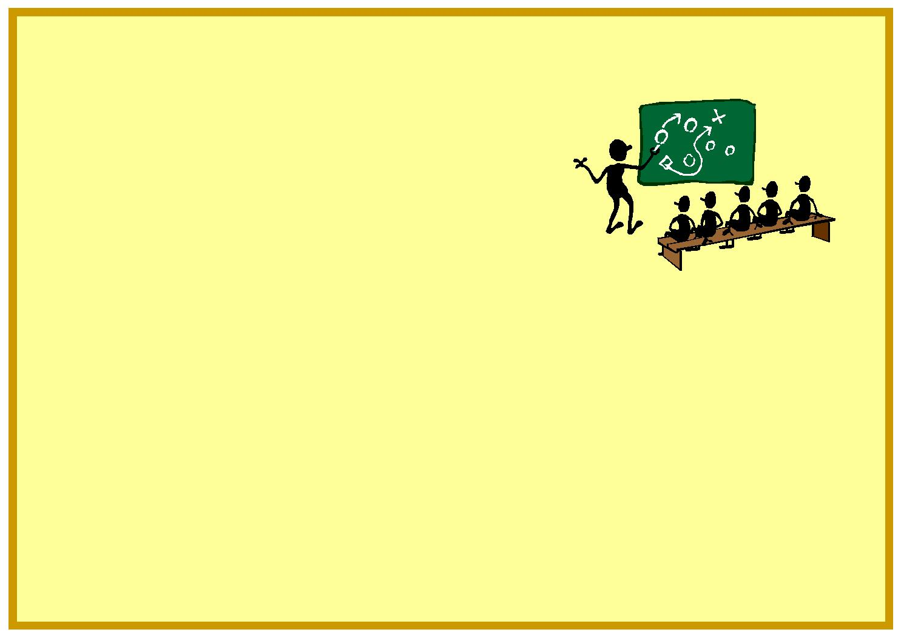

THE OREGON DEAFBLIND WORK GROUP

Malina Lindell: Region one, Eastern Oregon Jan Hearing: Region two, Central Oregon Lynette Kleespies: Region three, Southern Oregon

Terry Cadigan: Region four, Cascade Regional Anne Olson-Murphy: Region five, Willamette Regional Darlene Daniels: Region six, Columbia Regional

Trish Orr: Region seven, Lane Regional Claudia Martin: Region eight, Northwest Regional

Sharla Jones: Oregon School for the Deaf/RMT representative Linda Brown: Oregon Department of Education

Kathy Eckert-Mason: Department of Vocational Rehabilitation Sarah Mora: Oregon Commission for the Blind

Linda McDowell: NCDB representative, The Research Institute at WOU Caitlin Shockley: FACT/PTI parent representative
Lyn Ayer: Oregon Deafblind Project, The Research Institute at WOU

WEB INFORMATION:

The Oregon Deafblind Project Website: www.oregondb. org The home page has our newsletters, both current and archived. Also get frequent information from our Facebook page:

http://www.facebook.com/pages/Oregon-Deafblind-Project/132672043449117

We also have our newsletters and other information on our web-page with our partner organization, the Oregon Department of Education: http://www.ode.state.or.us/search/results/?id=185

Contact the Oregon Deafblind Project!

Lyn Ayer, Grant Project Director

Oregon Deafblind Project

Western Oregon University (TRI)

345 N. Monmouth Ave

Monmouth, OR 97361

ayerl@wou.edu |  | (503) 838-8328

www.oregondb.org

8

Federal Government or The Research Institute at Western Oregon .University .Education You should therefore not assume endorsement of the content by either the of The Research Institute at Western Oregon University or the .S.U Department of The opinions and policies expressed by this publication do not necessarily reflect those

OSEP Project Officer: Susan Weigert Office of Special Education .S.U Department of Education OSEP CFDA 326T.84 through grant award # H326T130008 The Oregon Deafblind Project is funded

Lyn Ayer, Oregon Deafblind Project
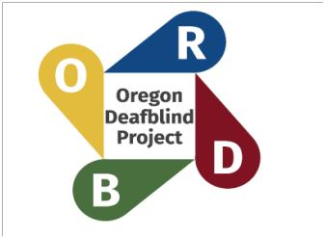Western Oregon University

The Research Institute
345 N. Monmouth Ave
Monmouth, OR 97361

TRI 199

9

