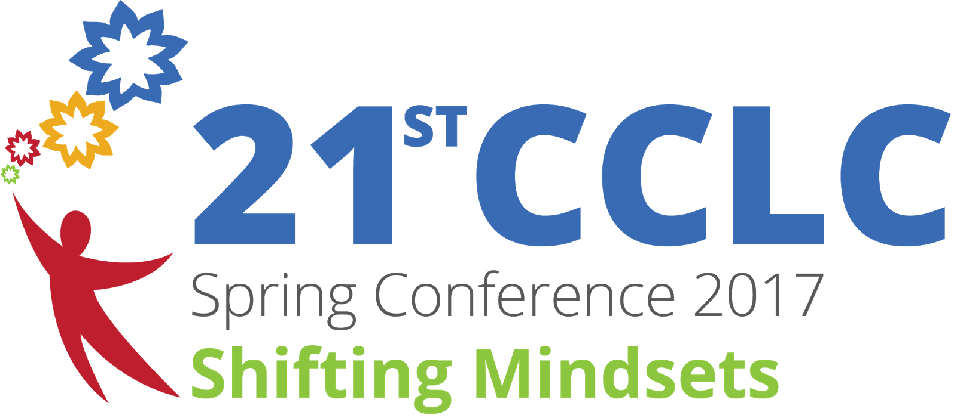

TOOL KIT

Accelerated Achievement:

Writing Through Arts Education

Presentation by
Michael “Chappie” Grice

“We can, whenever and wherever we choose, successfully teach all children whose education is of interest to us. We already know… more than we need to do this. Whether we do it or not must finally depend on
how we feel… about the fact… that we haven’t, so far.” Dr. Ron Edmonds

Western Oregon University and the Oregon Department of Education
Monmouth, Oregon - May 4-5, 2017

Introduction

After thirty-two consecutive years producing the annual tribute to Rev. Dr. Martin Luther King, Jr., we have come to rely on a just a few maxims that don’t evaporate when times are tough and that don’t boil over when the winds are favorable:

“We stand not only on the shoulders of those who have come before us, but we stand on the shoulders of those who are among us;”

“We work hard, at the intersection of education and the arts;” and…

“Teamwork makes the Dream work.”

We’ve learned to celebrate the sacrifice and reliability of collaborative efforts. Some years ago, we collaborated with the Portland Schools to effect improved writing through a phenomenal arts education project: “Discipline based Arts Education.” It was a schools-based project through the Getty Center for Education and the Arts. It brought prestige and more importantly resources to the public schools to train teachers and effect students with the DBAE curriculum.

Here, we depart from the formal program evaluation to settle on the more productive techniques employed in the training and study: the “Aesthetic Scanning Device.” This feature of the program design to augment the perceptions, appreciation, and real substance of visual art proved so powerful, personally, I have never stopped embracing its value. It is life-changing and sustaining in small or large doses. It is so simple that once revealed it is almost embarrassing, so acutely fundamental that it lasts a lifetime. Few interventions or short-term trainings can make such claims: learning to ride a bike, drive a car, or the HD television remote.

To invigorate writing, you must command language. Language is a feature of “culture.” But culture shapes and is shaped by an array of ideas and experiences. Because culture is at the vortex of learning and especially writing about learning art, I thought we could pause here to entertain an evolved definition of culture:

Culture

Culture is defined in the American Heritage Dictionary as “the totality of socially transmitted behavior patterns, arts, beliefs, institutions, and all other products of human work and thought… characteristic of a community or population.”

Defined, more universally, for the full complement of ethnic populations as “the sum total of the languages, mores, music, art, foods, styles, religions, child-rearing, rituals, achievements, contributions, struggles, faith, and other patterns of behavior and interpretations of reality,” culture both defines the full range of ethnic group values and illuminates its salient themes. Most central to most ethnic groups, and without which “cultural themes” are impossible to sustain, are the expressions of faith in their God; education as the currency of achievement; and the organizations and institutions that hold communities together.

This one, busy, and inevitable intersection serves as a vortex for looking backward into history and the apex for looking forward across the frontiers of innovation, and the imminent demands to preserve the rich heritage of each “cultural” group and develop the next generation of leaders in every field.

The Sensory Experience

Although we are made to hear all the sounds, smell all fragrances, taste all the flavors, see all the colors, and sense the difference between a penny and a dime. Our magnificent sensory system is biological and cultural. There is no doubt that the gift of sight is dominant among our senses and the source of more emotional cues than the others combined; except for those whose senses make up for the loss of sight.

When we see a painting, sculpture, drawing, photography, architecture, or any visual art, deliberately constructed to evoke even the mildest of responses, we must rely on our visual acuity to capture the idea and our culture to interpret the meaning.

Here, we want to use visual art to stimulate writing; first by exploring the vocabulary that can convey our interpretation, and then compare it with others, the common and simple; the exotic and sophisticated; and everything in between.

We are often stunned by some form of drawing, painting, sculpture, architecture, photograph or installation. Yet, we do not always connect the dots that link one famous or compelling work of art with the pedestrian and simplest work of a child.

The aesthetic scanning device, a Getty Center articulation, illuminates a set of visual criteria that is easily within reach… without a graduate degree in art history or an insatiable desire to consume commercial or museum art.

STOP HERE.

Let’s look at some art.
Let us be lured into the legitimate pretense of writing what we feel about each work of art. In order to do that, and in order to get our students to do that, we will most assuredly discover the cultural disparities and distinctions that will enable each student and each of us, here, to express freely what we see, what we feel and how we interpret what we see and feel.
Simultaneously, the sensory experience is accompanied by the cognitive experience where we are thinking… comparing our sensing and our thinking with other similar and dis-similar experiences in recent and distant memory. That makes our writing both original and authentic. It is, in effect, art itself. There are no rules for this. There is only the product.
In writing words or phrases, we have the opportunity to share those results with our fellow students and colleagues. Being careful to allow those expressions to remain unfettered by critique, convention, or comparison… is the goal. Mission accomplished, almost! That is, the more frequently we do this, the more comfortable we are to feel safe to express a completely different interpretation or meaning than that of our neighbor; and we can venture onto the frontier of art appreciation. We will not be the first or the last.
Now, we have two problems to solve. These are “opinions” and they may be void of some facts that could influence our thinking. The history, for example of the artist, or the work of art that may be more famous than we realize and already have been discussed in literature or whose purpose is widely known and connected to a particular era in history, a particular event (historical or contemporary), or a particular philosophy (political or apolitical). More factual knowledge about the artist, the genre, the medium, or the time in history or the intent could inform our pure, authentic, unguarded writing on the art subject.
A second problem, is our command of the language that enables the variety of quality and utility of our “pure” interpretation. This is indeed a problem.
Often our public schools fall short on cultivating this essential skill. Skill is defined, here, as the confluence of knowledge, experience, initiative, and ingenuity. How to get a diverse population of school children to approach the mastery of reading, writing, listening, speaking and thinking critically. There are many solutions: innovative, creative, diligent, experiential, dynamic, etc. The most effective means of teaching the craft of writing, involves at least three critical variables:
- teachers with accomplished skill and a passion for teaching;
- relevant topics or subject to write about; and
- an adequate opportunity to practice.
My reason for engaging you in the obvious… is to simply underscore the essential importance of WRITING, especially as a method for teaching reading.
Learning to read and reading to learn (with comprehension) are so fundamental and so essential to the work that is before us, that I cannot go a day without fulfilling this slice of my raison d’etre.
Thank you for joining me in this enterprise. Breeding mastery of the English language is not only practical and essential, it is fulfilling and contributes to the human capacity to make art in general and literary art in particular.
There are thousands of books and hundreds of links on the internet that can offer advice, curriculum, and formulae for helping your students and yourself gain mastery of language literacy. Our joint efforts to expand the students’ vocabulary and giving greater exposure to ideas and reasons of their own to travel and communicate in their own preferred modalities is precious. For some, a ministry. That’s it.
DON’T STOP.

The Aesthetic Scanning Device…
We’ve waited to introduce this surprise as if it were the prize in the Cracker Jack box. We have alluded to its simplicity and carved out this space because this little nuance to “see” art adds a dimension that we all possess, but may not have learned to employ.
Now, let’s look at art (photography, painting, drawing, sculpture, architecture, collage, etc.) in another way. It does not take anything away from your earlier observations. It may add to your ability to compare art, deepen your experience, and it will, free of charge… last you for the rest of your life:
Ask these questions and any others that would fit into this examination:
- Is there any color?
- What colors do you see?
- What colors are dominant?
- Are there any lines?
- Are the lines straight or curved?
- Are the lines heavy or light, mostly vertical or horizontal
- What is the mood of the art? (happy, sad, exciting, calm, etc.)
- To what degree is “symmetry” at work?
- To what degree is “centrality” at work?
- What role does “light” play?
- What is in the foreground, background?
- Is there attention paid to “balance? How is it managed?
Equipping your students, as early as grade 3, and yourself, with these questions adds a dimension to their vocabulary that can be used to write about art and a host of related subjects. Done.

Two years ago, I was invited to talk with the organization of African American Newspaper publishers and offer some ideas for enhancing the language literacy of our children. Here is my contribution.

WRITING FOR DEMOCRACY
Before newspapers go completely out of style, there is one element of their legacy that is richer than Fort Knox and more accessible than popcorn at the ball park: The Editorial Page.
For children with “the greatest need,” who suffer disproportionately in low school performance, we appeal to a simple practice that accelerates and elevates literacy in language and mathematics. This is accomplished with help from the educators and stakeholders who have that interest or that official responsibility for delivering learning objectives: a professional development infusion.
Using the editorial page, found in every newspaper, we can attest to several salient features:
Editorials express an opinion and is distinct from reporting facts even though they both are found in the newspaper. Examining the writer’s issues or position requires critical thinking.
- *Noteworthy contemporary issues, in a given local, regional or national community;
- *Thoughtfully crafted expressions with muted or passionate candor, even acceptable outrage;
- *Common and plentiful letters of concern or applause; and
- *More or less effective and persuasive use of language examples.
Most importantly, “letters to the editor” have several advantages as writing examples because they are… grammatically correct and balanced by an equally passionate, well-conceived, opposing view. This contrast of “reasons why” and “reasons why not” distinguishes itself from other writing primarily because it is dynamic, but because it is one of the richest, accessible demonstrations of democracy that we have easy access to.
It can be argued that “democracy,” as it was conceived historically, is not evident in the economy, sports, film, television news, or reality shows. That, in fact, newspapers, in the ways that they select topics and present opposing views may be controversial. Still, as examples of presenting both sides of an issue, the editorial page and especially “letters to the editor” offer a rare glimpse of democracy.
As young people mature and exchange “learning to read” for “reading to learn” much can be done to enhance literacy skills with these teaching and learning ideas:
- Select letters to the editor in an African American newspaper that are succinct, contemporary, intentional, and leverage people's biases to evoke the opposing counter-argument.
- Invite learners to copy, in their own hand, two short letters to the editor onto the worksheet.
- Invite the learners to then type the letters to the editor into a word processing document.
- Invite the learners to write an analysis the strengths and weaknesses of both sides of the issue.
- Invite the learners to present their analysis to an audience and receive their applause.

This simple, 15-30 minute writing exercise accomplishes several objectives:
*Expansion of circulation and readership of select newspapers, especially through schools.
*The learner experiences more “applied language skills” and boosts reading of diverse materials.
*The learner gets exposed to ideas that are important to people in their own community.
*The learner expands his/her vocabulary, with words, correctly spelled, and properly used in context.
*The learner practices thinking about and writing about opposing views, with objective criteria.
*The learners’ requisite “cultural and contextual evaluation and analysis” boosts critical thinking.
*The learner acquires, develops, and practices “presentation skills,” useful in every career field.
*The exercise is flexible, portable, and is not confined to school hours only, or any single language.
Writing for Democracy, Michael “Chappie” Grice, All Rights Reserved

References
Top of Form
Bottom of Form

Scholarly articles for teaching writing strategies
Effective teaching strategies that accommodate diverse … - ‎Kameenui - Cited by 685
Writing Better: Effective Strategies for Teaching … - ‎Graham - Cited by 282
Teaching Writing Strategies to Struggling Writers. - ‎Graham - Cited by 92

Teaching Writing Strategies
gse.buffalo.edu/org/writingstrategies/steps.html
Teaching Writing Strategies We recommend a four-step instructional process for teaching writing strategies. The steps are these: ...

30 Ideas for Teaching Writing - National Writing Project
https://www.nwp.org/cs/public/print/resource/922

The National Writing Project's 30 Ideas for Teaching Writing offers successful strategies contributed by experienced Writing Project teachers. Since NWP does not promote a single approach to teaching writing, readers will benefit from a variety of eclectic, classroom-tested techniques.
‎

10 Teaching Strategies to Improve Writing - TeachHUB
www.teachhub.com/10-teaching-strategies-improve-writing
Allow students to brainstorm their writing ideas through pictures and drawings or just add them to their stories. Whichever way you choose will be equally effective. The ultimate goal is to have students use their cognitive thinking skills to communicate their ideas.

Writing strategy guides - Results on ReadWriteThink - ReadWriteThink
www.readwritethink.org/search/?strategy-guide-series=30144
Results 1 - 10 of 10 - This strategy guide explains how to use small-group, guided writing instruction to teach students effective strategies and improve their ability ...

Evidence-based practices for teaching writing
education.jhu.edu/PD/newhorizons/Better/articles/Winter2011.html
The strategies for teaching writing are listed according to the magnitude of their effects. Practices with the strongest effects are listed first.

