Survive and Thrive



Personal Emergency Preparedness Plan
For __________________________



Reviewed July 2014
Table of Contents
Why have Emergency Plan page 3
Directions page 4
Personal Plan page 5
My information page 6
Emergency Contact page 6
Support Group page 6
Out of Town Contact page 6
Working with Me page 7
Important Phone Numbers page 8
Medical Information page 10
Transportation page 12
Family/House Plan page 13
Meeting Places page 14
Insurance Numbers page 14
Family Information page 15
Frequent Locations page 16
Pet Information page 17
Evacuation Routes page 18
Appendix A: Special Needs/Disabilities page 22
Appendix B: Emergency Preparedness page 30
Why Have An Emergency Plan?

When people talk about Emergency Preparedness, what images come to your mind; a hurricane or a tsunami happening to other people in other places? What about a car accident, weather storm, power-outage or severe illness? Those events also qualify as emergencies and can affect you and your community.

Emergency preparedness plans
- Help an individual or family prepare for the worst possible disaster
- Has phone numbers, medical information, evacuation routes
- Are tools to survive an emergency

Fill out the following plan with your family, loved ones and housemates. Modify the plan whenever information changes. Remember, in the event of any emergency, from a house fire to an earthquake, you can survive and thrive!
Directions

The following is a list of directions to fill out this personal emergency preparedness plan.
Section 1: Personal Emergency Information
- If you live alone then fill out Section 1 only and Appendix A: Special Needs/Disabilities if it applies to you.
- If you live with other people (family/roommates/etc.) then each individual in the house/apt. needs to have their own copy of Section 1completed.
Section 2: Household Emergency Plan
- If you live alone but want emergency plan information for loved ones not living with you, then you may fill out segments of Section 2, but the information should come from those not living with you. They should have their own emergency plan in place and if they wish, can share the information with you.
- If you live with other people (family/roommates/etc.), Section 2 should be filled out with everyone in the household involved.
Section 1:
Personal Emergency Information

Section 1 is a personal plan and everybody should fill out this section of the plan. It contains important information such as support groups, emergency contact numbers, medication lists, disabilities, and needs. If an individual has medical issues or may require special assistance, they should also fill out the forms in Appendix A. Section 1 should be copied and kept with your three emergency kits (home, car, work or school), if applicable. Use the information in Section 1 of this plan to fill out an emergency information card in Appendix B. Keep a copy of the emergency card in your wallet, purse or backpack.

Families, roommates, housemates, and those living a group setting, in addition to each individual filling out Section 1, should also fill out Section 2 of the plan.

My Information
Name: | Birth Date:
Social Security Number:
Address:
Home Phone Number: | Cell Phone Number:
Local Emergency Contact  Name: | Emergency Contact’s Numbers:
Local Emergency Contact  Name: | Home:
Local Emergency Contact  Name: | Cell:
Local Emergency Contact  Name: | Work:
Support Group: | Support Group Contact Numbers:
1) | Home:
1) | Cell:
1) | Work:
2) | Home:
2) | Cell:
2) | Work:
3) | Home:
3) | Cell:
3) | Work:
Out-of-town Emergency Contact  Name: | Out-of-town Contact’s Numbers:
Out-of-town Emergency Contact  Name: | Home:
Out-of-town Emergency Contact  Name: | Cell:
Out-of-town Emergency Contact  Name: | Work:
Working With Me
How It Is Best To Communicate With Me:
Other Information:

Important Phone Numbers
EMERGENCY - DIAL 911

Non-emergency
Name | Number
Police Department:  Marion County Sherriff’s Department | (352) 732-9111
Fire Department:
Hospital:
Other:
Family
Name | Number
Friends/Co-workers
Name | Number

Healthcare providers (doctors/nutritionist/psychiatrists)
Name | Number
Others
Name | Number

Medical Information
Primary Physician | Telephone:
Address:
Specialist: | Telephone:
Address:
Specialist: | Telephone:
Address:
Which Hospital Do You Prefer:
Health Insurance: | Policy Number:
Blood Type: | Allergies and Sensitivities:
Medications and Dosage Being Taken
1) | Dosage:
2) | Dosage:
3) | Dosage:
4) | Dosage:
5) | Dosage:

Specific Medical Conditions:
Physical Limitations:
Medical Equipment and Provider’s Phones:
Communication Difficulties:
Mental Health Condition:
Other:

Transportation
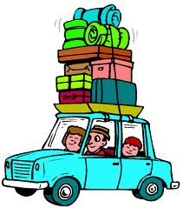
In an emergency or disaster situation, figuring out transportation can be over-whelming. Below are some questions that you may want to consider answering before an emergency so that if you need transportation, you already have alternative plans.

1. If you own a vehicle, does it have four-wheel drive? If not, or you don’t own a vehicle, are their friends or neighbors nearby that have a four-wheel drive vehicle that can offer you transportation assistance?

2. Are their bridges, overpasses, or especially wooded areas on the route that you commute? If so, those routes may be damaged or unavailable during a disaster. What are some alternate routes you can take?

3. Are there roads that you drive that are at risk for flooding? What are some alternate routes you can take?

4. Have you considered using public transit? Make sure you know the routes and bus lines near you.

5. If you need to evacuate and require a specialized vehicle for your normal transportation (wheelchair lift enabled vehicle), who will you contact to transport you? If you rely on a transportation agency, what are their policies and services during a disaster or emergency? Don’t assume that the ambulance will be available.

6. If you own a modified vehicle, do other individuals know how to drive it?
Section 2:
Household Emergency Plan

It is important to have a plan put together with your family, loved ones or housemates. In the event of an emergency, the plan will lessen fears and concerns for the wellbeing of others and help to bring everyone back together if an evacuation takes place.
This section includes
- phone numbers, emergency meeting locations, policy numbers, evacuation routes, pet information
- can be used for any emergency
It is best if everyone in the home helps with this section of the plan. A copy of this plan should be placed with your emergency kits.

Meeting Places
(If you have to evacuate your home or town, where will you and your family meet?)
Out-of-Town Contact Name | Phone
Email
Neighborhood Meeting Place | Phone
Out-of-Neighborhood Meeting Place | Phone
Out-of-Town Meeting Place | Phone

Insurance Policy Numbers
(Write important insurance numbers incase the original policies are destroyed)
 | Company Agent | Phone | Policy Number
Medical Insurance:
Home/Rental Insurance:
Car Insurance:
Other:

Family Information
(This section should have every household member’s information. In case someone is injured and
Can’t speak for themselves, this table can be given to Emergency Response Personnel)
Name | Social Security Number
Date of Birth | Important Medical Information
Name | Social Security Number
Date of Birth | Important Medical Information
Name | Social Security Number
Date of Birth | Important Medical Information
Name | Social Security Number
Date of Birth | Important Medical Information

We are Frequently Located Here. . .
(Besides your home, where do you and your family spend most of your time?)
Place

Address

Phone

Evacuation Location

Place

Address

Phone

Evacuation Location

Place

Address

Phone

Evacuation Location

Pet Information
This information is for the safety of your pet or service animal
Name: | Tag/ID Number:  Microchip (if applicable):
Is this Pet a Service Animal?
Yes |  | No
Veterinarian:
Address:
Phone:
Medications:
Emergency Shelter That Takes Pets
Address:
Phone:
Does This Pet Have Disabilities?
Yes |  | No
Disabilities:
How to work with pet's disabilities:

Evacuation Route (draw for home/apt./school/work/etc.)
Evacuation Route (draw for home/apt./school/work/etc.)
Evacuation Route (draw for home/apt./school/work/etc.)
Evacuation Route (draw for home/apt./school/work/etc.)
Appendix A: Special Needs/Disabilities
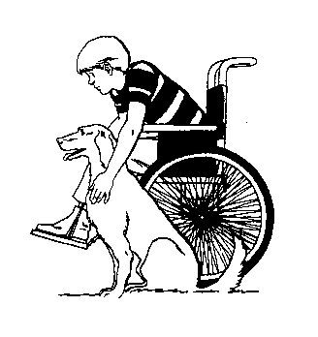
Appendix A includes a checklist that can detail an individual’s abilities to provide or care for themselves. People with physical or mental disabilities should fill out the following forms so that emergency personnel and those around them can know how to help them in an emergency.
Be completely honest with what your abilities are and if they change when under physical, mental, or emotional stress.
Also, included is a list of medical equipment that may allow you to be more independent. Mark what equipment you use and detail how to care for such equipment in an emergency as well as where extra supplies may be located or obtained (make sure you have some in your emergency kit). It would be a good idea to write identification numbers down in this section (for example, a heart pacemaker’s device number).

Activities of Daily Living

Check your level of ability for the following basic daily activities.
Activity | Independent | Needs Help | Dependent | Does Not Apply | Uses Special Equipment
Bathing
Dressing
Grooming
Oral Care
Toileting
Transferring
Walking
Climbing Stairs
Eating
Shopping
Cooking
Managing Medications
Using the Phone
Housework
Doing Laundry
Driving
Managing Finances

Special Equipment and Supplies
If you need special equipment, check the box next to the item you use and write any information about them that you may need in an emergency (location of equipment, extra supplies, if it is battery powered, etc).

□ Glasses
_____________________________________________________________
_____________________________________________________________

□ Eating utensils
_____________________________________________________________
_____________________________________________________________

□ Grooming utensils
__________________________________________________________________________________________________________________________

□ Dressing devices
_____________________________________________________________
_____________________________________________________________

□ Writing devices
_____________________________________________________________
_____________________________________________________________

□ Hearing devices
_____________________________________________________________
_____________________________________________________________

□ Oxygen/ Flow rate
_____________________________________________________________
_____________________________________________________________

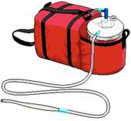
□ Suction equipment
_____________________________________________________________
_____________________________________________________________

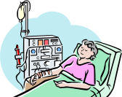
□ Dialysis equipment
_____________________________________________________________
_____________________________________________________________

□ Sanitary supplies
_____________________________________________________________
_____________________________________________________________
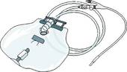
□ Urinary supplies
_____________________________________________________________
_____________________________________________________________
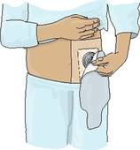
□ Ostomy supplies
_____________________________________________________________
_____________________________________________________________
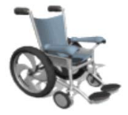
□ Wheelchair (motorized or manual) and repair kit
_____________________________________________________________
_____________________________________________________________
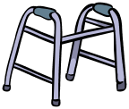
□ Walker
_____________________________________________________________
_____________________________________________________________

□ Crutches
_____________________________________________________________
_____________________________________________________________

□ Cane
_____________________________________________________________
_____________________________________________________________

□ Dentures or retainers
_____________________________________________________________
_____________________________________________________________
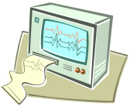
□ Monitors
_____________________________________________________________
_____________________________________________________________

□ Anything else?
_____________________________________________________________
_____________________________________________________________
Appendix B: Emergency Preparedness
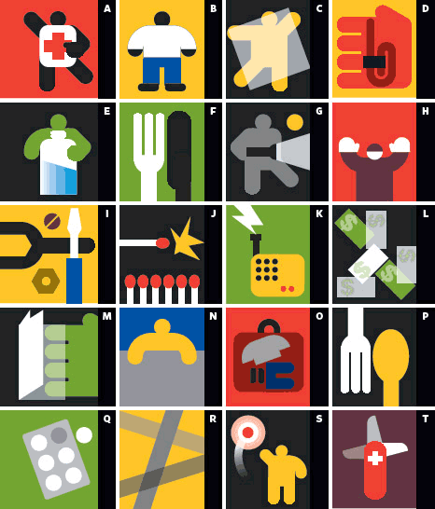
Included in this appendix is information on emergency preparedness kits. You should have emergency kits in areas where you spend most of your time such as your home, your car, your work or your school. Your kit should be set to sustain you, your family and your pets for 72 hours in the event of an emergency. Included is a list of basic items to pack in a kit. Remember, if you have special needs or medical issues to include medications or equipment in the emergency kit that will help you remain independent during an emergency, this includes supplies for your service animal if you have one.
Also included in this appendix is a template for emergency information cards. Fill out the information on the card and then fold up and keep in wallet, purse or backpack. This information will be useful for yourself, someone else or emergency personnel in a disaster situation.

Emergency Preparedness Kit Checklist
- Extra money (small bills like fives or ones, ATM’s may be out of service)
- Bottled water and water purification tablets
- Food (enough canned and dry food for 72 hours)
- First Aid supplies (include medications you take enough for 7 days)
- Fire extinguisher
- Can Opener
- Paper Towels
- Garbage bags
- Toilet Paper and feminine products
- Hand Sanitizer/liquid soap
- Bleach
- Paper and writing utensils
- Cell phone
- Health information card
- Emergency papers (vaccination records, insurance policy numbers, medical equipment manuals with identification number, copies of prescriptions)
- Flashlights and batteries
- Small Radio and batteries
- Watch or clock
- Signaling device (whistle or bell)
- Blankets
- Extra batteries
- Duct tape
- Full change of clothing (include for cold weather)
- Extra socks/undergarments
- Shoes
- Heavy gloves
- Cook stove with fuel
- Special medical equipment (contact lenses, extra glasses, hearing aids, mobility aids, etc.)
- Supplies for your pet (up to 72 hours sustainable)
- Anything else you think you will need:
- ________________________________________________________
- ________________________________________________________
- ________________________________________________________
- ________________________________________________________
Emergency Preparedness Tips
For People with Service Animals or Pets

Checklist:

__________ Make sure I.D. tags are current.

__________ Create a care plan for your animal.

__________ Be prepared to function without assistance from your service animal. Practice emergency drills using alternate mobility cues.

__________ Assemble an emergency kit for your service animal.

Emergency Kit for Service Animals

Assemble a kit for your service animal that will last seven days. Place it in a pack that your animal can carry (if it is large enough to do so) in case you need to evacuate. If your pet can not carry it, make sure you are able to.

The kit should include:

- A bowl for water and food
- A seven day supply of food
- A blanket for bedding
- Plastic bags and paper towels for disposing of feces
- Antibiotic ointment for minor wounds. (Animals can easily get cut after and earthquake; ask your veterinarian if there is anything specific you should include for your animal)
- A favorite toy

Veterinarian Emergency Contact Information

Vet’s Name:____________________________________

Phone Number:__________________________________

Location:_______________________________________

Your Pet’s Name:________________________________

License Number:_________________________________

- An extra harness

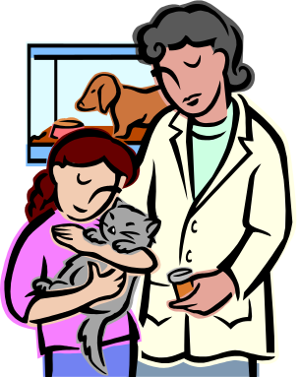

Personal Public Transit Emergency Kits

Public Transit Emergency Kits are designed to be small and inconspicuous. They can be carried in a backpack, purse or briefcase and have supplies to sustain on individual that uses public transit for 24 hours in an emergency situation.

Things you will need

- Small bag (fanny pack, large camera case)
- Re-sealable plastic bags
- Rain poncho (disposable)
- Small emergency blanket
- Waterproof matches
- Small flashlight
- Spare batteries
- Signaling mirror/whistle (some sort of alert system)
- Collapsible water bottle or water bag
- Pens for writing
- Notepad
- $30-$50 in spare cash (keep the cash in small bills and quarters. The quarters can be taped in a roll to prevent jingling)
- Emergency ID card
- Energy/protein bars (not candy, these are to supplement meals if your trapped)
- Portable charger for cell phone
- Medications (include medications if you can, especially supplies if your diabetic)
- Simple first aid kit (this is often known as a travel first aid kit)
  - Ibuprofen, Tylenol or aspirin
  - Antihistamine
  - Bandages (have a variety of sizes with at least 2 of each size)
  - Cotton balls
  - Antiseptic wipes
  - Triple antibiotic ointment
  - A 32 oz dressing
  - Gauze
  - Medical tape
  - Ace bandage wrap
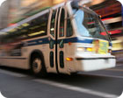

Personal Preparedness and Public Transit
If you ride public transit, there are three things you should consider when preparing yourself for an emergency.

- Don’t assume public transit will be available in an emergency.
- Identify other stations on your route if your normal station is unavailable.
- Plan an alternate route using another line in case your line is unavailable.
- Know alternate transit routes (i.e bus, train, subway) in case your normal form of transit is unavailable.
- Consider that you may have to walk. Wear walking shoes and appropriate clothing for the weather.
- Have arrangements with a family member, co-worker or friend that has a vehicle in case you become stranded.
- Form a habit of checking the weather forecast, news and transit updates before you leave.

- If the emergency happens while riding public transit:
- Don’t panic.
- Wait for help to arrive.
- If you have a cell phone and service, call for help.
- If you are on a train, do not leave the train unless you are directed to do so by the transit officials or emergency responders.
- Understand how to “shelter in place.” Often times, staying where you are and waiting instructions are best.
- Know the evacuation route of the bus/train/subway in case you need to evacuate due to immediate danger.

- Have a small emergency kit with you at all times. This kit should be able to sustain you for 24 hours in case you need to “shelter in place.”
Things To Discuss with your Doctor or Home Health



- Do you have any physical disabilities that could prevent you from being independent in an emergency or disaster?
  - Chronic disabilities (mental illnesses, developmental disabilities, etc.)
  - Acute disabilities (surgical procedure, broken limb, etc.)
- How do you plan to get access to your medications during an emergency?
  - Are you able to get 72 hours worth of medication for your emergency kit?
  - Are there alternative forms to get medications during emergencies?
- How do you plan to get access to medical treatment during an emergency?
  - Chronic treatment (dialysis, chemotherapy, radiation, etc.)
  - Acute treatment (physical therapy, chronic illness exacerbation, etc.)
- Do you rely on home health and have you discussed with your caregivers emergency plans?
  - How does home health ensure your safety during an emergency?
  - Does home health see people in an emergency/disaster evacuation?
- Do you have extra medical supplies for any medical needs?
  - Chronic supplies (wheelchair, CPAP, oxygen, urinary catheter, colostomy, etc.)
  - Acute supplies (bandages for surgical site, urinary catheter, colostomy, etc.)
  - How can you get access to those medical supplies during an emergency?
Emergency Preparedness Resources
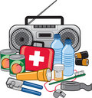

American Red Cross
The “Preparing and Getting Trained” tab on the American Red Cross website offers multiple informational packets regarding personal emergency preparedness. Information for businesses, homes, families, disabled and pets can be found. The information is also available in the following languages: Arabic, Chinese, French, Haitian-Creole, Khmer, Korean, Somali, Tagalog, Vietnamese and large-print English.
www.redcross.org

Ready.gov
Ready.gov is a website that offers general information regarding emergency preparedness to businesses, families and individuals. It includes information on writing an emergency plan and preparing an emergency kit as well as tools to get you started.
www.ready.gov

Center for Disease Control and Prevention
The emergency preparedness webpage features information regarding forming preparedness plans, making kits and knowing how to stay informed. It also provides links to other essential resources.
http://emergency.cdc.gov/preparedness/

York University
York University in Canada compiled a comprehensive webpage with information on how to be prepared for an emergency at anytime and anyplace. There is information regarding kits for the home, office, school and car as well as information for the public transit traveler and the college student living in a dorm. There is also information regarding preparedness for those with special needs or medical conditions.
http://www.yorku.ca/epp/

Federal Emergency Management Agency (FEMA)
FEMA provides a booklet of information regarding preparedness. The booklet can be downloaded, or previewed online. Chapters include information on preparing an emergency plan and kit, as well as what to do in specific emergencies such as a flood, hurricane or earthquake.
http://www.fema.gov/areyouready/

Prepare Now
Prepare now is a webpage that was developed by the city of San Francisco California. The webpage seeks to offer information that will support special needs and vulnerable populations during a disaster. Their information is also available in Spanish, Japanese, Korean, Vietnamese, Tagalog and Portuguese.
www.preparenow.org
Emergency Card Template
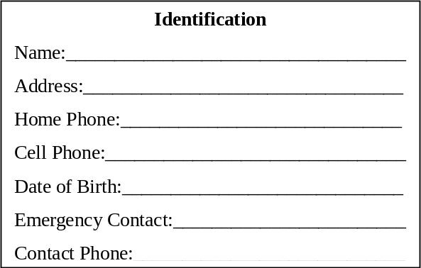
Identification
Name:___________________________________
Address:_________________________________
Home Phone:_____________________________
Cell Phone:_______________________________
Date of Birth:_____________________________
Emergency Contact:________________________
Contact Phone:____________________________

Medical Information
Medical Issues:___________________________
________________________________________

Medications:______________________________
________________________________________

Medical technology/equipment:______________
________________________________________

Allergies:_______________________________
Meeting Information
Neighborhood Meeting:_____________________
Phone:_________________________________
Out of town meeting:______________________
Phone:_________________________________
Out of town contact:______________________
Phone:________________________________
Important Contacts (write relation)
Name:________________________________
Phone:________________________________
Name:________________________________
Phone:________________________________
Name:________________________________
Phone:________________________________
Medical Information
Medical Issues:___________________________
________________________________________

Medications:______________________________
________________________________________

Medical technology/equipment:______________
________________________________________

Allergies:_______________________________
Meeting Information
Neighborhood Meeting:_____________________
Phone:_________________________________
Out of town meeting:______________________
Phone:_________________________________
Out of town contact:______________________
Phone:________________________________
Important Contacts (write relation)
Name:________________________________
Phone:________________________________
Name:________________________________
Phone:________________________________
Name:________________________________
Phone:________________________________

