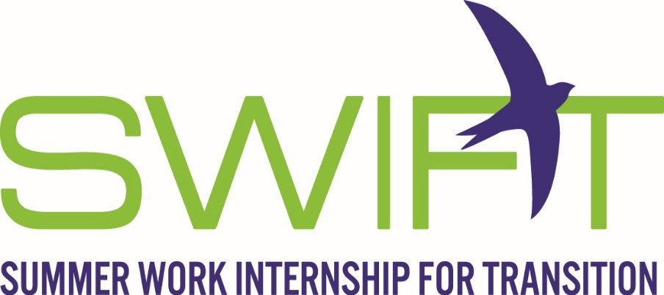
SWIFT, a 7-week residential (dorm living) program at Portland State University, will give a youth a taste of the world of work, independent living and more! SWIFT students experience:
- Paid Summer Work
- Develop Workplace Skills
- Build Self Confidence
- Social Skills
- Learn to Organize and Prioritize Tasks
- Time Management
- Customer Service Skills
- Operate Professionally at Work
- Independent Living Skills Participants Must be:
- YTP participant
- A VR Client (or ability to become/interested in becoming a client)
- In Plan by June 1
- 16 years of age and no older than 20 years of age in YTP
- An Oregon resident who has a disability that creates a barrier to employment
- Able to work legally in the United States
- Motivated to work hard and learn new skills

For more information about SWIFT, contact https://ytp.uoregon.edu/content/2019-summer-work-internship-transition-swift

56

