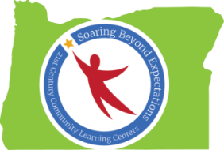

Peer-to-Peer Conversation: Supporting EL Students
Notes from Spring Conference 2016 Session
Ideas Generated by Oregon’s 21st CCLC Professionals

What Our Program Currently Does to Support EL Students and Families
- School day support for EL students
- Afterschool English classes for parents (with childcare provided)
- Rosetta Stone licenses for afterschool program use
- Office staff speak Spanish; bilingual staff translate materials
- Start language studies in home language, then add English studies as needed/desired
- Hands-on science lessons, demonstrations, group work
- Use visuals as often as possible
- Extra support during homework time
- Migrant Education
- Summer English classes for students
- EL Parent Nights
- Let students use translation apps
- Encourage students to write in home languages

What Resources We Need to Better Support EL Students and Families

- District or school coordinator to build multicultural staff relationships
- Multicultural/Diversity/Equity district specialist/school-based specialist/support for afterschool programs
- Outreach to community hubs
- Community Mentorship Connections
- Academic language translation
- Bi-lingual/bi-cultural staff (more effective hiring practices)
- Equity and diversity training for all staff
- Using apps and Rosetta Stone/other language programs awareness and training for afterschool staff
- More field trips

