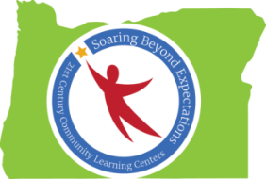

Peer-to-Peer Conversation: Summer Program Practices
Notes from Spring Conference 2016 Session
Ideas Generated by Oregon’s 21st CCLC Professionals

Summer Curriculum Ideas and Plans
- Bike Repair
- Gardening
- Credit Recovery
- Community Engagement Events
- Play Production
- Tournaments
- Language Programs
- Cultural Programs
- Music/Instrumental/Dance
- Yoga/Zumba
- Art
- Sailing/Kayaking
- Playwrights
- Pre-college
- Career Explorations
- Mentoring/Leadership
- Water/Sports
- Science Projects

Family Engagement Plans and Opportunities for Summer
- Math Activity Day
- Family Focus Groups (inviting family input in summer program planning)
- Parent Summer Program Orientation Night
- Volunteering
- Potlucks
- Outdoor Movie Night
- Family Hikes
- School Beautification/Give Back Day
- Barbecues
- Mini Pow Wows
- Family Skits
- Ice Cream Social

Summer Community Outreach Plans and Opportunities
- Gardens (School/Community)
- Volunteers (parents/elders/teens)
- Food – jobs
- Community Field Trips
- Service Programs/Partnerships
- Summer Works Program
- Favell Art Night (with the museum)
- Content/Career Field Trips
- OIT Dental Screening/Hygiene Education
- MyNewRedShoes
- Student-created Marketing
- Car Washes
- Yard Sales
- Yard Care

