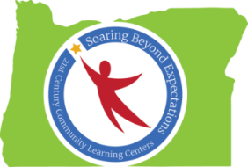

Peer-to-Peer Conversation: Family Engagement Best Practices
Notes from Spring Conference 2016 Session
Ideas Generated by Oregon’s 21st CCLC Professionals

Elementary: How We Connect with Families
- Adult Zumba class
- Registration
- SUN Showcase (student performances 4 times/year)
- Student pick up time
- Parent STEAM Events
- Voice messenger system
- Showcase of activities that will offered before enrollment
- Cooking class for parents
- Movie Nights
- Carnivals (beginning & end of the year. Students come and play games; open stage available)
- PTA/PTO meetings
- Food pantry

Middle and High School: How We Connect with Families

- Text messages (Remind101, Celly, etc.)
- Email
- Autodialer
- Flyers
- Home Visits
- School announcements; school websites
- Fundraisers
- Family Nights
- Phone calls
- Facebook/Twitter/Instagram

Elementary: Meaningful Family Engagement Opportunities
- Parent/Teacher Conferences
- Afterschool staff in classrooms as teacher assistants/aides
- Involve parents in decisions (examples: What classes are offered? What field trips would you like us to take?)
- Wednesday Folders (provides parents with information about school events and community offerings)
- Back-to-school supply giveaway during registration
- Partner with community (Self-Enhancement Inc. & Early Kindergarten Transition, for example)

Middle and High School: Meaningful Family Engagement Opportunities
- School Activities/Events
  - Conferences
  - Back to School Nights
  - Holiday events
  - College prep
  - Music/arts
  - Sports
  - Registration
- Family Nights
- STEM Camps
- High school prep/transition activities (from middle school)
- Parent Classes
- Food Pantry
- Volunteer opportunities

