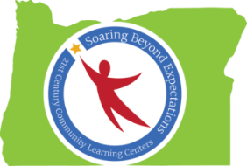

Peer-to-Peer Conversation: Effective Community Outreach
Notes from Spring Conference 2016 Session
Ideas Generated by Oregon’s 21st CCLC Professionals

Program Enhancement Partners
- AKA Science
- Head Start (trainings/PD)
- Girls Talk
- Girls on the Run
- Favel Museum
- Adelante Mujeres
- Pacific University (vision, mentors)
- Centro Cultural
- Tae Kwon Do
- Chess for Success
- Code.org
- OSU Extension
- Community members
- Police Department (forensics)
- Architecture firm & resources
- Parr Lumber
- Dance studios
- Lego Robotics
- Local businesses (restaurants, etc.)
- Community colleges
- Faith-based Organizations
- Drivers’ Ed. Program
- Children’s Theatre
- Kingsley Field
- Chamber of Commerce
- Oregon Coast Aquarium/Hatfield Marine Science Center

Program Sustainability Partners

- STEAM/STEM
- Native Education
- Museums
- Community colleges and universities (including work study students)
- Foster Grandparents
- Local pools
- Parks & Recreation programs
- High schools
- Movie theaters
- OST
- School districts
- Local businesses
- Community events (yard sales, etc.)
- Title I
- Local newspapers
- Interns from IRCO and Centro Cultural
- Federal government
- PAC/PTO
- Local libraries
- 21st CCLC/ODE
- Child Care Resource & Referral programs

