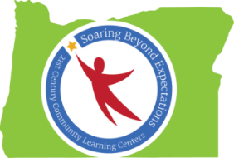

Peer-to-Peer Conversation: Career & College Prep
Notes from Spring Conference 2016 Session
Ideas Generated by Oregon’s 21st CCLC Professionals

Current Practices to Support Career Prep
- Partnerships with Community Colleges
- Aspire Mentors
- Career Exploration
  - Interest Inventory (3rd – 9th grades)
  - Strengths
  - Talents
  - Stereotypes
- “Game of Life” (incoming 6th graders)

Current Practices to Support College Prep
- College credit for summer school and in afterschool programming options
- AVID program
- Scope & sequence within club settings (including strengths, talents, goals, and vocational language)
- Contact with and visits to and from colleges and universities

Resources to Support Career Prep
- Sound studio at the high school
- Career Center – provides info and experiences related to many careers
- Connection w/local community colleges, including mentoring/tutoring from community college students
- “Scholarshop” elementary program (parent education component)
  - 8-week program
  - If completed, families receive $250 college savings credit
- Lane Arts Council (pairing students with artists)
- CIS (Career Info System)
- Afterschool staff (sharing their career experiences)

Resources to Support College Prep
- College visitations
- Partnership with Chamber of Commerce
- Partnerships w/local businesses (landscape design, golf course management, Lane Arts Council, urban/rural job locations, etc.)
- College possible
- AVID
- ASPIRE
- Gear Up
- Community Colleges
- Local universities
- High School Mentors; testimonials from current college students
- College Credit during High School
- Visuals

