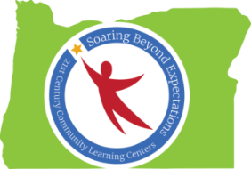

Peer-to-Peer Conversation: Behavior Management Tools & Resources
Notes from Spring Conference 2016 Session
Ideas Generated by Oregon’s 21st CCLC Professionals

Strategies to Support Effective Behavior Management
- Align with school day behavior management practices
- Afterschool staff receives training in school day behavior management (such as PBIS)
- Build relationships with every student
- Learn about each student’s needs (IEPs, behavior plans when applicable)
- Learn about each student’s strengths, interests, aptitudes
- Prevent, teach, respond
- Replace unwanted behavior with desired behavior
- Change one behavior at a time
- Reinforce appropriate behaviors (at least 4:1 ratio)
- Strength-based – teach to student’s strengths
- No sarcasm
- Model appropriate behavior
- Loss of privileges or items
- Predictable daily schedule/routines
- Student choices offered daily
- Student input on program activities

Behavior Management Tools & Resources

- Training/inservice on school day behavior management system (such as PBIS)
- District behavior specialists
- School day staff (what is working during the school day with students?)
- “Solution Room”
- “Tribes”
- Afterschool staff inclusion in RTI meetings
- Afterschool staff inclusion in parent-teacher conferences
- Targeted training provided by the district on how to meet a variety of student needs (ADHD, Autism Spectrum, trauma-informed care, etc.)

