Agency Resources
Pre-Employment Transition Services (Pre-ETS) Vocational Rehabilitation (VR)
What are Pre-ETS?
Pre-Employment transition services (Pre-ETS) are available to students between the ages of 14 and 21. Youth must be current students and experience a disability (receives services under an IEP or 504 plan or have some other medical documentation of disability). Services vary depending on the need of the individual, program, or school district.
The provision of these services is to support students in the early stages of career exploration. Pre-ETS are intended to enhance not supplant current transition programs offered in schools. VR and local school districts will collaborate to create the opportunity for students with disabilities to participate in the following five Pre-ETS:

Job Exploration and Counseling
- Work-Based Learning Experiences
- Counseling on Opportunities for Enrollment in Comprehensive Transition or Post-Secondary Educational Programs
- Workplace Readiness
- Instruction in Self-Advocacy
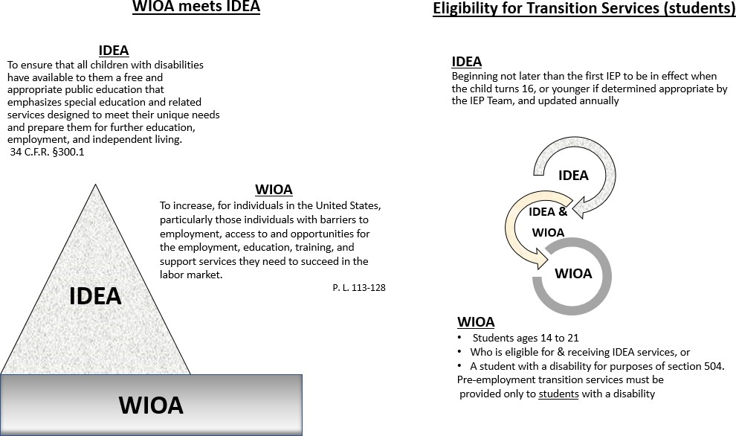
Link to Resource
Functional Limitations
State of Oregon Vocational Rehabilitation: To request services from VR contact your local VR office or Youth Transition Program in your local high school
https://is.gd/HeKz4W
Workforce Innovation Technical Assistance Center: Detailed information about Pre-ETS www.wintac.org

What Do requested Pre-ETS Services Look Like?
Pre-ETS are free services that are individualized dependent on the need of the student, classroom, or school district. Some examples of potential services include:
- Offering classes on Self Advocacy, Workplace Readiness, and Job Exploration
- Individual and group career counseling
- Enhancing established programs by incorporating local agencies and employers
- Acting as a VR liaison when discussing services with students and family
- Consult with schools about incorporating Pre-ETS into their classroom activities
- Support in transition to secondary learning opportunities
- Facilitating Person Centered Plans
- Assist with setting up connections with community agencies
- Connecting youth and educators to local businesses for educational opportunities
- Navigating career information systems
- Teaching of the importance of soft skills in the workplace
- Enhancing independent living skills and social interpersonal skills
- Attending IEP meetings when invited (when VRC schedules will not allow)
- Presenting at an Open House or Orientation held at local schools
- And much more! Feel free to ask.

Requesting Services
To request Pre-ETS, students or student advocates are required to complete a Pre-ETS request form, and email it to: Pre.ETS@state.or.us
To obtain a form:
- On line at TCN: English https://is.gd/6uEN89 , Spanish https://is.gd/fQTDK5
- In person from a Transition Network Facilitator or Pre-ETS Coordinator
- Via email from Pre.ETS@state.or.us
Schools and teachers can request consultations from individual coordinators without using the request form.
Pre-ETS coordinators partner with school districts, state agencies, and community providers to assist in delivering, enhancing and growing transition-based programs and opportunities for students.
Please contact our team for more information.

Pre-ETS Coordinators:
Nicole Perdue, Central & Eastern-Oregon Email: Nicole.J.Perdue@state.or.us Phone: (971)718-4054
Toni DePeel, Portland Metro-Oregon Email: Toni.M.DePeel@state.or.us Phone: (971)600-8358
C.J. Webb, Willamette Valley-Oregon Email Carolyn.Webb@state.or.us Phone: (503)476-4979
Pre-ETS Program Coordinator

