Oregon’s Post School Outcome Data Collection (PSO application)

Indicator 14 of the SPP requires that school districts must collect, and Oregon Department of Education (ODE) must report the percentage of special education students who are
(A) Enrolled in higher education,
(B) Competitively employed, or
(C) In some other postsecondary education or training, or some other employment,
one year after leaving special education services. This includes students all students who leave, including graduates with a regular diploma, students who, finish without a diploma and dropouts.

ODE must ensure that data are collected from each district each year. School districts are responsible for their data collection procedures, including staff assigned. The interview forms are posted at TCN website
The names of students to be interviewed, contact information, and online data entry form, is available on the secure ODE district web site

PSO Basics
- Access to the Special Ed Post School Outcomes 2.0 (PSO) Application on the secure district site: https://district.ode.state.or.us should be arranged through the District Security Administrator.
- Forms for the Exit and Follow Up collections can be found on the PSO Web Application 2.0 on the ODE Resources Tab on the top of each page.
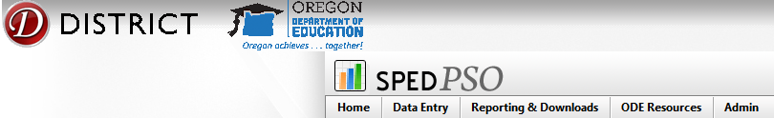
- Forms for the Exit and Follow-up collections can also be found on the Transition Community Network (TCN) website: http://triwou.org/projects/tcn/pso

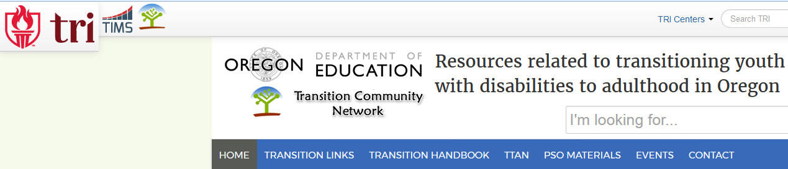

Welcome to the PSO Web Application 2.0

Follow-up Interview
- The final list of students to interview for the Follow-up interviews will be posted in early April; all Students are ‘required’. Data can be entered June 1 through September
- Names and contact information are provided for follow-up students.
- Follow-up interview materials, including the script, instructions, and interview, will be available on the ODE resource tab on the secure district site and on the district resources section of the TCN website
- Once data are entered, the interview remains open and modifiable until the collection closes on September 30. Click the blue Actions button to reopen a survey after you have submitted the final.
- Once names are selected on the follow up student list, their call logs can be printed all at once using the print call log feature on the page
- The Survey Status must be marked as ‘in process’ to show the interview questions.

Exit Interview [this is not required, but is encouraged]
- Timing:
  - Agreement to participate forms and contact information can be gathered in the fall
  - Exit Interview data can be submitted from January through September
- Names and contact information for exiting students must be entered by the district
- The Secure Student Identifier Number (SSID) is required to enter special education students
- Demographic information associated with the SSID number fills after you hit the Confirm option.
- Once data are entered, the interview remains open and modifiable until the collection closes the end of September. Click the blue Actions button to reopen a survey after you have submitted the final.
Please update the contact information below for the school year. Districts should include a special education administrator as one of their contacts.
The list of students to interview for the Follow-up collection is now available. You will need to update your district contacts to be able to move past this page. No changes were made to the Follow Up interview or documents from 2016.
The Exit Collection is now open for data entry on students expected to exit special education during the school year. You will need to enter the names of the students you expect to exit. No changes were made to the Exit interview or documents from 2016.

Choose your district from the drop down list

Data Entry and Reporting
- Select which collection you want to enter by clicking one of the links in the Data Entry option.
- The Reporting & Download option takes you to Excel data downloads and reports.
Data Entry: Exit Interview: Student List

- Districts need to enter students that leave SE services during the school year; this cannot be pre-populated.
- Click Add New Student, and enter the SSID number and the Find button. Data on student should appear.
- Click Confirm to enter the student, their name will appear in your list
- Click on the student’s name to enter interview.
- Information is saved when you move down to the next question.
- Click Submit Final when done. (You can return to edit the information by selecting Unlock Survey from the blue Action box at the end of the row.)
- When you have completed all data entry for the Exit collection, check the Yes button in the peach ‘Collection Complete’ box.
- If the SSID number does not work to access a student, contact James Foutch james.foutch@state.or.us as the student may be in the system for another district.

Data Entry: Follow-up Interview

When Data Entry: Follow-up student surveys is chosen the first page shows the follow-up surveys in data and chart form
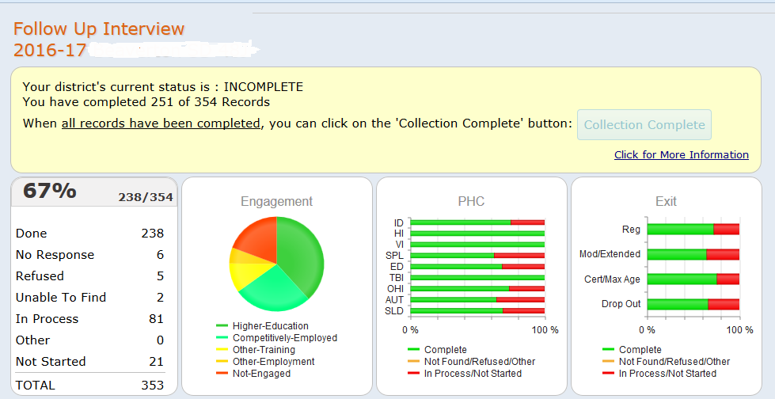

The data is also shown by school
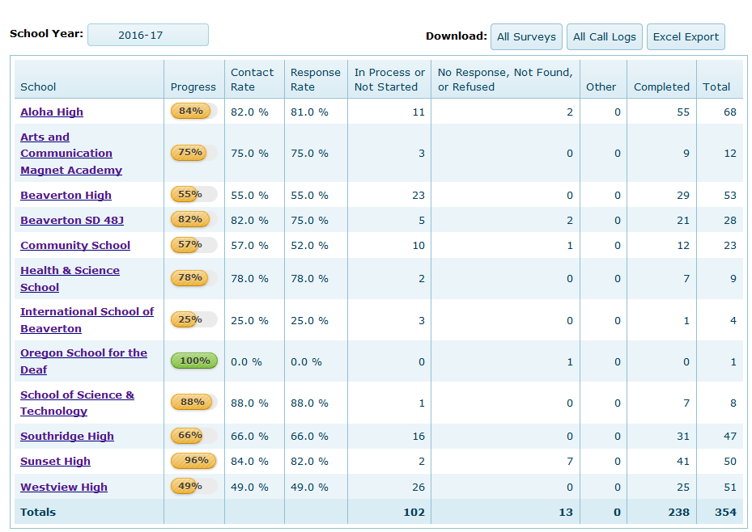

Data Entry: Follow up Interview: Student List

- Districts are provided with a list of all students who were reported as exited on the SE exit collection and did not return to be included in the following year SECC
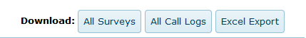
- All surveys, All call logs and a list of All students for the district are available by using the buttons above
- Or select a school, which will show a list of the students that school needs to interview

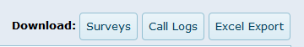

- For a selected school: Call logs are available which include contact information for the student, and tracking for interview attempts. Click a blue button to print a call log, print a survey, or down load a list of students in an Excel format
- You can print a collection of call logs by checking the box before the name and Downloading Call Log PDF’s from the option above the student list header. You can also download a copy of your data in Excel.
- Click on student name to open the follow up interview form for data entry.
The survey questions will not open unless you have selected Completed or in process for
the 1st question
- Information is saved when you move down to the next question. Click Submit Final when finished.
- When you have completed all data entry for the selected school Follow up collection click “Back to All Schools”.

When all schools in a district has completed the data entry for the Follow-up surveys then the district can use the “Collection Complete” button on the first page
Follow up interview data notes:
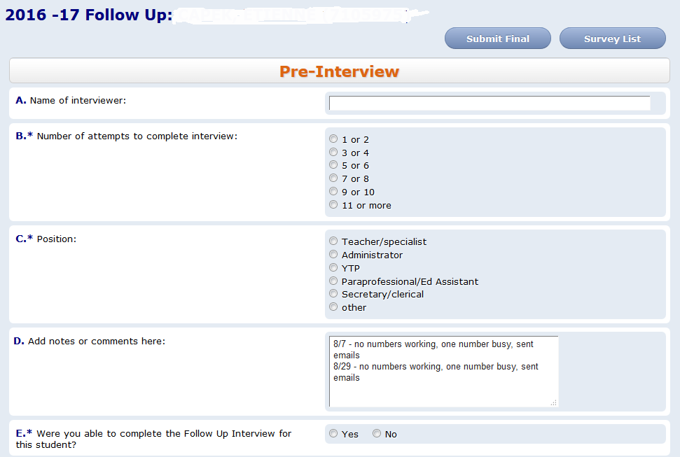
- Skip patterns are built into the follow up interview form: some follow up questions will only appear after a 'yes' answer has been entered in a question.
- Questions marked with an “*” are required for federal reporting.
- The Pre-interview information is on the top of the call log
- To exit after starting an interview, but before you are ready to submit final, use the Survey List button. DO NOT use the back button or the Home selection from the top bar or data may be lost
- A survey is considered completed when no additional efforts can be made to gain more information: data entered, client refused, or district unable to find the student despite making multiple attempts, preferably at different times of day or weekend.
- Completed or in-process interviews include forms still in process such as appointment made to complete interview.

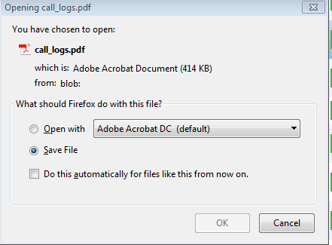
Download Call Log PDF
- To print the call log(s) select as many students as needed (check boxes in front of name)
- Use “Call Logs” to get PDF file of all selected students. This will open a window, see below (Firefox was used to open this window; it may look different using a different internet explorer).
- If additional call logs are needed later: un-select the check boxes of the students whose call logs have already been printed and select the next student or group of students
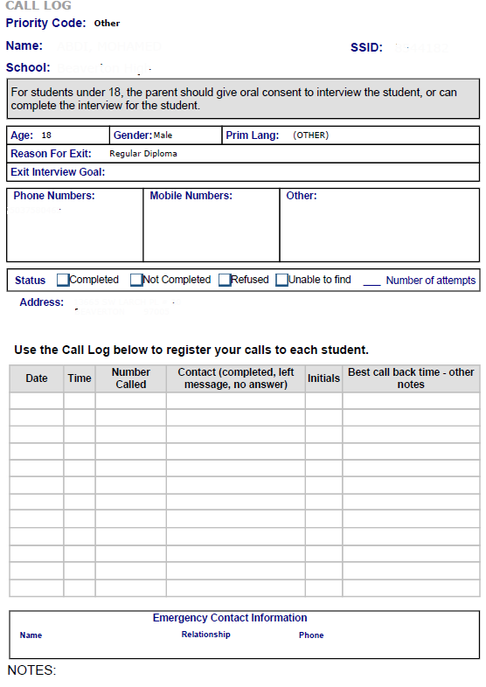

An example of the call log is shown here; the downloaded version contains student’s information.

Other things to know
- Interviews conducted during the summer or fall should only include work or school in the 12 months after leaving school
- All Special Education Students are now “required” and need to be contacted for the follow-up survey, even if they did not participate in the Exit interview last year. Use district discretion if there are individuals that shouldn’t be contacted, but leave a note in the Pre-Interview Question G text box explaining the situation.

Each year, other items have been added to the PSO application so other reports could be created.

