OREGON CTE STUDENTS WITH DISABILITIES

Why Career and Technical Education?
In the Class of 2016, CTE Concentrators with disabilities graduated at nearly 24 percentage points higher than their statewide counterparts.

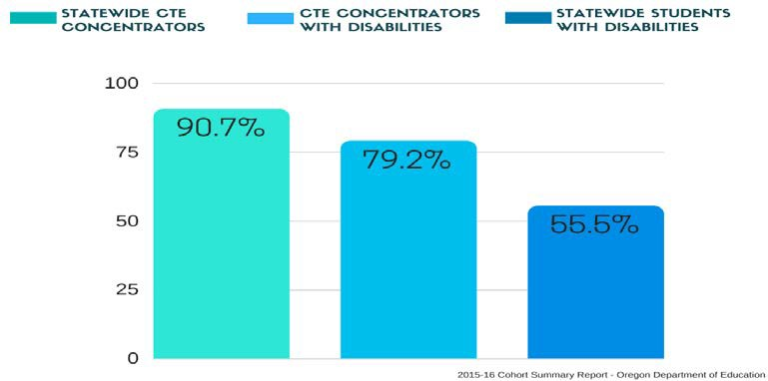
DID YOU KNOW?
People with disabilities across all age groups are AT LEAST two times more likely to be unemployed than their non-disabled counterparts.
What is a Career and Technical Education Concentrator?
A CTE Concentrator is any student who completed at least one credit of course work in a single approved CTE Program of Study.

Why does Career and Technical Education work?
Identified career path
Industry-generated technical skills Essential workplace skills
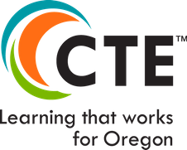
Aligns to academic content Applied contextual learning

Lauren Dressen (CTE Data Analyst) - July 2018
For more information please visit the website Career and Technical Education

