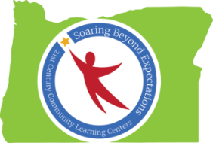

Promoting Resilience in Afterschool Programs
Notes from Spring Conference 2016 Session
Ideas Generated by Oregon’s 21st CCLC Professionals

Building Life Skills (Elementary)
- Showing how to set an example
- Acknowledging mistakes
- Sincerely apologizing
- Reflection
- Building self-confidence
- It’s okay to be different messages and modeling
- Validation
- Kindness and respect

Building Life Skills (Middle & High School)

- Financial planning – building a future (paychecks, budgeting, etc.)
- Post secondary prep (college and career, exploration, CTE/STEAM, etc.)
- Career/job experiences
- Internships
- Volunteer opportunities
- Leadership opportunities

Collaborative Learning (Elementary)
- Older grade buddies (1:1)
- Group Projects
- Peer Helpers
- Current students teaching new students about program

Collaborative Learning (Middle and High School)
- Use of technology (I-pads) in groups focused on researching social and economic topics
- Service learning and project-based learning opportunities
- Peer mentoring
- Peer tutoring
- PLC

Community Based Classroom Structure (Elementary)
- Focus on afterschool rules compared to school day rules; helps students understand rules are same/similar regardless of which time of day it is
- Restorative practices

Community Based Classroom Structure (Middle and High School)
- Collaborative learning
- Check in (circle time – speak/listen)
- Student driven projects – team-based
- Maker Space – community/business partners
- Community oriented problem solving
- Fundraising

Other Examples of How to Promote Resiliency
- Staff training about ACES, trauma-informed care, and building resiliency

