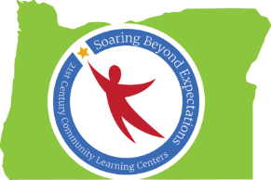

Peer-to-Peer Learning Conversation
Notes from September 17, 2015
The Whats, Whys, and Hows of Formative Assessment

Participants: Lisa Utz, Pat Ketcham, Christina Reagle, Gary Glasenapp, Roxanna Marvin, Candi Scott, and Pete Ready

What is formative assessment?
“Formative assessment is a range of formal and informal assessment procedures conducted by teachers during the learning process in order to modify teaching and learning activities to improve student attainment. It typically involves qualitative feedback (rather than scores) for both student and teacher that focuses on the details of content and performance. It is commonly contrasted with summative assessment, which seeks to monitor educational outcomes, often for purposes of external accountability.” (Wikipedia, 2015)
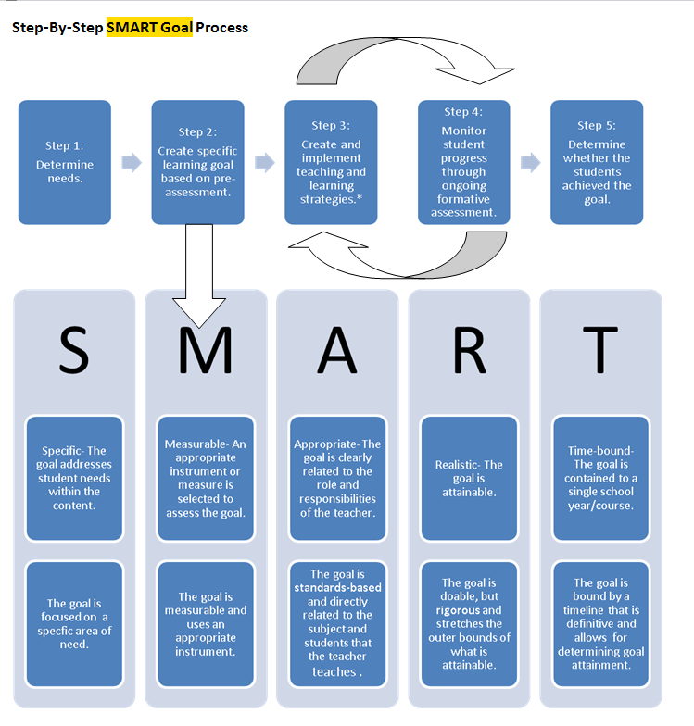
Formative assessment is based on project goals which need to be SMART = Specific, Measureable, Appropriate, Realistic, and Time-bound.
Guidance for Setting Student Learning and Growth (SLG) Goals: A Component of the Oregon Framework for Teacher and Administrator Evaluation and Support Systems. Oregon Department of Education, online, 2014.

Why is formative assessment important?
- Formative assessment provides opportunities for feedback and adjustments during the educational process. Deficits can be identified and addressed before a summative assessment is conducted.
- Formative assessment can be used to differentiate instruction to meet the individual needs of students.
- Formative assessment is required of 21st CCLC programs and is included in the programs’ work plans. If changes are made to goals or metrics, an amendment to the work plan needs to be submitted.
  - Pete: NOTE: Because of the focus on continuous assessment of objectives, the Oregon State Assessment is not appropriate as the only source of information. A combination of other measures of continuous academic progress such as report card grades, teacher surveys, pre-post skill assessment, etc. are required.
How can after school programs conduct formative assessment?
- Communicating and coordinating with the school is the best option for after school programs. Having connections with school day teachers, or having school day staff also working in the after school program makes it easier to keep track of individual student goals and progress.
From Mike Loretz (Oregon City):

My contribution would have centered around the concept of using the assessment data that the schools already use and have. Too many supplemental programs, like after school, try to create their own assessments to measure their impact when in reality the goal is to boost data that is already being measured (attendance, behavior, attitude, achievement). Are students that are participating in expanded learning opportunities on a regular basis strengthening their data and performance in school? So, if folks have not yet met with school staff to see what things they are measuring and what things they value, they should do that. When it comes time to report on progress, it should tell the story.

At the high school we are using work samples to assess progress toward the graduation requirements for demonstrating proficiency in essential skills. We also track attendance, behavior and overall school success. "Formative" is not always a "test". Are you monitoring student success? Are you doing it often and adjusting interventions, including after school support?

- Connect with Special Education services in order to get information about student goals and objectives that may be included in a student’s IEP or 504 plan. Consider whether accommodations need to be made for the student when conducting formative assessment activities.
- Pete recommends that programs start a formative assessment profile when students enroll with the intent of assessing skills in order to identify where students are in achieving goals and to plan next steps for when goals are met. Assessment needs to be proficiency-based and can include applied learning. Assessment is not “just a test” and can include demonstrations of skills or products.
- When examining your goals, consider:
  - Are they still relevant?
  - Are they written as SMART goals?
  - Are your metrics achievable and relevant?
  - Do students have access to results of formative assessment in order to know how they are progressing on their individual goals?
Which sources of formative assessment are you using?
- Sources of formative assessment can include:
  - attendance records
  - grades
  - family surveys
  - credit recovery
- Formative assessment instruments used by some programs include:
  - The EZ-CBM assessment, an online benchmark screening and progress monitoring tool developed at the University of Oregon. Educators use the data to make informed instructional decisions. The test items are multiple choice, and testing occurs on a secure website. https://dibels.uoregon.edu/
  - MobyMax is a personalized learning solution for K-8 Math and ELA (reading, vocabulary, language, and writing). All built from the Common Core. http://www.mobymax.com/
  - Imagine Learning is an individualized language and literacy software program with actionable data. This program can be tied to EL program goals and folded into family outreach and assistance. http://www.imaginelearning.com/

Note: Christina Reagle and Pat Ketcham, Education and Evaluation Specialists, will be co-presenting a session on Formative Assessment at the 21st CCLC Fall Conference on November 20th. More details will be included in the conference registration information.

