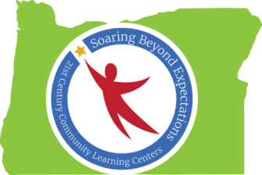

Peer-to-Peer Learning Conversation - June 18, 2015
“Summer Programming: What’s the same or different and why?”
Getting and keeping staff is a challenge – especially for people with specialized skills – due to short time of work (an hour or two a day – once or twice a week)
  - There is also difficulty with the school’s ability to pay them – districts have requirements (business ID, EIN#, license?) before they can pay people. People need to be vetted and have background checks.

- Ideas:
- Look to people from the community and existing businesses to participate – music stores (musicians), gyms (boxing), art galleries (artists), auto mechanic, etc.
- develop linkages and network (asset mapping approach) in community to find sources that would be able and willing to participate. Find some that are associated with school.
- (Mike) Create a resource of pre-vetted individuals or businesses (Salem art association) that can be called on to donate time. Someone can recruit, approve, catalog, location, etc. – and share the information so that all CCLC programs can access resources without having to do the work themselves.
- Bigger school districts could hire people to work across multiple sites

Sustainability is a challenge
- Need to do strategic planning with grantees; programs must demonstrate that they are serving at least 90% of the students they proposed in their rfp.

Summer school planning at HS level is mainly aimed at credit recovery. They hold a bunch of field trips. If students attend a certain number of the trips, they can receive partial credit. A possibility is to associate with an organization such as the NW Youth Corp.

Usually planning starts in April – who is staffing, what will they teach, transportation, etc.
- Mike suggested that we call programs that are having Summer programs to do a debrief at the end of Summer. – what worked and what would they do differently?

