Transition Needs Chart below can be used to track services over time

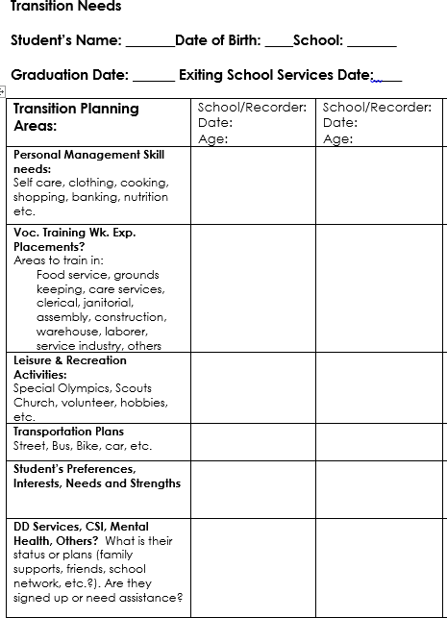

Consider these areas when planning with the transition team

Find a copy of Transition Needs form at
https://tcntransition.org
https://tcntransition.org

Key Points in the Transition Process
The ultimate purpose of transition planning is to make decisions and assign responsibilities related to the student’s desired post-school goals. In this regard, the importance of a common understanding of available services and corresponding activities to receive such services cannot be overstated. All members of the IEP and Individual Plan for Employment (IPE) Teams are encouraged to be active participants, especially students with disabilities, their family members or, as appropriate, agency representatives.
The following Key Points table is provided as a quick reference tool for the youth and their families to have a better understanding of the coordination between IEP and IPE team members with respect to the transition activities in the transition process.
The Key Points table begins with activities and services starting while the student is in school, such as participation in IEP meetings, consulting with other State agencies, applying for VR services and moving forward to engage in employment services provided by the VR agency. You may use the following information to ensure a common understanding among all involved in the transition process.

KEY POINTS IN THE TRANSITION PROCESS
Alignment: IEP and IPE alignment facilitates a seamless service delivery process.
#1 | Individualized Education Program | Participate in your IEP or child’s IEP development to ensure that transition services are addressed in your child’s IEP by age 16 (or earlier, depending on your state’s laws). Students with disabilities and their representative are critical members of the IEP Team and have valuable information that is needed for quality transition planning.
#2 | Be Familiar with the Steps to Transition  Planning | Schools should:  - Invite the student;  - Administer age appropriate transition assessments;  - Determine needs, interests, preferences, and strengths;  - Develop post-secondary goals;  - Create annual goals consistent with post-secondary goals;  - Determine transition services, including course of study needed to assist your student in reaching those goals;  - Consult other agencies, in particular, the VR agency; and  - Update annually.
#3 | Implementation of Transition Services | Provide transition services as identified in the IEP. Pre-employment transition services are provided under the Rehabilitation Act. Alignment of the IEP and IPE facilitates a seamless service delivery process.
#4 | Referral to VR and/or Other Adult  Agencies | - Pre-employment transition services provided under the Rehabilitation Act, as appropriate;  - Familiarize yourself with laws relating to other programs; and  - Learn about community agencies that provide services to support students, such as travel training and daily living skills.
#5 | VR Application  Process | - Share employment interests and capabilities during the intake interview.  - Focus on assessment(s) to lead to the student’s post-secondary goals.
#6 | Individualized Plan for  Employment | Once a student has been determined eligible for VR services, the IPE must be developed and approved within 90 days, and no later than the time student leaves the school setting.
#7 | Common VR Services Available  Under the  Rehabilitation Act | - Transition services;  - Vocational counseling;  - Vocational training;  - Post-secondary education;  - Supported employment services;  - Career development; and  - Job placement.
#8 | VR Service Record Closure | As a result of the student or youth with disability:  - Achieving an employment outcome; or  - No longer pursuing an employment outcome and, therefore, determined ineligible for VR services.

