Learning from Summer:
Findings and Implications for Summer Learning Programs

Highlights from Afterschool Alliance January 18, 2017 Webinar:

- The three factors most correlated with improved student outcomes are these: consistent attendance, high dosage of academic content, and quality instruction.

- Recommendations for Summer Programs:
  - 5-week programs (20 or more days)
  - Maximize attendance (get commitments from families)
  - Schedules need to protect instructional time (30 – 35 hours of instruction for maximum benefit)
  - Focus on instructional quality (highly effective teachers)
  - Full-day programming with enrichment (allows for both academic and enrichment time)
  - Individualized outreach for recruitment (phone calls to families)

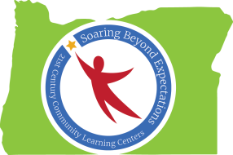
(TRI Team Notes)

