Secondary Transition Professionals in Oregon—
Check Out this New Opportunity to Connect!!
Go to this website to join:
http://teachingresearchinstitute.org/groups
Scroll down to PSO Secondary Transition!
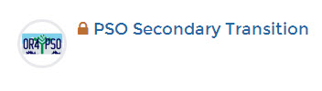
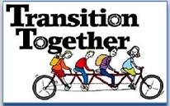
Become a PSO Secondary Transition Group member

All members can post information, start conversation threads, contribute to discussions and submit materials

FORUMS
Conversations about
Secondary Transition Issues

WIKI

Document Posting, Blurbs, News Blogs

EVENTS
Trainings, Webinars, Announcements,
Group Meetings, Conferences

Educator Institute on Networking and Transition--Baker City, Oregon
Educator Institute on Networking and Transition -- Redmond, Oregon
MATERIALS

A Library of Current Resources

Post School Outcomes
Effective Practices (EP)
Predictors of Success
Applying EP to classrooms
Meeting Accountability Goals

Transition Profiles from 2012-13

Notes from WOU Legal Issues Class

District Provided Resources

Effective Practice Documents
Most Current Transition Resource Booklet

Post School Outcomes information

District supplied transition materials

Q & A

