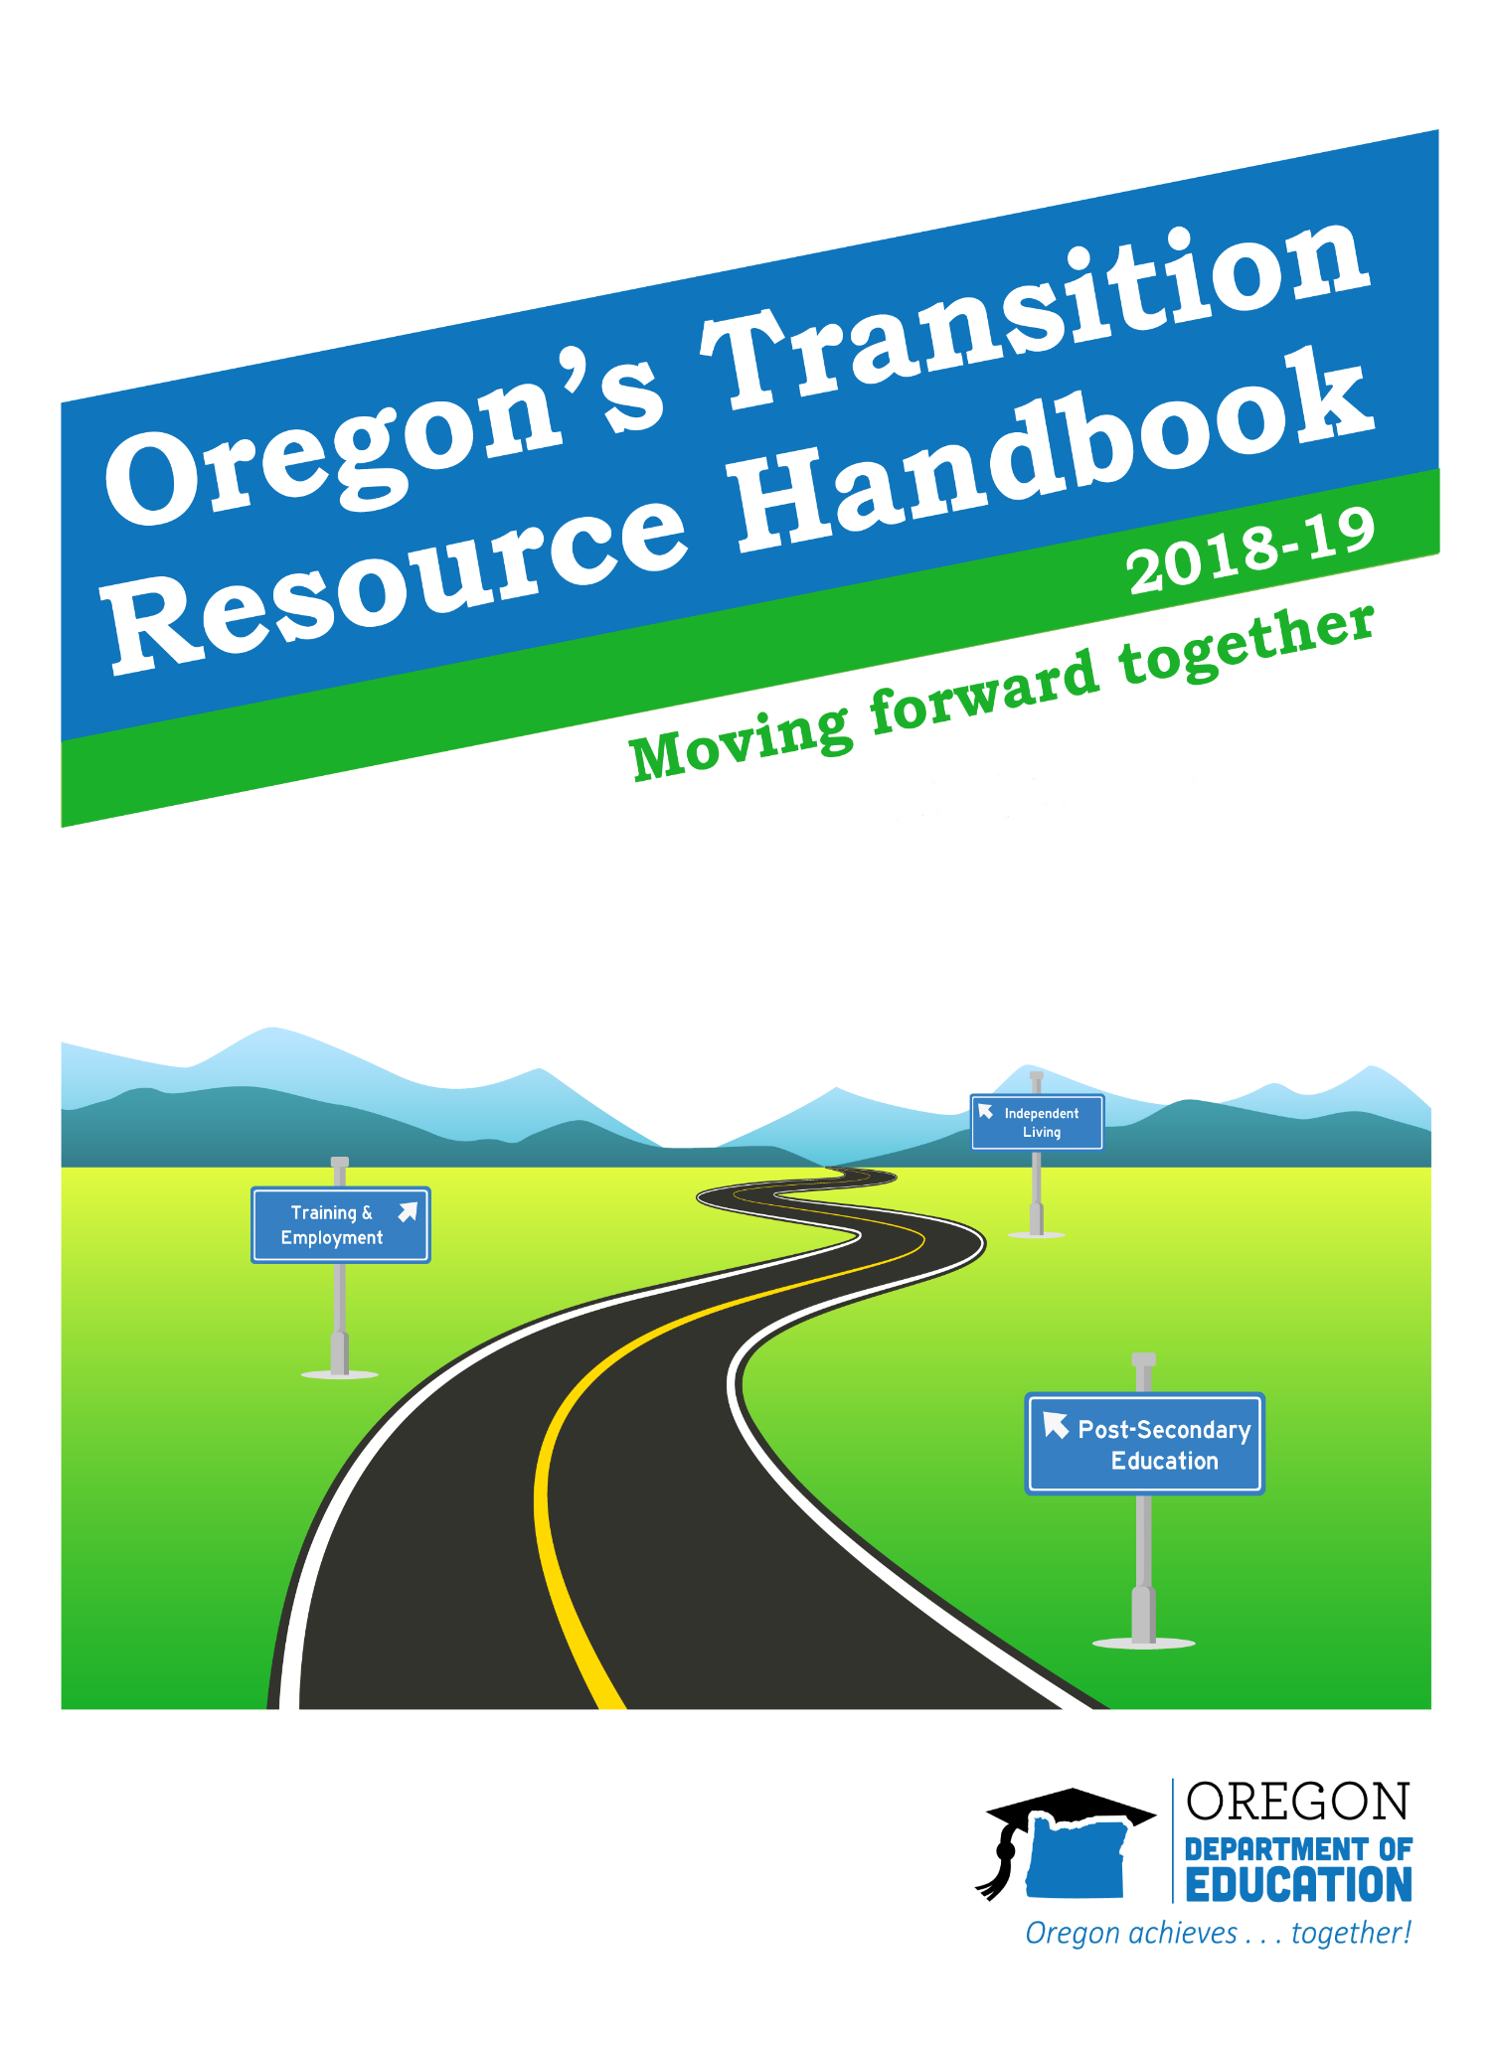

## Table of Contents

**State Expectations** 3

**State Performance Plan** 4

**Hot Topics in 2018-2019** 5

**Introduction to IEP Requirements**

Post School Outcomes & Other 7

Transition Indicators

Evidence Based Practices that Support Predictors 11

Case Examples 13

Eight Components of a Transition IEP 14

**Invite the Student** 15

Person Centered Thinking 17

Agency Awareness and Attendance18

Case Examples 20

**Age-Appropriate Transition Assessments** 22

Suggested Timeline for Assessments 24

Case Examples 26

Oregon Extended Assessment Decision 29

Making Guidance

**Post-Secondary Goals** 31

Case Examples 33

**Transition Services** 36

Examples of Behavior that could fit 37

Post-Secondary Goals

Case Examples 38

**Course of Study** 41

Case Examples 42

**Coordinate with Agencies** 45

**Agency Resources** 47

**Annual IEP Goals** 57

**Summary of Performance** 58

**Miscellaneous Resources** 59

## State Expectations Educational systems at the national and state levels are working to design programs so that students graduate from high school with the skills to be college and career ready. Future Ready Oregon is an initiative to connect what students are learning to the jobs that businesses are creating. By increasing our students’ opportunities for hands-on learning, we motivate students to keep coming to school and keep learning, right up until they cross the graduation stage and head into the world of work. In addition, if we match those learning opportunities to the job skills businesses are looking for, every student in Oregon can graduate with a plan for the future, and the skills to make that plan into a reality.

Oregon’s Employment First initiative has been the vehicle for state agencies to continue to operate together in improving competitive integrated employment outcomes for people with intellectual and developmental disabilities.  Employment establishes community connections that allow people to become contributing and valued members of their communities. As with all other citizens, for individuals with I/DD, employment has many positive impacts. These impacts include increasing self-worth, building relationships, and access to community resources. Employment improves economic well-being as well as physical and mental health.

**Priorities for Improvement in Oregon**

* Decreasing the 25% of former students who have not spent a term in a post-school education or training program or worked for 90 days in the year after leaving high school (measured in the Post-School Outcomes (PSO) data collection).
* Decreasing the 5% of students with disabilities who drop out before receiving a diploma.
* Increasing the 63% of students with disabilities who have completed school with a regular or modified diploma after five years in school.
* Increasing employment training and vocational experiences in school which will lead to better post-school outcomes*. A preliminary look at sample data from the* ***PSO Exit data*** *collection showed that three quarters of students who left during 2014-2015 were reported as having 1 or more community work experience while in school.*
* Using PSO data to make decisions on implementation of the NTACT Evidence Based Practices and Predictors for transition program planning and service provision to improve outcomes.
* Increasing educators’ engagement with Employment First as an integral part of new community partnerships across the state.
* Increasing the use of the Transition Technical Assistance Network (TTAN), and the talents of the eight Transition Network Facilitators (TNF) who are now available full time throughout Oregon.

## State Performance Plan

The state is required to have in place a State Performance Plan (SPP) that evaluates the state's implementation of special education services for school-aged children and describing how the state will make improvements. This plan is called the Part B State Performance Plan (SPP) and is required to be posted on the state's website.

Oregon’s Performance Plan lists four transition related indicators:

*Indicator 1*: Increase **graduation** rate

*Indicator 2*: Decrease the **drop-out** rate

*Indicator 13*: Achieve 100% compliance **transition related standards** in the IEP

*Indicator 14*: Improve **Post-School Outcomes**: employment, education or training, and independent living

For Indicator 13 there are eight procedural compliance standards related to transition-aged youth on the Oregon IEPs. Schools are required to document **100% compliance** on these standards.

Oregon has not met the required percentage of compliant IEP’s for the past two years on the SPP, dropping from 82% of files being compliant on the eight transition standards to 75% for 2014-2015. This moves the state into the **Needs Assistance** for two consecutive year’s category.

### Checklists & Tips

As districts review the transition IEP page these eight components must have documented evidence. **In order to be compliant the answer should be “yes” to all of the following questions.**

* Is there **evidence that the student was invited to the IEP team meeting** where transition services were discussed?
* Is there evidence that the measurable post-secondary goal(s) were based **on age-appropriate transition assessment?**
* Is there evidence that the student’s **preferences, interests, needs and strengths** were considered as part of the IEP development?
* Are there **appropriate measurable post-secondary goals** in the areas of education & training, employment, and as needed, independent living?
* Are there **transition services** in the IEP that will reasonably enable the student to meet their post-secondary goal?
* Do transition services **include courses of study** that will reasonably enable the student to meet their post-secondary goal(s)?
* If appropriate, is **there evidence that a representative of any participating agency was invited to the IEP team meeting** with prior consent of the parent or student who has achieved the age of majority? List not applicable (NA) if the agency did not participate because of age or grade.
* Are there **annual IEP goals** related to the student’s transition service needs?

Hot Topics in 2018-19

2018 legislative session final ruling on **Senate Bill (SB) 1522** passed, and returns language in ORS 339.115 to status prior to passage of SB 20 (2017), allowing districts to admit students who have already received a modified diploma to be eligible to return for education and transition services.

The bill also makes modified diploma recipients in Youth Corrections Education Programs eligible for transition services and allows modified diploma recipients to be eligible for the Expanded Options Program. See Senate Bill 20 (2017) and Senate Bill 1522 (2018) for more information. Questions: [sally.simich@state.or.us](mailto:sally.simich@state.or.us)

## **Online Version of the Transition Resource Handbook Coming Soon**

Beginning this year, Oregon’s Transition Resource Handbook will be made available online through a mobile friendly website at <http://tcntransition.org/handbook/2018>

Several exciting features will come with this change including the ability to browse, search, bookmark, share, and print single or multiple pages of the handbook.  In years past, the handbook has been made available as downloadable PDF documents.  However, this method never really allowed more advanced and useful features like navigating through a menu or searching.

By providing the Transition Resource Handbook in a completely online format, our hope is that its usefulness, accessibility, and reach will be substantially improved.  We anticipate the online handbook going live by mid-October, 2018.

.

**ODE Guidance: Avoiding Mock Sheltered Workshop (MSW) activities in schools-**

This guidance document and flow chart is provided for special education directors, secondary special education teachers, administrators and transition specialists.  The Settlement Agreement for the Lane vs. Brown case was approved in December 2015, and relates to persons with intellectual and developmental disabilities (I/DD) who worked in or were referred to sheltered workshops.

There has been some confusion regarding the definition of Mock Sheltered Workshop (MSW) activities contained in the Settlement Agreement and their prohibition within public schools.  Clarification is needed around pre-vocational activities, similar to those that might occur in a sheltered workshop.

ODE Guidance- <https://is.gd/Ri2Wl1>

MSW Flow Chart- <https://is.gd/mAHb3s>

MSW Self-Assessment- <https://is.gd/Kuz6Ng>

**First Person Language**

Language is very important, and using person first language emphasizes the person, not their disability.

Words to avoid: disabled, deaf person, handicapped

Words to use: person experiencing a disability, a person who is deaf.

**Diplomas are for Everyone**

ODE and FACT Oregon are making it a priority to raise the number of diplomas earned by students experiencing disability and lowering the number of certificates issued. All students should be on track for a diploma. Oregon’s diploma options are available throughout the state, in every district, and make earning a diploma possible for all. Starting in grade 5 the IEP team, including the student and their parent, should discuss the extended, modified and standard diploma requirements and track for the most rigorous. We must create a culture that earning a diploma is possible! Earning a diploma is a huge rite of passage that should be experienced by everyone.

**ODE and CTE**

The ODE transition team has been fortunate to add ODE Career Technical Education (CTE) members to our state planning group for Transition with National Transition Technical Assistance Center (NTACT). As a group we have analyzed statewide data for CTE and Post school Outcomes to understand if students with disabilities are accessing Career and Technical Education (CTE) programs and the post school outcome results. CTE provide an unparalleled opportunity to explore the place where learning, career opportunity, and interest meet. CTE programs are offered in harmony with standard academic programs in local high schools and provide students with the opportunity to explore high-wage/high demand career areas.

CTE encompasses a wide range of activities intended to simultaneously provide students with skills demanded in the labor market while preparing them for post-secondary degrees in technical fields. It is defined as “*[a] sequence of organized educational activities that provides individuals with coherent and rigorous content aligned with challenging academic standards and relevant technical knowledge and skills needed to prepare for further education and careers…”*(Source: [Oregon Administrative Rule 581-022-0102](https://secure.sos.state.or.us/oard/viewSingleRule.action;JSESSIONID_OARD=ow0FVWBjxR2xTD0RFucY77fIQElVcof8GbwjwHD_LGT7axJrId9v!568786841?ruleVrsnRsn=246696))

**Inclusive education**

Inclusive education happens when children with and without disabilities participate and learn together in the same classes. A comprehensive review of the research shows that when students with disabilities attend classes alongside peers who do not have disabilities, good things happen:

* Students with disability are more likely to develop stronger skills in reading and math, have higher rates of attendance, are less likely to have behavioral problems, and are more likely to complete secondary school then students who have not been included.
* Students without disability benefit from less fear of human difference and increased comfort and awareness, growth in social cognition, increased self-esteem and a sense of belonging, development of personal moral and ethical principles, and warm and caring friendships.

Read a comprehensive review of the literature at <https://bit.ly/2PKYAHM>.

## Post School Outcomes and Other Transition Indicators

Districts are required to complete follow-up interviews with all students who received special education services (i.e., had an IEP) and who left secondary school. To help districts, materials from the National Post School Outcomes document, **Contacting Hard to Find Youth: Strategies for the Post-School Interviews**, have been adapted for Oregon districts.

### Checklist & Tips

#### Using Outcome Data to Inform District Improvement

Ultimately, districts that demonstrate a high proportion of their students attending post- secondary school and/or working in competitive settings are likely to offer strong transition programs and quality services,

Post school outcomes should improve when predictors of post-school success and evidence- based practices are used as part of quality transition planning and services. The inclusion of the predictors in assessing district needs and priorities should lead to **higher graduation** rates and **lower dropout** rates as the planning is focused on the needs of the students.

**Guiding Questions Using Transition Data**

*The following questions relate to the district’s overall secondary transition program.*

1. When a student turns 16, how does the district provide explicit transition planning services specifically designed to help students move from high school into work and or postsecondary education and training opportunities?
2. Do the IEPs meet the requirements for Indicator 13?
3. Does every IEP contain appropriate measurable postsecondary in education and employment for students who are 16 or older?
4. What percentage of former students was engaged (i.e., working, going to school, or doing both) one year out of school?
5. Was this percentage consistent with the engagement rates of previous years?
6. What percentage of the district’s respondents was not engaged at any level?

*The following questions address issues related to the graduation and dropout rates experienced by youth with disabilities in the district and or school.*

1. What percentage of former students graduated with a diploma last year?
2. What is the number of students with disabilities represented by this percentage?
3. Is the current year’s graduation rate similar to, higher, or lower than the graduation rate in past years?
4. What percentage of former students dropped out of school last year?
5. What is the actual number of students with disabilities represented by this percentage?
6. Is the current year’s dropout rate similar to, higher, or lower than the dropout rate of past years?

*The following questions address issues experienced by youth with disabilities in the district and or school.*

1. Considering the overall graduation and dropout rates for youth with disabilities from your school/district, what surprised you?
2. What do you think contributes to the graduation and dropout rates?
3. What types of classes, academic/vocational, do students who graduate (or dropout) from high school typically take while in high school?
4. What district-wide policies and or procedures contribute to students with disabilities dropping out of high school? What are barriers to their dropping out?

*If the competitive employment rate for youth with disabilities in your district/school is lower than the State’s employment rate or benchmark consider the following questions:*

1. What services does the district provide that contribute to youth becoming competitively employed once they exit school? For example, does the district provide job coaches; is there an interagency agreement between the school district and the local vocational rehabilitation office?
2. What district barriers limit competitive employment for youth with disabilities? How is the district addressing the barriers or preparing students to overcome them?
3. How is career awareness and job training an explicit part of the curriculum?
4. Is there a concerted district-wide effort to provide vocational and career technical education courses to youth with disabilities in high school?

*If you determine the enrollment rate for youth with disabilities in postsecondary education and training is lower than the State target or benchmark, consider the following:*

1. How are youth with disabilities provided specific opportunities to learn about a variety of post high school learning opportunities, including vocational and training programs, trade schools, community and adult learning programs (i.e., not just 2- or 4-year colleges)?
2. When do youth who are interested in attending a vocational, training, or trade school program have opportunities to visit the school, apply for scholarships, and receive help with admittance procedures? Are youth with disabilities specifically targeted to participate in these activities?
3. Do youth with disabilities have the skills, services, and supports to successfully complete their high school education, thereby preparing them to enroll in and complete postsecondary education or training programs?
4. How are youth with disabilities explicitly taught self-advocacy and self-determination skills that they will need to successfully avoid or overcome a variety of challenges they may face once they leave high school and seek further education?
5. How are youth and their parents informed about postsecondary education/training programs?
6. How are parents and youth active participants in the decision making process relative to identifying post-school goals for further education?

**Strategies to Encourage Participation**

1. Provide Pre-Notification & Create Familiarity

* Discuss the follow-up interview with students before they leave school. Tell them what to expect and why.
* The most motivating factor for completing interviews was the chance to help other students. Tell them how the information they share will be used to help others like them.
* Include PSO information (e.g., the PSO postcard they will be receiving about the interview) along with other information distributed at the end of school (e.g., information about diplomas, graduation).
* 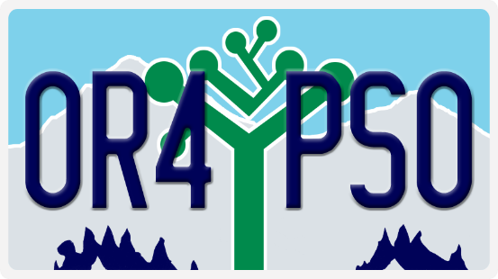During the last IEP meeting, ask students to address the PSO post card to themselves (copy available on TCN). This card will be mailed as a reminder to complete the Follow-Up interview.

1. Show Interest When Conducting the Survey
2. Making Contact

* Use PSO logo on all materials and reminders

|  |  |  |  |
| --- | --- | --- | --- |
| **Example- most current district data** | **District** | **District Trend** | **State** |
| Graduation Rate (4 year) | 67% | Increase  (state increase)1 | 59% |
| Graduation Rate (5 year) | 68% | Increase  (state increase)1 | 63% |
| Drop Rate | 3.7% | Decrease  (state decrease) | 5% |
| Students with quality IEP’s as measured by compliance on all 8 transition standards | 100% | Increase (state increase) | 80% |
| Students in post-secondary school 1 year out | 38% | Increase  (state increase) | 60% |
| Students competitively employed one year out & in post-secondary school 1 year out | 65% | Increase  (state increase) | 60% |
| Total engagement | 83% | Increase  (state increase) | 75% |

1Modified diplomas included as graduates

Evidence Based Practices that Support the Predictors

The following table illustrates **evidence-based practices (EBP)** that support implementation of in-school predictors of post-school success. Column 1, Predictor, lists the name of the predictor identified through ongoing reviews of rigorous correlational research ([www.transitionta.org/postschool](http://www.transitionta.org/postschool) ). Column 2, Definition of Predictor and Related EBPs, lists examples of evidence- based practices that could be used to support implementation of the predictor.

| **Predictor** | **Description & How They Relate to Evidence Based Practices** |
| --- | --- |
| Family Expectation | Include family planning and articulate expectation that their child will participate in post-secondary education and will be employed in the community after high school.   * Using Training Modules |
| Inclusion in General  Education | Access to general education classes and curriculum. Classes with non-disabled peers.   * Practices to teach academic skills:   + Using Mnemonic Strategies   + Using Peer-Assisted Instruction   + Using Self-Management   + Using Visual Displays   + Using Technology-Based Interventions   + Using the Self-Determined Learning Model of Instruction |
| Independent Living Skills | Self-care and life skills are skills necessary for management of one’s personal self-care and daily independent living, including the personal management skills needed to interact with others, daily living skills, financial management skills, and the self-management of healthcare/wellness needs.   * Practices to teach functional life skills (general) * Using Backward Chaining * Using Constant Time Delay * Using Forward Chaining * Using Progressive Time Delay * Using Self-Monitoring Instruction * Using Simultaneous Prompting * Using Least-to-Most or Most-to-Least Prompting Systems * Using Total Task Chaining |
| Social Skills | Behaviors, attitudes that focus on communication and collaboration.   * Practices to teach social skills: * Using Response Prompting * Using Self-Management * Using Simulations Practices to teach communication skills * Using Least–to-Most Prompting * Using Community-Based Instruction |
| Family Involvement | Parents/family/supportive adults are active, engaged participants in planning.   * Using Training Modules |
| Student Support | Network of family, educators, and agencies that provide services to facilitate transition.   * Using Check & Connect * Using Peer Assisted Instruction to teach academic skills |
| Career Awareness | Learn about opportunities, education and skills needed for a variety of careers.   * Using Extended Career Planning Services after Graduation * Using the Self-Determined Learning Model of Instruction |
| Self-Advocacy/Self-Determination | Ability to make choices, solve problems, set goals, evaluate options, and state goals.   * Using the Self-Determined Learning Model of Instruction * Using Whose Future is it? |
| Program of Study | Courses, experiences, and curriculum designed to develop student academic, functional skills. |
| Interagency Collaboration | Cross agency and program collaborative efforts to link youth/families to resources. |
| Transition Program | Contracts with agencies that moves students from school settings to adult life. |
| High School Diploma | Meet district graduation requirements for diplomas. |
| Community Experience | Activities that occur outside the school setting and supported by in-class instruction. |
| Occupational Courses | Career-Technical classes. |
| Vocational Education | Courses that focus on career development and preparation for specific careers. |
| Work Study | Paid or unpaid work experience and work skills instruction; integrated academic/work skills. |
| Paid Employment  Work Experience | Participation in workplace. Can include job shadowing, internships or paid work experience. |

 www.transitionta.org 

### Introducing Case Examples

In this Handbook, you will be introduced to materials on three students, based on original information posted on the NSTTAC website (now NTACT).

Materials using **Allison, Alex,** and **Rolanda** include case study information and various examples showing how districts might develop Post-secondary Goals, Transition Services and Course of Study using Oregon requirements and forms.

Throughout the handbook, there will be examples of what might be on the IEP for each of these students in three areas:

* + Case history information
  + Post-secondary goals
  + The course of study
  + Transition Planning and services
  + Age-appropriate transition assessments
  + IEP discussion starters (planning, academic skills, and functional skills for IEP team to consider)
  + Appropriate, measureable post-secondary goals for education, training, employment and independent living
  + Summary of Performance to take with student on leaving school
  + Person Centered Plan



**ALLISON**

Bio: an 18 year old student experiencing a specific learning disability in reading comprehension and written expression who will attend Eastern Oregon University and access EOU disability services.

**ALEX**

Bio: is a 17 year old student experiencing autism who will be going to a Technical School and receiving services from Vocational Rehabilitation.



**ROLANDA**

Bio: an 18 year old student who is experiencing a profound cognitive disability who will be entering technologically supported self-employment or volunteer work and will be receiving assistance from Vocational Rehabilitation and Social Security Administration.

Checkout additional student transition plans for Jason, Drew, and Susie on the ODE-<https://is.gd/MFLZOt> and TCN- <https://is.gd/40e9TE> websites**.**

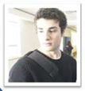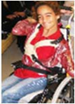

Susie is a 14 year old student who is experiencing Deafblindness and multiple disabilities. She is working toward assisted work in the community.

Jason, a 17 year old student who experienced a Traumatic Brain Injury who will access College Disability Services.



Drew, an 18 year old student identified as Deafblind who will attend a 4 yr. university. He will access University Disability Services, Commission for the Blind, and Vocational Rehabilitation.

Eight Components of a Transition IEP

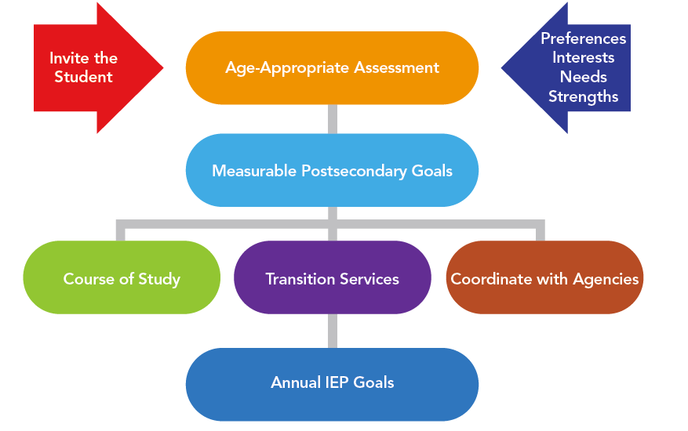

Center for Change in Transition Services

[www.seattleu.ed](http://www.seattleu.ed)

For more information check out the “Transition Path to Adulthood” on the TCN Website.

**Tips**

As districts review the new transition IEP page these eight standards must be considered. In order to be compliant the answer should be “yes” to each of the following questions.

* Is there **evidence that the students was invited to the IEP team meeting** where transition services were discussed?
* Is there evidence that the measureable post-secondary goal(s) were based **on age-appropriate transition assessment?**
* Is there evidence that the student’s **preferences, interests and needs** were considered as part of the IEP development?
* Are there **appropriate measureable post-secondary goals** in the areas of education & training, employment, and as needed, independent living?
* Are there **transition services** in the IEP that will reasonably enable the student to meet their post-secondary goal?
* Do transition services **include courses of study** that will reasonably enable the student to meet their post-secondary goal(s)?
* If appropriate, is **there evidence that a representative of any participating agency was invited to the IEP team meeting** with prior consent of the parent or student who has achieved the age of majority? List not applicable (NA) if the agency did not participate because of age or grade.
* Is (are) there **annual IEP goals** related to the student’s transition service needs?

## Invite the Student

### Law & Guidelines

**IDEA Regulations** 34 CRF 300.321(a)(7) 300.321

(a) General. The public agency must ensure that the IEP Team for each child with a disability includes—(7) whenever appropriate, the child with a disability.

IDEA requires that the school district invite the student with a disability to attend their IEP meeting if the purpose of the meeting will be the consideration of the post- secondary goals for the student and the transition services needed to assist the student in reaching those goals.

Transition planning is about the student’s movement from high school to post-school life. It is based on the **student’s** plans for the future. The student may need preparation and practice in participating in the IEP meeting. The needs and desires of the student and family are the core of the planning process; therefore, the student’s input is essential.

Students may play different roles and provide input through various methods based on their level of comfort. For example, the student may:

1. Provide input indirectly based on a questionnaire or survey,
2. Be a reluctant participant (avoids conversation or responds only to direct questions).
3. Provide input directly by computer or electronic device.
4. Be a self-advocate (practices self-advocacy skills).
5. Be a leader (demonstrates leadership skills in the IEP).

When the student is invited but does not attend the IEP Team meeting, the school district must take other steps to ensure that the student’s preferences and interests are considered.

### Checklists & Tips



**Checklist for Planning a Youth-Led IEP**

* Identify students who are 16 or older
* Get written consent to invite adult service providers to IEP meetings from parents or adult youth
* Connect with student’s adult service providers and invite them to the IEP meeting
* Schedule time in advance to meet with student to review transition IEP
* Prepare student for participating in their IEP
* Review student’s formal and informal assessments and make sure they align with the student’s post-secondary goals
* Review student’s course of study and make sure they align with the student’s post- secondary goals
* Consider which transition assessments (formal and informal) would best identify students PINS and PSGs
* Plan for parent and family input/interview
* Discuss student’s annual goals and a method for tracking those goals (how does the student reflect/report progress on their goals?).

#### Ways to Involve Students in the IEP Process:

* Planning the IEP includes laying the foundation for the meeting by identifying strengths, needs, establishing goals, considering options and preparing resources to use at the IEP meeting.
* Drafting the IEP provides practice in self-advocacy skills - includes having students write a draft of their IEP that reflects their strengths and needs as well as interests and preferences.
* Participating in the IEP Meeting: Demonstrate self-advocacy skills. Student has the opportunity to share interests, preferences and needs as well as participate in the process of developing the transition plan.
* Leading the IEP: Student has the opportunity to demonstrate self-advocacy and leadership skills.
* Implementing the IEP: Evaluate their own progress toward achieving goals.

### Person Centered Thinking

**Person Centered Thinking & Self-Determination**--- Person centered thinking is a broad term that includes forms of person centered planning as well as the philosophy that is inherent in approaches whereby the student is truly at the “center” of their own planning activities for the future. Forms of person centered planning include MAPS, PATH, Futures Planning, Essential Lifestyle Planning, etc.

Student Behaviors Associated with Post-School Employment and Education

* Strengths/Limitations: Able to express and describe personal strengths and limitations, as well as assistance needs
* Disability Awareness: Ability to describe disability and accommodation needs.
* Persistence: Ability to work toward goal until it is accomplished or after facing adversity
* Interaction with others: Ability to maintain friendships; work collaboratively with small groups, or teams
* Goal Setting: Able to understand importance of setting goals; set post-school goals that match interests
* Employment: Ability to express desire to work, demonstrate job readiness, complete training, get a job
* Student involvement in IEP: Discuss goals with IEP team & actively lead the IEP

Source: Transition Education Fast Facts, Council for Exceptional Children (2013)

Agency Awareness and Attendance

### Law & Guidelines

IDEA requires that a school district invite a student with a disability to their IEP meeting beginning not later than the first IEP to be in effect when the child turns 16. The school district must also identify any other agency (e.g. Vocational Rehabilitation, College-Disability Services, Independent Living Centers) that will be invited to send a representative to the IEP meeting. The school district must obtain parental consent before inviting representatives from other participating agencies to attend an IEP Team meeting. The representatives of these agencies should not have access to all the student’s records unless the parent gives consent for such a disclosure.

Once the participating agency commits to transition services on the IEP, that agency is responsible to provide those services to the student. If a participating agency, other than the school district, FAILS to provide the transition services described in the IEP, the school district must reconvene the IEP Team to identify alternative strategies to meet the transition objectives for the student set out in the IEP. This does not mean that the school district must provide the identical services written on the IEP; it means the IEP Team must reconvene to identify alternative strategies to meet the transition objectives

### Tips

**Learn about the local agencies/partners that provide transition services after high school**

|  |  |  |
| --- | --- | --- |
| **Education or Training** | **Employment** | **Independent Living** |
| * Community Colleges/Universities * College-Disability Services * Adult Education * Short Term Certification Community Education * Military * Technical Training | * Vocational Rehabilitation * Department of Labor * Employment Department * Work Source of Oregon * Job Corps * Pre-ETS Coordinators * ODDS Employment Specialist * Transition Specialist (i.e. YTP) | * Social Services-DHS * Social Security- SSI * WIN/DRO benefits * Housing Authority * City and County Housing * Health Departments * Independent Living Centers * Public Transportation (i.e. Dial-a-Ride, LIFT, Cherriots, Ride Source) |

**Ideas for Identifying Agencies**

* Work with Transition Network Facilitator’s for ideas and resources to learn which relationships they have made with community partners.
* Hold transition fairs. Contact your TNF for ideas and regional resources.
* Create community resource maps and information for students and parents to navigate transition.
* Learn about adult agencies, services and eligibility, and gather materials to share with students and families.
* Take advantage of cross-training opportunities between agencies.
* Develop procedures and plans to address the needs of students with disabilities, and barriers they may face during the transition process.
* Develop a systematic way to invite agencies that the student would possibly access after high school.
* Learn from community partners. What does the student or parent need to get ready for the post-school environment, community college, trade school, or local businesses?
* Get involved with local Employment First programs.
* Guidance from ODE for Agency Attendance
* In August look at your caseload and decide which students on your caseload should have agencies represented at their IEP meeting.
* When scheduling IEP meetings obtain required written parent/guardian consent before inviting representatives from other participating agencies to attend an IEP Team meeting. The representatives of these agencies cannot access all the student’s records unless the parent, or adult student, gives consent for such a disclosure.
* Schedule IEP meetings with other agency representatives early in the year. Agency representatives have full schedules and may not be able to attend meetings with a short notice.

Please look at pages 47-56 for a list of Agency Resources.

### Case Examples

### 

**ALEX**

**Oregon Standard INDIVIDUALIZED EDUCATION PROGRAM**

|  |
| --- |
| **Results of age-appropriate transition assessments, including student’s preferences, interests, needs and strengths (PINS) *34 CFR 300.320(b)(1); 34 CFR 300.43(a)(2)*** |
| **Appropriate, measurable post-secondary goals based upon age-appropriate transition assessments *34 CFR 300.320(b)(1)*** |
| **Transition Services/Activities**  ***34 CFR 300.43*** |
| **Course of Study:**  ***34 CFR 300.320(b)(2)*** |
| **Agency Participation: To the extent appropriate, with consent of the parents or adult student, the school district must invite a representative of any participating agency likely to be responsible for providing or paying for transition services.**  ***300.321(b)(3)*** |
| * Signed consent by Alex’s father for the LEA to communicate with the vocational rehabilitative services office * Invitation to conference for a representative from the VR agency * Summary of evaluation completed by vocational rehabilitation with recommendations for the IEP team |
| **Annual Academic and Functional Goals and Objectives** |
| **Goal Area: *34 CFR 300.320(a)(2)(i)*** |
| **Goal Area: *34 CFR 300.320(a)(2)(i)*** |

For an expanded version of Alex’s Case Study please go to <https://is.gd/sxxfFt>.



**ROLANDA**

**Oregon Standard INDIVIDUALIZED EDUCATION PROGRAM**

|  |
| --- |
| **Results of age-appropriate transition assessments, including student’s preferences, interests, needs and strengths (PINS) *34 CFR 300.320(b)(1); 34 CFR 300.43(a)(2)*** |
| **Appropriate, measurable post-secondary goals based upon age-appropriate transition assessments *34 CFR 300.320(b)(1)*** |
| **Transition Services/Activities**  ***34 CFR 300.43*** |
| **Course of Study:** ***34 CFR 300.320(b)(2)*** |
| **Agency Participation: To the extent appropriate, with consent of the parents or adult student, the school district must invite a representative of any participating agency likely to be responsible for providing or paying for transition services.**  ***300.321(b)(3)*** |
| * + A consent form signed by Rolanda’s mother indicating that the school district may contact vocational rehabilitative (VR) services inviting them to the IEP meeting to complete a referral for services.   + A consent form signed by Rolanda’s mother indicating that the school district may contact Social Security Administration (SSA) to invite them to the IEP meeting with plans to analyze Rolanda’s benefits with the family.   + A consent form signed by Rolanda’s mother indicating that the school district may contact Medicaid to invite them to the IEP meeting to coordinate referrals to outside agencies therapy referrals and transportation coordination.   Invitations on file to a representative of VR, SSA, and Medicaid. |
| **Annual Academic and Functional Goals and Objectives** |
| **Goal Area: *34 CFR 300.320(a)(2)(i)*** |
| **Goal Area: *34 CFR 300.320(a)(2)(i)*** |

For an expanded version of Rolanda’s Case Study please go to <https://is.gd/hTEyoG>.



**ALLISON**

**Oregon Standard INDIVIDUALIZED EDUCATION PROGRAM**

|  |
| --- |
| **Results of age-appropriate transition assessments, including student’s preferences, interests, needs and strengths (PINS) *34 CFR 300.320(b)(1); 34 CFR 300.43(a)(2)*** |
| **Appropriate, measurable post-secondary goals based upon age-appropriate transition assessments *34 CFR 300.320(b)(1)*** |
| **Transition Services/Activities**  ***34 CFR 300.43*** |
| **Course of Study**  ***34 CFR 300.320(b)(2)*** |
| **Agency Participation: To the extent appropriate, with consent of the parents or adult student, the school district must invite a representative of any participating agency likely to be responsible for providing or paying for transition services.**  ***300.321(b)(3)*** |
| * A consent form signed by Allison, who is 18, indicating that the school district may contact the disability services office at Eastern Oregon University. * An invitation to conference in the file, mailed to an individual in the disability services office of Eastern Oregon University |
| **Annual Academic and Functional Goals and Objectives** |
| **Goal Area: *34 CFR 300.320(a)(2)(i)*** |
| **Goal Area: *34 CFR 300.320(a)(2)(i)*** |

For an expanded version of Allison’s case study please go to <https://is.gd/bBrwv1>.

### Links to Resources

**Pre-ETS: Student Inclusion/Invite**

ME! Lessons for Teaching Self-Awareness & Self-Advocacy- <https://is.gd/9rV7RY>

Speaking Up!- <https://is.gd/nAk7mf>

It’s My Choice/Moving Students Forward- <https://is.gd/bk7wEY>

Dude Where’s My Transition Plan? - <https://is.gd/jHYJsC>

**One Page Profile Resources -**<https://is.gd/ub9JeH>

Letter of Introduction- <https://is.gd/Yk087o>

Letter of Introduction Completed Example- <https://is.gd/9wXXBF>

Student Led IEP Template- <https://is.gd/Lmggob>

Student Led IEP Script- <https://is.gd/LeLeUI>

Student Owned IEPs Top 10 PDF- <https://is.gd/TGEPg1>

## Age Appropriate Transition Assessments

### Law & Guidelines

**IDEA Regulation** 34 CRF300.43(a)(2) 300.320(b)(1)

(a) Transition services means a coordinated set of activities for a child with a disability that—

(2) Is based on the individual child's needs, taking into account the child's strengths, preferences, and interests; and includes—

(i) Instruction;

(ii) Related services;

(iii) Community experiences;

(iv) The development of employment and other post-school adult living objectives; and

(v) If appropriate, acquisition of daily living skills and provision of a functional vocational evaluation.

(b) Transition services. Beginning not later than the first IEP to be in effect when the child turns 16, or younger if determined appropriate by the IEP Team, and updated annually, thereafter, the IEP must include—

(1) Appropriate measurable postsecondary goals based upon age appropriate transition assessments related to training, education, employment, and, where appropriate, independent living skills;

IDEA requires an IEP Team to develop appropriate measurable postsecondary goals based upon age appropriate transition assessments related to training, education, employment, and, where appropriate, independent living skills”. Types of transition assessments include:

* behavioral assessment information
* aptitude tests
* interest and work values inventories
* intelligence tests
* achievement tests
* personality or preference tests
* career maturity or readiness tests
* self-determination assessments
* work-related temperament scales
* transition planning inventories

Age-appropriate transition assessments are defined as an ongoing process of collecting data on the individual’s needs, preferences, and interests as they relate to the demands of current and future work, education, living, and personal and social environments (Council for Exceptional Children).

Age-appropriate transition assessments including student’s preferences, interests, needs and strengths (PINS).

Assessment data from the age appropriate transition assessments serve as the common thread in the transition process and form the basis for defining goals and services to be included in the IEP. The present levels of academic achievement and functional performance must include the student’s preferences, needs, interests and the results of age-appropriate transition assessment.

### Checklists & Tips

Transition assessments may be paper and pencil tests, structured student and family interviews, community or work-based assessments (situational) and curriculum-based assessments. These assessments or procedures come in two general formats –formal and informal.

Formal assessments are standardized instruments that have been tested and have data to show that reliability and validity measures support their use. In contrast, informal assessments generally lack formal reliability and validity measures.

These assessments require more subjectivity to complete and should be given more than once and by more than one person to strengthen their validity. Examples of formal and informal assessments include:

**Formal Informal**

* Achievements Tests
* Adaptive Behavior and Independent Living
* Aptitude Tests
* Interest Inventories
* Intelligence Tests
* Personality or Preference Tests
* Career Development Measures
* Self-Determination Assessments
* Curriculum-Based Assessments
* School Performance Measures
* On the Job or Training Evaluations
* Career Planning Resources
* Observations
* Student Interviews

**Assessments should lead to self-discovery**

Considerations for choosing career / vocational assessments:

* Is it easy for the student to use?
* Is it age/grade appropriate?
* Can students relate to the language?
* Does it stereotype career choices?
* Is it easy to read and interpret? (Does it assess interests or reading skills?)
* Does it provide feedback that leads to reflection?
* Does it enhance insights?
* Does it reflect the current and emerging job market?

**Suggested Timeline for Commonly Used Assessments**

The charts below are sample instruments of age-appropriate transition assessments organized under various domains (Academic Assessment, Self-Determination Assessment, Vocational Interests, Exploration, and Career Development Tools, and Adaptive Behavior/Independent Living). Each assessment instrument describes:

1. whether the test is formal (standardized instruments that have been tested and have data to show that reliability and validity measures support their use) or informal (generally lack formal reliability and validity measures);
2. the name of the assessment; and,
3. the grades most appropriate to use the instrument.

**Academic Assessment**

|  |  |  |  |  |  |
| --- | --- | --- | --- | --- | --- |
| Formal/ Informal | Suggested Assessment | 9th grade | 10th grade | 11th grade | 12th grade+ |
| I | Curriculum-Based Assessments | X | X | X | X |
| I | End of Grade or Course Assessments | X | X | X | X |
| F | Pre-Scholastic Achievement Test (PSAT) or Scholastic Achievement Test (SAT) | X |  | X | X |
| F | American College Testing (ACT) | X |  | X | X |
| F | Armed Services Vocational Aptitude Battery (ASVAB) |  |  | X | X |
| F | Kaufman Test of Educational Achievement (KTEA) | X |  |  | X |
| F | Peabody Picture Vocabulary Test (PPVT) | X |  |  | X |
| I | Tests of Adult Basic Education (TABE) |  |  |  | X |
| I | ACT WorkKeys |  |  | X | X |
| F | Wide Range Achievement Test – 4th Ed. (WRAT – 4 or above) | X | X | X | X |
| F | Weschler Individual Achievement Test (WIAT) | X |  |  | X |
| F | Woodcock-Johnson Test of Achievement or Reading Mastery | X | X | X | X |

**Self-Determination Assessment**

|  |  |  |  |  |  |
| --- | --- | --- | --- | --- | --- |
| Formal/ Informal | Suggested Assessment | 9th  grade | 10th  grade | 11th  grade | 12th  grade+ |
| F * | AIR SD Assessment | X | X | X | X |
| F * | ARC SD Assessment | X | X | X | X |
| F * | Me! Lessons for Teaching Self-Awareness & Self- Advocacy- New Addition | X | X | X | X |
| F | ChoiceMaker Self-Determination Assessment | X | X | X | X |
| I | “I’m Determined” | X | X | X | X |
| I * | Direct Observations | X | X | X | X |
| I * | Interviews/Questions | X | X | X | X |
| I * | Environmental Analysis | X | X | X | X |
| I | Curriculum-based Assessments | X | X | X | X |

**Suggested Timeline for Commonly Used Assessments**

**Vocational Interests, Exploration, and Career Development Tools**

|  |  |  |  |  |  |
| --- | --- | --- | --- | --- | --- |
| Formal/ Informal | Suggested Assessment | 9th grade | 10th grade | 11th grade | 12th grade+ |
| I | Occupational Outlook Handbook | X | X | X | X |
| I | Student-Directed Transition Planning (SDTP) | X | X | X | X |
| I | ACT Plan |  | X |  |  |
| F | Self-Directed Search PAR | X | X | X | X |
| F | CIPSI: Career Interests, Preferences, and Strengths Inventory | X | X | X | X |
| F * | ONET Interest Profiler | X |  |  | X |
| F | Campbell Interest and Skill Survey (CISS) | X | X | X | X |
| I | Choosing Employment Goals (to job shadow or conduct dream job interviews) | X | X | X | X |
| I | Choose and Take Action | X | X | X | X |
| I | Self-Directed Employment | X | X | X | X |
| I | Brigance Transition Inventory*-[combination of Brigance Life Skills and Employability]* | X | X | X | X |
| I | Practical Assessment Exploration System (PAES)- 11th grade to age 21 |  |  | X | X |
| I * | Interviews/Questionnaires | X | X | X | X |
| I | Job Try Outs* | X | X | X | X |
| I | Curriculum-Based Assessments | X | X | X | X |
| F | Armed Services Vocational Aptitude Battery (ASVAB) | X | X | X | X |

**Adaptive Behavior/Independent Living**

|  |  |  |  |  |  |
| --- | --- | --- | --- | --- | --- |
| Formal/ Informal | Suggested Assessment | 9th grade | 10th grade | 11th grade | 12th grade+ |
| F * | Casey Life Skills | X | X | X | X |
| F * | Personal Preference Indicators | X | X | X | X |
| I * | New Parent Transition Survey- *[applicable to education, employment, independent living]* | X | X | X | X |
| I | Enderle-Severson Transition Rating Scale | X | X | X | X |
| I | Life Centered Career Education (LCE) | X | X | X | X |
| I * | Transition Success Assessment: A Transition Behavior Profile | X | X | X | X |
| I | Transition Planning Inventory | X | X | X | X |
| F | The Vineland–II | X | X | X | X |
| F | Checklist of Adaptive Living Skills (CALS) | X | X | X | X |
| F | Scales of Independent Behavior-Revised (SIB-R) | X | X | X | X |
| I | Brigance Transition Inventory*-[combination of Brigance Life Skills and Employability]* | X | X | X | X |
| I * | Direct Observations | X | X | X | X |
| I * | Interviews/Questionnaires | X | X | X | X |
| I * | Environmental Analysis | X | X | X | X |
| I | Curriculum-based Assessments | X | X | X | X |

### Case Examples



**ALEX**

**Oregon Standard INDIVIDUALIZED EDUCATION PROGRAM**

|  |
| --- |
| **Results of age-appropriate transition assessments, including student’s preferences, interests, needs and strengths (PINS) *34 CFR 300.320(b)(1); 34 CFR 300.43(a)(2)*** |
| * Alex scored below basic in reading, math, and writing on the **state exit exam.** * His scores on the **Weschler Intelligence Test** suggest that Alex’s academic functioning should be within the average range. * Results of the **Vineland Adaptive Behavior Scale** suggest that Alex is functioning below average in communication and socialization and above average in the areas of daily living and motor skills. * A **formal observation** form completed by Alex’s employment at Office Depot, demonstrates Alex’s ability to stay on task and perform to the standards required by all Office Depot employees. Alex reports to work on time each day, cooperates with his boss and co-workers, and completes all assigned tasks in a timely manner. * Results from **career interest inventories** completed by Alex in the 9th and 11th grade suggest a career in business would be suitable, particularly a job that works with computers. * Alex completed a **business employment skill inventory** in the 12th grade, which suggests he has many of the prerequisite skills to pursue a career in this area. * After school, Alex works part-time at Office Depot entering numerical data to keep track of stock and services rendered by store staff.   His behavior is appropriate at work and he has expressed that he likes working. He is punctual each day, and he is willing to stay late when needed. He really enjoys getting a paycheck and he usually spends his money on fast food and movies from the local video rental shop. Alex is detail-oriented and reviews each column of numbers several times before moving on to type another column. |
| **Appropriate, measurable post-secondary goals based upon age-appropriate transition assessments *34 CFR 300.320(b)(1)*** |
| **Transition Services/Activities *34 CFR 300.43*** |
| **Course of Study *34 CFR 300.320(b)(2)*** |
| **Agency Participation** ***300.321(b)(3)*** |
| **Annual Academic and Functional Goals and Objectives** |
| **Goal Area:  *34 CFR 300.320(a)(2)(i)*** |
| **Goal Area: *34 CFR 300.320(a)(2)(i)*** |

For an expanded version of Alex’s Case Study please go to <https://is.gd/sxxfFt>.

 **ROLANDA**

**Oregon Standard INDIVIDUALIZED EDUCATION PROGRAM**

|  |
| --- |
| **Results of age-appropriate transition assessments, including student’s preferences, interests, needs and strengths (PINS) *34 CFR 300.320(b)(1); 34 CFR 300.43(a)(2)*** |
| **Anecdotal records for an observation period** of 10 days indicate that Rolanda is curious; stays alert and awake throughout the school day; seems to enjoy activity around her. She enjoys getting verbal and tactile attention from her peers and staff. She is tolerant of position changes on mat table and allows hand-over-hand assistance to participate in activities. She likes using a switch (with assistance) to activate a variety of devices, including the radio and computer.  A **portfolio assessment** indicates thatRolanda accesses the general education curriculum through extension activities. She benefits from sensory stimulating activities and activities to improve her independence and communication.  Rolanda uses facial gestures to communicate her pleasure and displeasure with her current state. She offers a smile to show happiness and a blank stare to indicate disinterest.  **Picture/symbol augmentative communication** supports have not been successful. She uses simple one-button communication devices with assistance when offered during class activities.  A **physical therapy evaluation** and reports from the medical doctor indicate Rolanda uses a manual wheelchair dependently. She requires a 2-person lift or mechanical device for all transfers. She tolerates positioning on a mat table and demonstrates limited fine motor skills which results in her dependency for all care and hand-over-hand assistance for all activities.  **Signed examination summary from Rolanda’s pediatrician**, dated during the current year indicated that she is: 18 years old, is fed via G-tube, has a tracheotomy and uses a ventilator with oxygen to breathe.  **Parent Input:** Rolanda’s parents want her to live with them for approximately 20 years. At that point, they will seek supported housing in a group home, or with a relative who is willing to care for her.  **Preferences and Interests:** Rolanda indicates that she enjoys music, movies, concerts and art exhibits. She prefers indoor and outdoor activities with others. |
| **Appropriate, measurable post-secondary goals based upon age-appropriate transition assessments *34 CFR 300.320(b)(1)*** |
| **Transition Services/Activities *34 CFR 300.43*** |
| **Course of Study *34 CFR 300.320(b)(2)*** |
| **Agency Participation** ***300.321(b)(3)*** |
| **Annual Academic and Functional Goals and Objectives** |
| **Goal Area:  *34 CFR 300.320(a)(2)(i)*** |
| **Goal Area: *34 CFR 300.320(a)(2)(i)*** |

For an expanded version of Rolanda’s Case Study please go to <https://is.gd/hTEyoG>.



**ALLISON**

**Oregon Standard INDIVIDUALIZED EDUCATION PROGRAM**

|  |
| --- |
| **Results of age-appropriate transition assessments, including student’s preferences, interests, needs and strengths (PINS) *34 CFR 300.320(b)(1); 34 CFR 300.43(a)(2)*** |
| * Record of student grades throughout high school, indicating a B average throughout high school (9th through first half of 11th grades) and a statement of how her GPA meets the minimal requirements for entry into college * a summary of student Psychological test scores obtained during her 3-year re-evaluation in the spring of 10th grade indicating specific learning disabilities in reading comprehension and written expression * End of grade test scores from the end of 10th grade demonstrating her participation in the standard course of study with passing scores of 3’s (on a 4-point scale) in reading and math and a statement of how she has met the graduation requirements for statewide testing * Scores from curriculum-based measurements that indicate Allison’s level of performance in English and math and a statement describing how her level performance is acceptable for admission into college * A statement by Allison, gathered during an informal interview, recorded on the IEP regarding her interest in attending a university to pursue a degree in Child Development. |
| **Appropriate, measurable post-secondary goals based upon age-appropriate transition assessments *34 CFR 300.320(b)(1)*** |
| **Transition Services/Activities *34 CFR 300.43*** |
| **Course of Study *34 CFR 300.320(b)(2)*** |
| **Agency Participation** ***300.321(b)(3)*** |
| **Annual Academic and Functional Goals and Objectives** |
| **Goal Area:  *34 CFR 300.320(a)(2)(i)*** |
| **Goal Area: *34 CFR 300.320(a)(2)(i)*** |

For an expanded version of Allison’s case study please go to <https://is.gd/bBrwv1>.

## Oregon Extended Assessment Decision Making Guidance

Oregon’s Alternate Assessment Based on Alternate Achievement Standards (Oregon’s Extended Assessment (ORExt) is for students with significant cognitive disabilities. The “Oregon Extended Assessment Decision-Making Guidance” is provided by the Department of Education to support IEP teams in determining whether a student should take this assessment. This guidance takes into account the current policies regarding Oregon’s general assessments; specifically, the focus on appropriately measuring the student populations they were designed to measure. To that purpose, students who participate in the ORExt are not allowed to participate in Oregon’s general assessments.

Having determined that the student has been evaluated and found eligible under IDEA and has an IEP, Oregon Extended Assessment Decision-Making Guidance asks IEP teams to consider the following:

* The student demonstrates significant cognitive disabilities with commensurate delayed adaptive skills that may be combined with physical or behavioral limitations.
* The significant cognitive disability impacts the student’s access to the general education curriculum and requires individualized instruction.
* The significant cognitive disability impacts the student’s post-school outcomes.
* Additional factors considered for the student.

For more detailed information as well as a decision making flowchart, please access the Oregon Extended Assessment Decision Making Guidance at: <https://is.gd/E2rBHY>

For more information:

* + **Contacts**:
    - Brad Lenhardt (ODE Education Specialist): [Brad.Lenhardt@state.or.us](mailto:Brad.Lenhardt@state.or.us)
    - ESD Assessment Partner: <https://is.gd/48lUL6>

****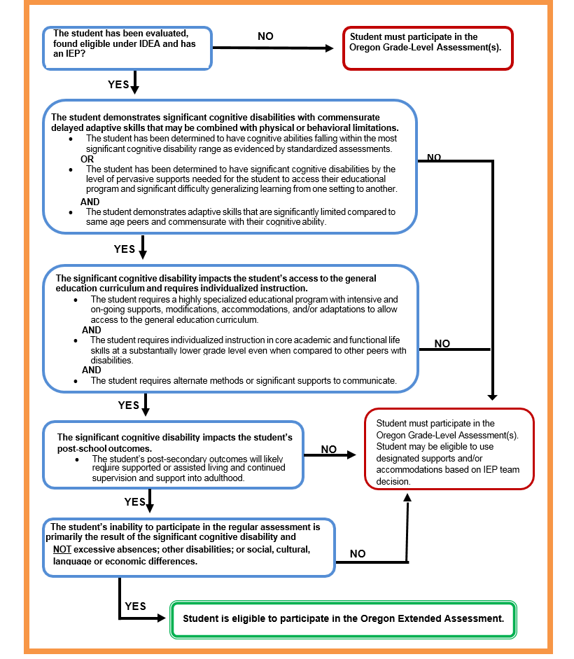**Assessment Decision Making Tool**

### Links to Resources

**Pre-ETS: Age-Appropriate Transition Assessments**

Traitify Career Discovery Test- <https://www.traitify.com/>

Pictorial Interest Inventory- <https://is.gd/jQEtCJ>

My Next Move Interest Profiler- <https://www.mynextmove.org/>

**Other Resources**

Transition Assessment Student Interview- <https://is.gd/QvaTqP>

Know the Student Age Appropriate Transition Assessments- <https://is.gd/AKA9Gz>

Age Appropriate Transition Assessment Toolkit- <https://is.gd/oxt1tb>

Assessment & Accountability Update (e-newsletter) sign-up at https://is.gd/HpaPVY

## Post-Secondary Goals

A post-secondary goal (PSG) refers to those goals that a student hopes to achieve after leaving secondary school. All students who have an IEP in effect the year the student turns 16 or younger, if determined appropriate by the IEP team, must have PSGs. The PSG must be based upon age-appropriate transition assessments. A measurable post-secondary goal provides an outcome, not just a process for the student and it must be able to be counted, tabulated or observed. There must be at least two goals for all students: one for employment and one for education or training. Some students, based on assessment information, may require a goal for independent living.

### Law & Guidelines

**IDEA Regulation** 300.320(b)(1)

(b) Transition services. Beginning not later than the first IEP to be in effect when the child turns 16, or younger if determined appropriate by the IEP Team, and updated annually, thereafter, the IEP must include—

(1) Appropriate measurable postsecondary goals based upon age appropriate transition assessments related to training, education, employment, and, where appropriate, independent living skills;

The IEP Team writes the PSGs based on age appropriate transition assessment and the student’s preferences, interests, needs, and strengths.

The IEP team must consider goals in four areas when appropriate:

* education
* training
* employment
* independent living skills

The PSGs must be developed **annually** at the student’s IEP meeting.

When determining whether post-secondary goals in the areas of training and education overlap, the IEP team must consider the unique needs of each individual student with a disability in light of his or her plans after leaving high school.

If the IEP Team determines that separate post-secondary goals in the areas of training and education would not result in the need for distinct skills for the student after leaving high school the IEP Team can combine the training and education goals of the student into one or more post-secondary goals addressing those areas.

**Formula for Writing Post-Secondary Goals**

___________ ______________ **will** _____________ _______________

*(Time) (The Student) (Goal Behavior) (Where & How)*

Two months after HS Susan **will**  enroll in Community College.  
 *(Time) (The Student) (Goal Behavior) (Where & How)*

### Checklists & Tips

|  |  |
| --- | --- |
| **Example of post-secondary goals and words for IEP** | |
| **If student has a post-secondary goal of:** | **Words to describe behavior for IEP:** |
| ***Education, Training*** | ***Education, Training*** |
| 4 year college university | Attend a college or university |
| 2 year community or technical college | Earn an occupational certificate, associate’s degree |
| Short term vocational or technical school | Attend vocational training (beauty school, pet grooming, trucking school) |
|  | |
| ***Employment*** | ***Employment*** |
| Competitive employment | Work a full or part time job |
| Supported employment | Establish connection with appropriate agency |
| Volunteer work in the community | Sign up with volunteer program |
|  | |
| ***Independent Living*** | ***Independent Living*** |
| Money management | Manage finances |
| Grocery shopping- Meal preparation | Access community independently |
| Transportation | Use public transportation |

**Tips**

* Remember words like “hopes to, plans to” are not measureable.
* Have you considered all four areas?
* Does it happen after exiting school system?
* Is there an education or training goal?
* Is there an employment goal?
* Are there independent living skills goals, when appropriate?
* Are all of the goals measureable?



### Case Examples

****ALEX**

**Oregon Standard INDIVIDUALIZED EDUCATION PROGRAM**

|  |
| --- |
| **Results of age-appropriate transition assessments, including student’s preferences, interests, needs and strengths (PINS) *34 CFR 300.320(b)(1); 34 CFR 300.43(a)(2)*** |
| **Appropriate, measurable post-secondary goals based upon age-appropriate transition assessments *34 CFR 300.320(b)(1)*** |
| **Education** |
| After graduation from high school, Alex will enroll at ITT Technical Institute (a technical school) and take a business math class to improve his work-related math skills and to advance his career in business. |
| **Training** |
| After finishing high school, Alex will engage in further on the job training in order to increase his hours at Office Depot. |
| **Employment** |
| After finishing high school, Alex will increase his work hours from 10 hours per week to 20 hours per week in the business department of a local office supply store with temporary supports provided through Vocational Rehabilitation. |
| **Independent living skills (where appropriate)** |
| Upon completion of high school, with the assistance of the Springfield OVRS Office, Alex will develop better communication and social skills so that he can find appropriate living quarters with roommates. |
| **Transition Services/Activities *34 CFR 300.43*** |
| **Course of Study *34 CFR 300.320(b)(2)*** |
| **Agency Participation** ***300.321(b)(3)*** |
| **Annual Academic and Functional Goals and Objectives** |
| **Goal Area: *34 CFR 300.320(a)(2)(i)*** |
| **Goal Area: *34 CFR 300.320(a)(2)(i)*** |

For an expanded version of Alex’s Case Study please go to <https://is.gd/sxxfFt>.



**ROLANDA**

**Oregon Standard INDIVIDUALIZED EDUCATION PROGRAM**

|  |
| --- |
| **Results of age-appropriate transition assessments, including student’s preferences, interests, needs and strengths (PINS) *34 CFR 300.320(b)(1); 34 CFR 300.43(a)(2)*** |
| **Appropriate, measurable post-secondary goals based upon age-appropriate transition assessments *34 CFR 300.320(b)(1)*** |
| **Education** |
| After exiting school services, Rolanda will participate in an in-home or center-based program designed to provide rehabilitative and vocational training with medical and therapeutic supports. |
| **Training** |
| Immediately after exiting school services, Rolanda will receive job development services from vocational rehabilitation or a community rehabilitation program and will participate in technologically supported self-employment or volunteer skill building. |
| **Employment** |
| Within one year of exiting school services, Rolanda will be in a supported self-employment work in her local community at the art museum. |
| **Independent living skills (where appropriate)** |
| After exiting school services, Rolanda will participate in community-integrated recreational/leisure activities related to music, movies, and art by accessing movie theaters, concerts at the local community college, art and craft museums downtown, and the entertainment store at the mall. |
| **Transition Services/Activities *34 CFR 300.43*** |
| **Course of Study *34 CFR 300.320(b)(2)*** |
| **Agency Participation** ***300.321(b)(3)*** |
| **Annual Academic and Functional Goals and Objectives** |
| **Goal Area: *34 CFR 300.320(a)(2)(i)*** |
| **Goal Area: *34 CFR 300.320(a)(2)(i)*** |

For an expanded version of Rolanda’s Case Study please go to <https://is.gd/hTEyoG>.

 **ALLISON**

**Oregon Standard INDIVIDUALIZED EDUCATION PROGRAM**

|  |
| --- |
| **Results of age-appropriate transition assessments, including student’s preferences, interests, needs and strengths (PINS) *34 CFR 300.320(b)(1); 34 CFR 300.43(a)(2)*** |
| **Appropriate, measurable post-secondary goals based upon age-appropriate transition assessments *34 CFR 300.320(b)(1)*** |
| **Education** |
| After graduation from high school, Allison will attend Eastern Oregon University and take coursework leading to a major in the area of Child Development. |
| **Training** |
| IEP team considered training goal and decided that education goal is appropriate for Allison. |
| **Employment** |
| After graduation from college, Allison will become an early childhood education teacher in Pendleton School District. |
| **Independent living skills (where appropriate)** |
| Upon entrance to Eastern Oregon University, Allison will access EOU Disability Services for assistance in note-taking and study partners. |
| **Transition Services/Activities *34 CFR 300.43*** |
| **Course of Study *34 CFR 300.320(b)(2)*** |
| **Agency Participation** ***300.321(b)(3)*** |
| **Annual Academic and Functional Goals and Objectives** |
| **Goal Area: *34 CFR 300.320(a)(2)(i)*** |
| **Goal Area: *34 CFR 300.320(a)(2)(i)*** |

For an expanded version of Allison’s case study please go to <https://is.gd/bBrwv1>.

### Links to Resources

**Pre-ETS: Post-Secondary Goals**

Going to College <http://www.going-to-college.org/>

Back to the Youth Hood <https://www.youthhood.org/>

## Transition Services

### Law & Guidelines

**IDEA Regulations** 4 CFR 300.320, 4 CFR 300.43

(b) Transition services.

Beginning not later than the first IEP to be in effect when the child turns 16, or younger if determined appropriate by the IEP Team, and updated annually, thereafter, the IEP must include—

(1) Appropriate measurable postsecondary goals based upon age appropriate transition assessments related to training, education, employment, and, where appropriate, independent living skills; and

(2) The transition services (including courses of study) needed to assist the child in reaching those goals.

(a) Transition services means a coordinated set of activities for a child with a disability that—

(1) Is designed to be within a results- oriented process, that is focused on improving the academic and functional achievement of the child with a disability to facilitate the child’s movement from school to post-school activities, including postsecondary education, vocational education, integrated employment (including supported employment), continuing and adult education, adult services, independent living, or community participation;

(2) Is based on the individual child’s needs, taking into account the child’s strengths, preferences, and interests; and includes—

(i) Instruction;

(ii) Related services;

(iii) Community experiences;

(iv) The development of employment and other post-school adult living objectives; and

(v) If appropriate, acquisition of daily living skills and provision of a functional vocational evaluation.

The coordinated set of **transition services delineates the activities** to assist the student in achieving their post-secondary goals.

### Checklists & Tips

Evidence-Based Best practices tell us:

* At least one transition service should be listed that corresponds or connects to each annual goal; and
* Transition services include documented academic and functional activities, supports and services.



**Examples of Behavior that Could Fit Post-Secondary Goals**

|  |  |  |  |
| --- | --- | --- | --- |
| Transition Services | **EDUCATION OR TRAINING** | **EMPLOYMENT** | **INDEPENDENT LIVING** |
| ***Instruction:***  *Academic and functional instruction that will be provided to the student to build the skills necessary to reach their post-secondary goals.* | Self-advocacy skills | Work related skills  (i.e. punctuality) | Self-care skills |
| ***Related Services:***  *Services needed for students to access integrated work, education and living environments. They may include occupational and physical therapy, speech therapy, rehabilitative counseling services, and other professional supports.* | Speech/language | VR referral Occupational therapy | Meeting with SSI representative |
| ***Community Experience:***  *A variety of activities and experiences that are provided outside the school building. These might include community resources utilized as part of the student’s school program, whether during school hours or after school hours, to achieve the stated outcome(s) of community integration.* | Visit community college including a visit to the disability services office | Job shadow | Visits to agencies (i.e. Independent Living Center) |
| ***Development of Employment & Other Living Objectives:***  *Development of work-related behaviors, job seeking, career exploration and actual employment (i.e., career planning, job shadowing, job training)* | Computer skills Apply for financial aid | Part time employment related to student’s goals | Visits to recreational agencies/facilities  Community-based vocational training |
| ***Acquisition of daily Living Skills:***  *The skills involved in caring for oneself on a daily basis (i.e., dressing, hygiene, household chores, shopping, and managing finances) and an important component of independent living.* | Using accommodations | Using accommodations Asking for help Learning routines | Personal banking Instruction Utilizing technology support (phone reminders to take meds) |
| ***Functional Vocational Assessment:***  *An additional assessment process if the regular vocational assessment has not provided enough information to make a vocational program decision. Additional assessment activities (i.e., situational assessments, community-based assessments, assistive technology evaluations) can be performed to get more information about the student’s needs, preferences, and interests* | College entrance exams | Work assessments | Functional skills inventory |



### Case Examples

**

**ALEX**

**Oregon Standard INDIVIDUALIZED EDUCATION PROGRAM**

|  |
| --- |
| **Results of age-appropriate transition assessments, including student’s preferences, interests, needs and strengths (PINS) *34 CFR 300.320(b)(1); 34 CFR 300.43(a)(2)*** |
| **Appropriate, measurable post-secondary goals based upon age-appropriate transition assessments *34 CFR 300.320(b)(1)*** |
| **Transition Services/Activities:** Transition Services include instruction, related services, community experiences, the development of employment and other post-school adult living objectives, and if appropriate, acquisition of daily living skills and provision of a functional vocational evaluation. ***34 CFR 300.43*** |
| **Education and Training Instruction**   * Self-advocacy skills instruction * Personal banking instruction * Work related social skills instruction * Computer skills (word-processing, data entry) instruction   **Education and Training Related Service**   * Speech language services to increase oral language fluency   **Functional Vocational Evaluation**   * Completing a computation/ business math skill inventory * Completing an office skill inventory |
| **Employment and Other Post School Living Objectives**   * Work hours (for credit) in the school district business department * After school paid work experience in the business office of Office Depot * Interview with adult agency staff regarding possible future needs (self-advocacy support, tax form completion assistance, transportation services) * Voter registration |
| **Course of Study *34 CFR 300.320(b)(2)*** |
| **Agency Participation** ***300.321(b)(3)*** |
| **Annual Academic and Functional Goals and Objectives** |
| **Goal Area: *34 CFR 300.320(a)(2)(i)*** |
| **Goal Area: *34 CFR 300.320(a)(2)(i)*** |

For an expanded version of Alex’s Case Study please go to <https://is.gd/sxxfFt>.



**ROLANDA**

**Oregon Standard INDIVIDUALIZED EDUCATION PROGRAM**

|  |
| --- |
| **Results of age-appropriate transition assessments, including student’s preferences, interests, needs and strengths (PINS) *34 CFR 300.320(b)(1); 34 CFR 300.43(a)(2)*** |
| **Appropriate, measurable post-secondary goals based upon age-appropriate transition assessments *34 CFR 300.320(b)(1)*** |
| **Transition Services/Activities:** Transition Services include instruction, related services, community experiences, the development of employment and other post-school adult living objectives, and if appropriate, acquisition of daily living skills and provision of a functional vocational evaluation. ***34 CFR 300.43*** |
| **Education and Training Instruction**   * Self-advocacy skills instruction * Personal banking instruction * Work related social skills instruction * Computer skills (word-processing, data entry) instruction   **Education and Training Related Service**   * Speech language services to increase oral language fluency   **Functional Vocational Evaluation**   * Completing a computation/ business math skill inventory * Completing an office skill inventory |
| **Employment and Other Post School Living Objectives**   * Work hours (for credit) in the school district business department * After school paid work experience in the business office of Office Depot * Interview with adult agency staff regarding possible future needs (self-advocacy support, tax form completion assistance, transportation services) * Voter registration |
| **Course of Study *34 CFR 300.320(b)(2)*** |
| **Agency Participation** ***300.321(b)(3)*** |
| **Annual Academic and Functional Goals and Objectives** |
| **Goal Area: *34 CFR 300.320(a)(2)(i)*** |
| **Goal Area: *34 CFR 300.320(a)(2)(i)*** |

For an expanded version of Rolanda’s Case Study please go to <https://is.gd/hTEyoG>.

 **ALLISON**

**Oregon Standard INDIVIDUALIZED EDUCATION PROGRAM**

|  |
| --- |
| **Results of age-appropriate transition assessments, including student’s preferences, interests, needs and strengths (PINS) *34 CFR 300.320(b)(1); 34 CFR 300.43(a)(2)*** |
| **Appropriate, measurable post-secondary goals based upon age-appropriate transition assessments *34 CFR 300.320(b)(1)*** |
| **Transition Services/Activities:** Transition Services include instruction, related services, community experiences, the development of employment and other post-school adult living objectives, and if appropriate, acquisition of daily living skills and provision of a functional vocational evaluation. ***34 CFR 300.43*** |
| **Education and Training Instruction**   * Instructional support of guided notes for lessons * Instructional support for organization and study skills * Audio-taped texts for English 12 * Extended time on tests in English, Algebra II and Advanced Biology |
| **Employment and Other Post School Living Objectives**   * Job shadow experiences with children * Visit Eastern Oregon University, including a tour through the admissions department and a visit to the disability services office, between the late Spring and early Fall * Part time employment in a position related to working with children * Apply for possible college financial aid * Vocational rehabilitation referral to determine eligibility for tuition assistance * Apply for college and disability support service, no later than December |
| **Course of Study *34 CFR 300.320(b)(2)*** |
| **Agency Participation** ***300.321(b)(3)*** |
| **Annual Academic and Functional Goals and Objectives** |
| **Goal Area: *34 CFR 300.320(a)(2)(i)*** |
| **Goal Area: *34 CFR 300.320(a)(2)(i)*** |

For an expanded version of Allison’s case study please go to <https://is.gd/bBrwv1>.

### Links to Resources

**Pre-ETS: Transition Services**

Histogram- <https://is.gd/s8mP3e>

[Virginia Career View](http://vacareerview.org/%20%20mostly%20for%20younger%20students)- <https://vacareerview.org/>

[My Next Move Career Explore](https://www.mynextmove.org/)- <https://www.mynextmove.org/>

[Career Jeopardy](https://www.nd.gov/cte/crn/CareerJeopardy/Jeopardy.htm)- <https://is.gd/9dhI8W>

[Sprout Films: Employment Theme](http://sproutflix.org/browse/theme-employment/)- <https://is.gd/ths0dm>

[How to Guide for Job Shadows](http://www.newwaystowork.org/qwbl/tools/kcktoolkit/Guides/How_To_Guide_Job_Shadows.PDF)- <https://is.gd/pNFUmC>

[College planning for students with disabilities](https://oregonstudentaid.gov/finaid-student-disabilities-planning.aspx)- <https://is.gd/LmINwQ>

## Course of Study

### Law & Guidelines

**IDEA Regulation** 34 CFR 300.320(b)(2)

(b) Transition services. Beginning not later than the first IEP to be in effect when the child turns 16, or younger if determined appropriate by the IEP Team, and updated annually, thereafter, the IEP must include—

(2) The transition services (including courses of study) needed to assist the child in reaching those goals

The course of study defines the **multi-year set of classes or activities** on a pathway to secondary goals that begins in middle school and culminates the last year in school.

**The course of study is:**

* A multi-year description of coursework and activities from the student’s current to anticipated exit year that is designed to help achieve the student’s desired post-secondary goals (PSGs).
* Reflects an educational program and plan that specifies all courses,

educational experiences, and activities from the first IEP to be in effect when the student turns 16, or younger if determined appropriate by the IEP team.

* Reflects the planning that relates to the student achieving their desired measurable post-secondary goals and helps them make a successful transition to post-school adult life.
* Reflects multiple years of classes and educational experiences, not just one year.

**Remember:**

* Course of study **is not** the coursework required to attain a specific high school diploma.
* The courses of study must **align** with the post-secondary goals.
* Course of study must be **reviewed annually**.

### Checklists & Tips

* Look at your September caseload and determine which students are turning 16 and plan for the Transition IEP.
* Look at assessment to see student strengths, interests, preferences and needs.
* Think of course of study as a pathway for student to gain skills in order to achieve their PSGs.
* Ask what classes or activities include skills that will support this student’s PSGs?

### Case Examples

For a Post-Secondary Education Goal is to enroll at a college or university, the post- secondary institution entrance requirements influence the course of study. The course of study may also include extracurricular activities that relate to post-secondary goals (yearbook, school newspaper, athletics, etc.).



**ALEX**

**Oregon Standard INDIVIDUALIZED EDUCATION PROGRAM**

|  |  |
| --- | --- |
| **Results of age-appropriate transition assessments, including student’s preferences, interests, needs and strengths (PINS) *34 CFR 300.320(b)(1); 34 CFR 300.43(a)(2)*** | |
| **Appropriate, measurable post-secondary goals based upon age-appropriate transition assessments *34 CFR 300.320(b)(1)*** | |
| **Transition Services/Activities**  ***34 CFR 300.43*** | |
| **Course of Study:** (designed to assist the student in reaching the post-secondary goals)  ***34 CFR 300.320(b)(2)*** | |
| **2018**   * Work Study I * Business Math I * Community Living * Computer Applications I | **2019**   * Work Study II * Business Math II * Community Living Computer |
| **Agency Participation** ***300.321(b)(3)*** | |
| **Annual Academic and Functional Goals and Objectives** | |
| **Goal Area: *34 CFR 300.320(a)(2)(i)*** | |
| **Goal Area: *34 CFR 300.320(a)(2)(i)*** | |

For an expanded version of Alex’s Case Study please go to <https://is.gd/sxxfFt>.

 **ROLANDA**

**Oregon Standard INDIVIDUALIZED EDUCATION PROGRAM**

|  |  |
| --- | --- |
| **Results of age-appropriate transition assessments, including student’s preferences, interests, needs and strengths (PINS) *34 CFR 300.320(b)(1); 34 CFR 300.43(a)(2)*** | |
| **Appropriate, measurable post-secondary goals based upon age-appropriate transition assessments *34 CFR 300.320(b)(1)*** | |
| **Transition Services/Activities**  ***34 CFR 300.43*** | |
| **Course of Study:** (designed to assist the student in reaching the post-secondary goals)  ***34 CFR 300.320(b)(2)*** | |
| **2018**   * Functional Reading/Communication * Occupational Skills * Healthy Living | **2019**   * Work Study I * Business Math I * Community Living Computer |
| **Agency Participation** ***300.321(b)(3)*** | |
| **Annual Academic and Functional Goals and Objectives** | |
| **Goal Area: *34 CFR 300.320(a)(2)(i)*** | |
| **Goal Area: *34 CFR 300.320(a)(2)(i)*** | |

For an expanded version of Rolanda’s Case Study please go to <https://is.gd/hTEyoG>.



**ALLISON**

**Oregon Standard INDIVIDUALIZED EDUCATION PROGRAM**

|  |  |
| --- | --- |
| **Results of age-appropriate transition assessments, including student’s preferences, interests, needs and strengths (PINS) *34 CFR 300.320(b)(1); 34 CFR 300.43(a)(2)*** | |
| **Appropriate, measurable post-secondary goals based upon age-appropriate transition assessments *34 CFR 300.320(b)(1)*** | |
| **Transition Services/Activities**  ***34 CFR 300.43*** | |
| **Course of Study:** (designed to assist the student in reaching the post-secondary goals)  ***34 CFR 300.320(b)(2)*** | |
| **1st Semester**   * Psychology * English 12 * Algebra II * Band * Cooperative Work Experience * Advanced Biology | **2nd Semester**   * Physical Education * English 12 * Algebra II * Band * Child Development * Advanced Biology |
| **Agency Participation** ***300.321(b)(3)*** | |
| **Annual Academic and Functional Goals and Objectives** | |
| **Goal Area: *34 CFR 300.320(a)(2)(i)*** | |
| **Goal Area: *34 CFR 300.320(a)(2)(i)*** | |

For an expanded version of Allison’s case study please go to <https://is.gd/bBrwv1>.

### Links to Resources

**Pre-ETS: Course of Study**

Postsecondary Education- <https://is.gd/Xl8fYi>

Skills that Pay the Bills Curriculum- <https://is.gd/9V0ArW>

Skills to Pay the Bills Videos- https://is.gd/Dpvv5g

ME! Lessons for Teaching Self-Awareness & Self-Advocacy- <https://is.gd/9rV7RY>

In the Driver’s Seat Workshops- <https://is.gd/3VqC53>

## Coordinate with Agencies

### Law & Guidelines

**IDEA Regulation** 4 CFR300.321(b)(3)**,** *300.321*

(b) Transition services participants. (1) In accordance with paragraph (a)(7) of this section, the public agency must invite a child with a disability to attend the child's IEP Team meeting if a purpose of the meeting will be the consideration of the postsecondary goals for the child and the transition services needed to assist the child in reaching those goals under §300.320(b).

(3) To the extent appropriate, with the consent of the parents or a child who has reached the age of majority, in implementing the requirements of paragraph (b)(1) of this section, the public agency must invite a representative of any participating agency that is likely to be responsible for providing or paying for transition services.

Linking youth to agencies while in school make connections easier.

**Participating Agencies** should be invited to the IEP team meeting with the prior consent of the parent (or student who has reached the age of majority). When a representative of a participating agency that is likely to be responsible for providing or paying for transition services is identified, **they should be invited to the first IEP meeting where transition services will be discussed.**

As VR, ODDS and ODE work to improve policies and systems for employment outcomes for students at the state level, schools are working to improve relationships with community partner agencies to ensure these agencies become an integral part of the transition IEP process for the students planning to access services after school. For more information, contact your local Transition Network Facilitator.

**Things to consider:**

* What agencies should the school district invite to an individual student’s IEP meeting?
* Did I get approval to invite agencies well before IEP meetings?
* How much time will another agency need to prepare for an IEP meeting? Can invites be done months early to get on schedules?
* Should you invite more than one agency to an IEP meeting?
* Where can I find the names of people to contact in each agency?

### Checklists & Tips

**Tips for Interagency Collaboration**

* Gather contact information and discuss partner agencies with the student and family. Determine who they want for collaboration and collect release of information agreement
* Reach out to partners, contact representatives.
* Set up alternative methods to get input from partners if they cannot attend a meeting (i.e. phone conversation, shared documents, video conferencing).
* Be aware that partner agencies have their own vocabulary and process. They may need clarification of services and terminology between education, county developmental disability services, and vocational rehabilitation and brokerage services.
* Schedule meetings far enough in advance so everyone is able to attend. Find out from agencies partners guidelines on the time frame for advance notification.
* Schedule enough time for planning and input from partner agencies.
* Send draft IEP’s to all approved invited members, ahead of time, for a chance to prepare for meeting.
* Establish clearly defined goals and measurable objectives.
* Follow a pre-agreed upon set of guidelines for conducting the meeting, (i.e. active listening, no side-bar conversations, respect opinions, stay pro-active and positive).
* Recognize some partner agencies might prefer to be involved and various times with specific age students.
* Make sure meetings are purposeful and everyone has a voice.

For more information on Transition Network Facilitators (TNF) see page 51.

# Agency Resources

**Pre-Employment Transition Services (Pre-ETS) Vocational Rehabilitation (VR)**

**What are Pre-ETS?**

Pre-Employment transition services (Pre-ETS) are available to students between the ages of 14 and 21. Youth must be current students and experience a disability (receives services under an IEP or 504 plan or have some other medical documentation of disability). Services vary depending on the need of the individual, program, or school district.

The provision of these services is to support students in the early stages of career exploration. Pre-ETS are intended to enhance not supplant current transition programs offered in schools. VR and local school districts will collaborate to create the opportunity for students with disabilities to participate in the following five Pre-ETS:

* Job Exploration and Counseling
* Work-Based Learning Experiences
* Counseling on Opportunities for Enrollment in Comprehensive Transition

or Post-Secondary Educational Programs

* Workplace Readiness
* Instruction in Self-Advocacy

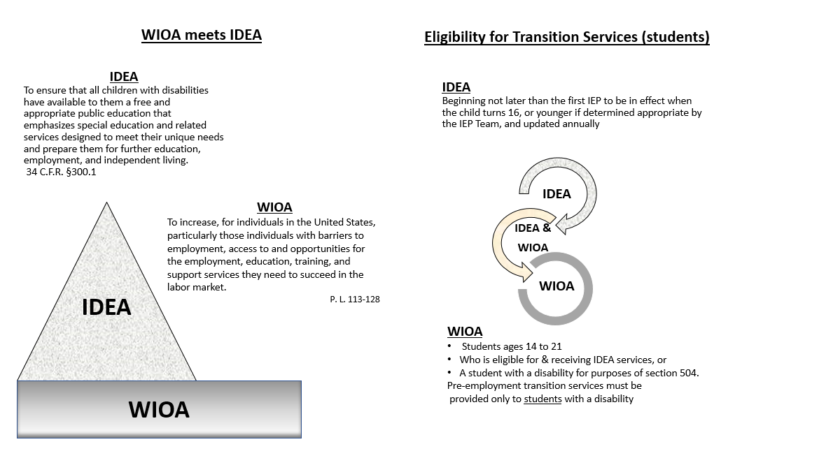

**Link to Resource**

**Functional Limitations**

**State of Oregon Vocational Rehabilitation: To request services from VR contact your local VR office or Youth Transition Program in your local high school**

[**https://is.gd/HeKz4W**](https://is.gd/HeKz4W)

**Workforce Innovation Technical Assistance Center: Detailed information about Pre-ETS** [**www.wintac.org**](http://www.wintac.org)

**What Do requested Pre-ETS Services Look Like?**

Pre-ETS are free services that are individualized dependent on the need of the student, classroom, or school district. Some examples of potential services include:

* Offering classes on Self Advocacy, Workplace Readiness, and Job Exploration
* Individual and group career counseling
* Enhancing established programs by incorporating local agencies and employers
* Acting as a VR liaison when discussing services with students and family
* Consult with schools about incorporating Pre-ETS into their classroom activities
* Support in transition to secondary learning opportunities
* Facilitating Person Centered Plans
* Assist with setting up connections with community agencies
* Connecting youth and educators to local businesses for educational opportunities
* Navigating career information systems
* Teaching of the importance of soft skills in the workplace
* Enhancing independent living skills and social interpersonal skills
* Attending IEP meetings when invited (when VRC schedules will not allow)
* Presenting at an Open House or Orientation held at local schools
* And much more! Feel free to ask.

**Requesting Services**

To request Pre-ETS, students or student advocates are required to complete a Pre-ETS request form, and email it to: [Pre.ETS@state.or.us](mailto:Pre.ETS@state.or.us)

To obtain a form:

* On line at TCN: English  <https://is.gd/6uEN89> , Spanish  <https://is.gd/fQTDK5>
* In person from a Transition Network Facilitator or Pre-ETS Coordinator
* Via email from [Pre.ETS@state.or.us](mailto:Pre.ETS@state.or.us)

Schools and teachers can request consultations from individual coordinators without using the request form.

Pre-ETS coordinators partner with school districts, state agencies, and community providers to assist in delivering, enhancing and growing transition-based programs and opportunities for students.

Please contact our team for more information.

**Pre-ETS Coordinators:**

Nicole Perdue, Central & Eastern-Oregon Email: [Nicole.J.Perdue@state.or.us](mailto:Nicole.J.Perdue@state.or.us) Phone: (971)718-4054

Toni DePeel, Portland Metro-Oregon Email: [Toni.M.DePeel@state.or.us](mailto:Toni.M.DePeel@state.or.us) Phone: (971)600-8358

C.J. Webb, Willamette Valley-Oregon Email [Carolyn.Webb@state.or.us](mailto:Carolyn.Webb@state.or.us) Phone: (503)476-4979

Pre-ETS Program Coordinator

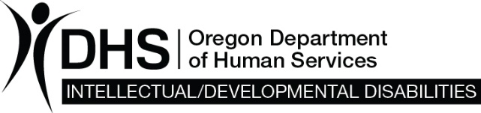

#### Developmental Disability

A Developmental Disability (DD) is a mental or physical impairment or combination of mental and physical impairments.

* Begins before 22 years of age;
* Begins in and directly affects the brain and has continued indefinitely; and
* Causes impairment of daily living skills (adaptive behavior) such as, but not limited to, communicating, grooming, dressing, safety and social skills.

#### Intellectual Disability

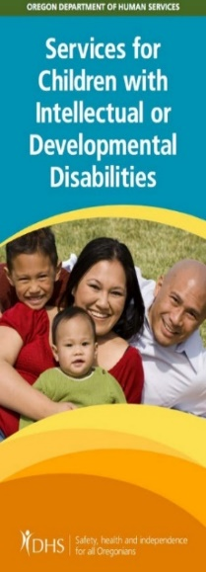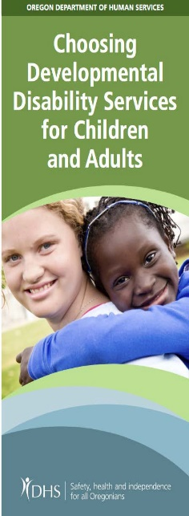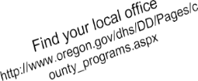

An Intellectual Disability (ID) impacts a person’s learning, reasoning and problem-solving skills. In Oregon, ID means a person has an intelligence quotient (IQ) of 70 or under as measured by a qualified professional, along with a lack of daily living skills (adaptive behavior) such as, but not limited to, communicating, grooming, dressing, safety and social skills.

* Begins before 18 years of age, and
* Begins in and directly affects the brain

and has continued indefinitely.

#### Eligibility

Your county Community Developmental Disability Program (CDDP) decides eligibility. The worker in your county will help with the necessary papers you need and help you through the eligibility process.

To find out if you are eligible for services, contact your county CDDP. Information: <https://is.gd/J7BxPy>

#### DD Services

You may receive services in your own home, your family home, a group home or foster home. Based on your needs and goals, here are some services that may be available to you:

* Support with everyday activities like bathing, dressing, shopping, making meals, managing your money, and help with behavior and communication challenges.
* Supports in your community. Everyone benefits when you are active in your community.
* Employment supports

**Transmittal DDS:** <https://is.gd/6ZlATt>



#### Employment First

Employment First is a national movement centered on the belief that all people, regardless of disability, are capable of full participation in integrated employment and community life. In Oregon, Employment First is also a state policy that working age adults and youth with intellectual and developmental disabilities (I/DD) can work in jobs fully integrated in the community. Oregon Employment First is a collaboration between the Office of Developmental Disabilities Services, Vocational Rehabilitation and the Oregon Department of Education.

More information on Employment First is available at: <http://iworkwesucceed.org>

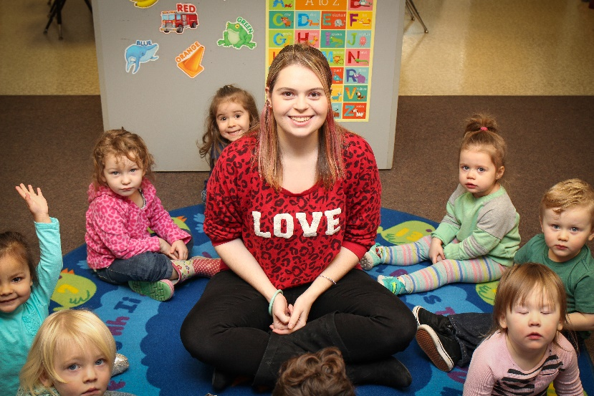

Karisue started working at Gresham Heights Learning Center before she graduated from her transition program in June 2016. After graduation, she increased her hours to 20 hours per week.

#### DD Employment Services

The Office of Developmental Disability Services (ODDS) offers Supported Employment Services that can help a person find, maintain, and advance in an integrated job in the community. Services include:

* Job Development
* Job Coaching
* Discovery
* Small Group Employment

More information, including videos and fact sheets is at: <https://is.gd/2hAVJO>

There are also six Regional ODDS Employment Specialists located throughout the state of Oregon.

Six Regional ODDS Employment Specialists provide training and technical assistance to individuals and their families, Community Developmental Disabilities Programs (CDDPs), Brokerages, Service Providers, Vocational Rehabilitation, and the Oregon Department of Education (ODE). They work as a partner in local communities on employment issues.

The Employment Specialists work closely with the Transition Network Facilitators (TNFs) through the Oregon Department of Education and the VR I/DD Counselors through Vocational Rehabilitation.

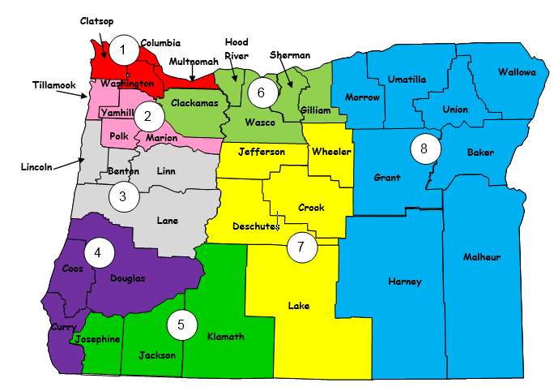**Transition Technical Assistance Network**

The Transition Technical Assistance Network (TTAN) jointly funded by VR and ODE; continues the work to further improve Oregon’s systems of designing and delivering employment services for students with disabilities.  The Transition Network Facilitators (TNF) and Pre-ETS/TNF Support Specialists work to support the collaborative efforts of Vocational Rehabilitation, Developmental Disability Services, Employment First Teams, and Local Education Agencies in Oregon in the implementation of the Workforce Innovate Opportunity Act (WIOA) and the provision of Pre-Employment Transition Services (Pre-E.T.S.).  The TTAN has established relationships with community partners to implement training and professional development for educators and agency staff on policy and systems change. For more information about the Transition Technical Assistance Network- <https://is.gd/t4gWlI>

|  |  |  |  |
| --- | --- | --- | --- |
| **Region 1** (Portland, Washington, Clatsop, Columbia) | | | |
| **Transition Network Facilitator** | | | |
| Elizabeth(Lizzie) Juaniza (Portland, Washington) | | [ejuaniza@mesd.k12.or.us](mailto:ejuaniza@mesd.k12.or.us) | 503.257.1657 |
| **TNF/Pre-ETS Support Specialist** | | | |
| Jodi Johnson | [Jjohnson01@mesd.k12.or.us](mailto:Jjohnson01@mesd.k12.or.us) | | 503.257.1773 |

|  |  |  |
| --- | --- | --- |
| **Region 2** (Tillamook, Yamhill, Polk, Marion) | | |
| Eivind-Erik Sorensen | [eivind.sorensen@wesd.org](mailto:eivind.sorensen@wesd.org) | 503.474.6915 |

|  |  |  |
| --- | --- | --- |
| **Region 3** (Lane, Lincoln, Linn, Benton) | | |
| Vikki Mahaffy | [vikki.mahaffy@lblesd.k12.or.us](mailto:vikki.mahaffy@lblesd.k12.or.us) | 541.812.2737 |

|  |  |  |
| --- | --- | --- |
| **Region 4** (Douglas, Coos, Curry) | | |
| **Transition Network Facilitator** | | |
| Darci Shivers | [darci.shivers@douglasesd.k12.or.us](mailto:darci.shivers@douglasesd.k12.or.us) | 541.440.477 e. 6601 |
| **TNF/Pre-ETS Support Specialist** | | |
| Joy Ward | [joy.ward@douglasesd.k12.or.us](mailto:joy.ward@douglasesd.k12.or.us) | 541.530.1989 |

|  |  |  |
| --- | --- | --- |
| **Region 5** (Josephine, Jackson, Klamath) | | |
| Cindy Cameron | [cindy_cameron@soesd.k12.or.us](mailto:cindy_cameron@soesd.k12.or.us) | 541.245.3508 |

|  |  |  |
| --- | --- | --- |
| **Region 6** (Clackamas, Wasco, Hood River, Sherman, Gilliam) | | |
| Kriss Rita | [krita@clackesd.k12.or.us](mailto:krita@clackesd.k12.or.us) | 503.675.4163 |

|  |  |  |
| --- | --- | --- |
| **Region 7** (Jefferson, Deschutes, Crook, Wheeler, Lake) | | |
| Marguerite Blackmore | [marguerite.blackmore@hdesd.org](mailto:marguerite.blackmore@hdesd.org) | 541.693.5717 |

|  |  |  |
| --- | --- | --- |
| **Region 8** (Morrow, Umatilla, Union, Wallowa, Baker, Grant, Harney, Malheur) | | |
| **Transition Network Facilitator** | | |
| Lon Thornburg | [lon.thornburg@imesd.k12.or.us](mailto:lon.thornburg@imesd.k12.or.us) | 541.966.3162 |
| **TNF/Pre-ETS Support Specialist** | | |
| Donna Lowry | [donna.lowry@imesd.k12.or.us](mailto:donna.lowry@imesd.k12.or.us) | 541.975.5653 |

|  |  |  |
| --- | --- | --- |
| **General Questions** | | |
| Heather Lindsey | [heather.lindsey@state.or.us](mailto:heather.lindsey@state.or.us) | 503.947.5791 |

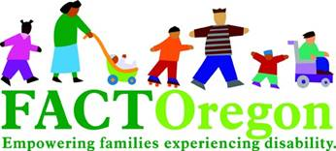

FACT Oregon is the designated parent training and information center for Oregon and serves to empower families experiencing disability in their pursuit of a whole life by expanding awareness, growing community, and equipping families.

**FACT Oregon is your one-stop resource! We are able to support you with:**

 Understanding special education

 Trainings, workshops and in-services

 Information and resources

 A support line to answer your questions Phone: (503) 786-6082

**Visit our website to learn more!**[www.FACTOregon.org](http://www.FACTOregon.org)

|  |  |
| --- | --- |
|  | **Family Advocacy Network Recommends for Parents** |
| * Be Prepared: Gain insights into how to be the best advocate you can by participating in an advocacy training. * Get Involved: Serve on budget committees and work groups; attend forums and information sessions. * Connect: Identify other families and pull your energy together to form a stronger alliance. * Be Heard: Tell your story; share at board meetings, meet with stakeholders and decision-makers. |



We are committed to supporting families, connecting families with their communities, and helping Oregon’s communities welcome and support all families. To reach us, see below:

Bridging Communities https://[www.facebook.com/bcoregon](http://www.facebook.com/bcoregon) (541) 690-8542

Central Oregon Disability Support Network (CODSN) [www.CODSN.org](http://www.codsn.org/) (541) 548-8559

Creating Opportunities Family Network [www.CreatingOps.org](http://www.creatingops.org/) (503) 559-3674

Families Connected, The Arc Lane County <http://www.arclane.org/services/families-connected/> (541) 343-5256 x113

Families Engaging and Thriving Together (FEATT) [www.FEATT.org](http://www.featt.org/) (541) 670-2750

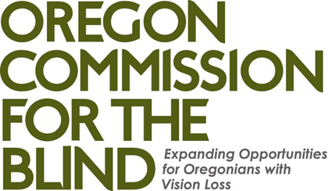

The Oregon Commission for the Blind works directly with individuals who are legally blind or likely to become legally blind in the near future to promote the confidence and skills necessary for successful employment. Our Youth Transition Services focuses on working with eligible students starting at 14 years, in order to successfully transition from high school to the workforce, college, or other post-secondary training. We work closely with all members of the IEP team and other agencies (Vision, Orientation & Mobility, Case Manager/SPED, and County IDD services) to ensure a smooth transition into the world of work. A central focus of VR Counseling services includes:

* Job exploration counseling
* Work-based learning experiences, which may include in-school or after school opportunities or experience outside the traditional school setting (including internships), that is provided in an integrated environment to the maximum extent possible
* Counseling on opportunities for enrollment in comprehensive transition or postsecondary educational programs at institutions of higher education
* Workplace readiness training to develop social skills and independent living
* Instruction in self-advocacy, which may include peer mentoring

Part of our Youth/Transition Services includes the Summer Work Experience Program (SWEP)- a 5-6 week specialized, ‘hands-on’, residential (dorm living) summer training program for Oregon teens age 16-20 who are legally blind at Portland State University and Willamette University. SWEP participants get the chance to complete a paid summer work experience, develop essential workplace skills, build self-confidence and prepare for future employment opportunities.

Contact:

Locations throughout the state.

Main office located at [535 SE 12th Ave, Portland, OR 97214](https://maps.google.com/?q=535+SE+12th+Ave,+Portland,+OR+97214&entry=gmail&source=g). Phone: 971-673-1588

Phone: 888-202-5463

Fax: 503-234-7468

Email: [ashley.jopling@state.or.us](mailto:ashley.jopling@state.or.us)

OREGON CTE STUDENTS WITH

DISABILITIES

Why Career and Technical Education?

In the Class of 2016, CTE Concentrators with disabilities graduated at nearly 24 percentage points higher than their statewide counterparts.

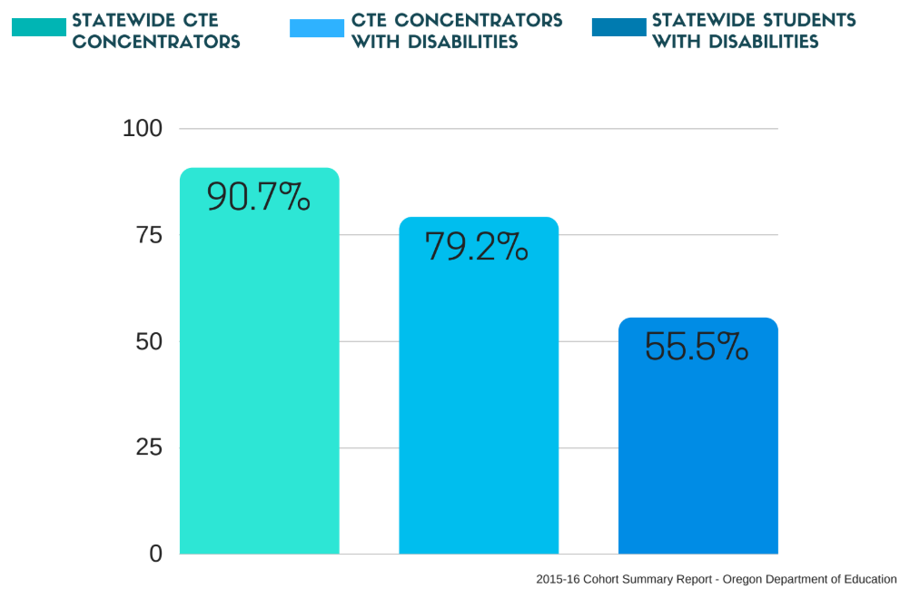

**DID YOU KNOW?**

People with disabilities across all age groups are AT LEAST two times more likely to be unemployed than their non-disabled counterparts.

# What is a Career and Technical Education Concentrator?

A CTE Concentrator is any student who completed at least one credit o f course work in

a single approved CTE Program of Study.

# Why does Career and Technical Education work?

 Identified career path



Industry-generated technical skills

Essential workplace skills



Aligns to academic content

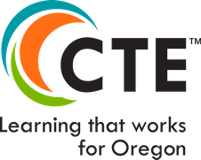Applied contextual learning

[**Lauren Dressen (CTE Data Analyst) - July 2018**](http://lauren.dressen@ode.state.or.us/)

**For more information please visit the website:** [**https://is.gd/HY01nh**](https://is.gd/HY01nh)

The Youth Transition Program (YTP) is a collaborative partnership between Vocational Rehabilitation, Oregon Department of Education, local high schools throughout Oregon and the University of Oregon. The purpose of the grant funded program is to prepare high school youth with disabilities for employment and/or career related post-secondary education or training. Students in the program receive comprehensive patterns of services year-round to address transition needs including:

* Pre-Employment Transition services: Work readiness, Job Exploration, Post-Secondary Counseling, Work based Learning, and Self Advocacy.
* Individualized planning, focused on post school goals and self-determination, and help to coordinate school plans with community agencies;
* Instruction in academic, vocation, independent living and personal social skills to stay in and complete school;
* Career Development services and goal setting;
* Emphasis on paid employment such as connections with local employers, development of school businesses, and job training;
* Support services to assist student with specific interventions;
* Follow up services for one year after leaving the program to maintain positive outcomes of employment and training.

For more information about YTP, visit the website: [www.ytp.uoregon.edu](http://www.ytp.uoregon.edu)

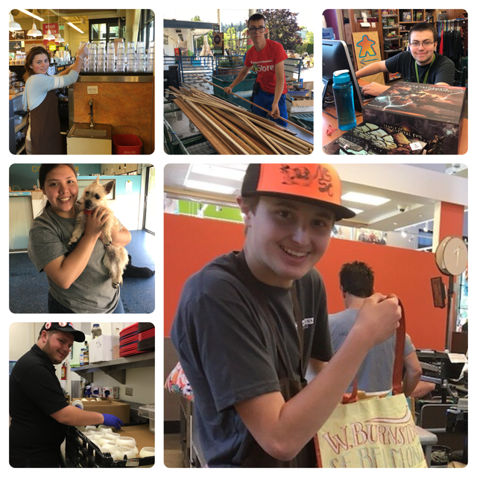

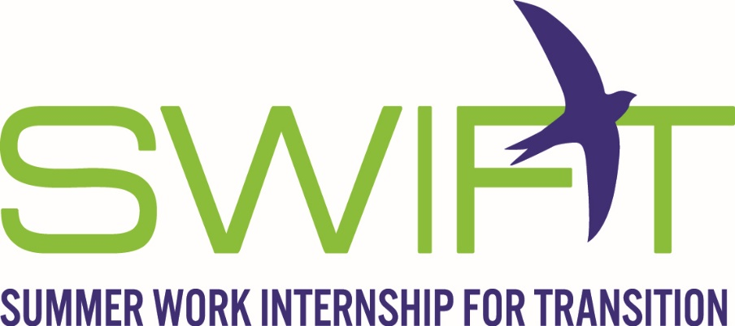

SWIFT, a 7-week residential (dorm living) program at Portland State University, will give a youth a taste of the world of work, independent living and more! SWIFT students experience:

* Paid Summer Work
* Develop Workplace Skills
* Build Self Confidence
* Social Skills
* Learn to Organize and Prioritize Tasks
* Time Management
* Customer Service Skills
* Operate Professionally at Work
* Independent Living Skills

Participants Must be:

* YTP participant
* A VR Client (or ability to become/interested in becoming a client)
* In Plan by June 1
* 16 years of age and no older than 20 years of age in YTP
* An Oregon resident who has a disability that creates a barrier to employment
* Able to work legally in the United States
* Motivated to work hard and learn new skills

For more information about SWIFT, contact [SWIFT.Program@state.or.us](mailto:SWIFT.Program@state.or.us)

## Annual IEP Goals

### Law & Guidelines

**IDEA Regulation** 34 CFR 300.320(a)(2)(i)

(a) *General.* As used in this part, the term individualized education program or IEP means a written statement for each child with a disability that is developed, reviewed, and revised in a meeting in accordance with §§300.320 through 300.324, and that must include—

(2)(i) A statement of measurable annual goals, including academic and functional goals designed to—(A) Meet the child's needs that result from the child's disability to enable the child to be involved in and make progress in the general education curriculum;

Annual goals are statements that describe what a student with a disability can reasonably be expected to accomplish within a 12-month period of the student's program. Measurable annual goals include timeframe, conditions, behavior, and criterion. The annual goals, which are updated annually, are designed to support improvement in academic and functional skills necessary to achieve post- secondary goals. The IEP should be aligned so that for each post-secondary goal there should be an annual goal that will help the student make progress towards the post-secondary goals.

Here is a comparison between Annual Transition Goals in an IEP and Post-Secondary Goals.

**Annual Transition Goals in IEP** **Post-Secondary Goals**

|  |  |
| --- | --- |
| * Targeted to be completed **during** school services * Measurable * Based on student’s needs * Written in areas of : * Academic * Functional * Align to meet the post-secondary goals | * Won’t be achieved until **after** exiting school services * Measureable * Based on age of appropriate transition assessment * Written in areas of: * Education/Training * Employment * Independent living skills, when appropriate |

### Checklists & Tips

**SMART Goal Development** – After reviewing your present levels (academic and functional performance) develop **S.M.A.R.T. (*Specific, Measurable, Attainable, Relevant, Time- Specific*)** goals that address the individual needs of the student. You will need to do some evaluation of what is most important or what skills build upon each other in order to select the more appropriate goals.

### Links to Resources

SMART goal components and explanation <https://is.gd/bncT0F>

## Summary of Performance

### Law & Guidelines

The **Summary of Performance** (SOP) is *required* under the reauthorization of the Individuals with Disabilities Education Act of 2004 (IDEA 2004). The SOP must be given to students that graduate with a regular diploma or age out. ODE guidance is that all students that leave school with a modified diploma, an extended diploma, or an alternative certificate should also receive an SOP.

The SOP is a document that is given to the student before leaving school to assist the student in the transition from high school to higher education, training and/or employment. This important information about students’ current level of functioning is intended to help post-secondary settings consider accommodations for access and may be useful in the assessment process for other adult service agencies. Post-secondary institutions will continue to make eligibility decisions on a case-by-case basis.

### Checklists & Tips

* In many situations, waiting until the spring of a student’s final year to complete the SOP will provide an agency or employer with the most current information on the performance of the student.
* Components of an SOP can be cut and pasted from the student’s 12th grade IEP
* Consider using the functional limitation language for eligibility to VR services in the student’s SOP

### Links to Resources

Oregon Summary of Performance Form- <https://is.gd/kKjx4x>

Three Examples of SOP filled out- <https://is.gd/Oj0mFO>

## Miscellaneous Resources

### FAQ

FAQ for Student Participation in the IEP- <https://is.gd/CiS4jS>

FAQ for Assessments- <https://is.gd/XGJ2VS>

FAQ About Diploma Options- <https://is.gd/Xpqjs7>

FAQ for Transition Services, including Course of Study- <https://is.gd/z37RkP>

### Transition Path

<https://is.gd/pYBXdf>

### Terminology

<https://is.gd/zm2wF8>

### Acronyms

<https://is.gd/lYO6Mp>

Special thanks to The Transition Technical Assistance Network, Office of Developmental Disability Services, Oregon Department of Education, DHS Vocational Rehabilitation and The Research Institute at WOU for help with the Handbook development.

