Developmental Disability
A Developmental Disability (DD) is a mental or physical impairment or combination of mental and physical impairments.
- Begins before 22 years of age;
- Begins in and directly affects the brain and has continued indefinitely; and
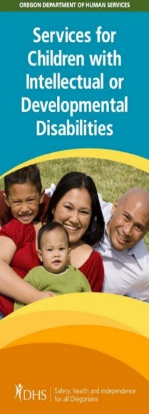
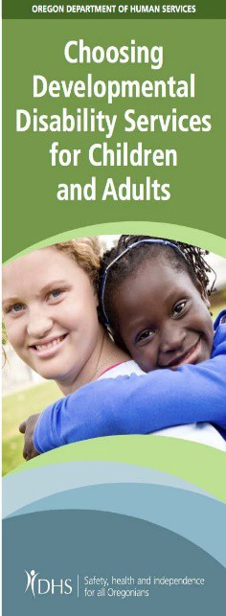
- Causes impairment of daily living skills (adaptive behavior) such as, but not limited to, communicating, grooming, dressing, safety and social skills.

DD Services
Intellectual Disability
An Intellectual Disability (ID) impacts a person’s learning, reasoning and problem-solving skills. In Oregon, ID means a person has an intelligence quotient (IQ) of 70 or under as measured by a qualified professional, along with a lack of daily living skills (adaptive behavior) such as, but not limited to, communicating, grooming, dressing, safety and social skills.
- Begins before 18 years of age, and
- Begins in and directly affects the brain and has continued indefinitely.

Eligibility
Your county Community Developmental Disability Program (CDDP) decides eligibility. The worker in your county will help with the necessary papers you need and help you through the eligibility process.
To find out if you are eligible for services, contact your county CDDP Information

You may receive services in your own home, your family home, a group home or foster home. Based on your needs and goals, here are some services that may be available to you:
  - Support with everyday activities like bathing, dressing, shopping, making meals, managing your money, and help with behavior and communication challenges.
  - Supports in your community. Everyone benefits when you are active in your community.
  - Employment supports
Transmittal DDS

49

