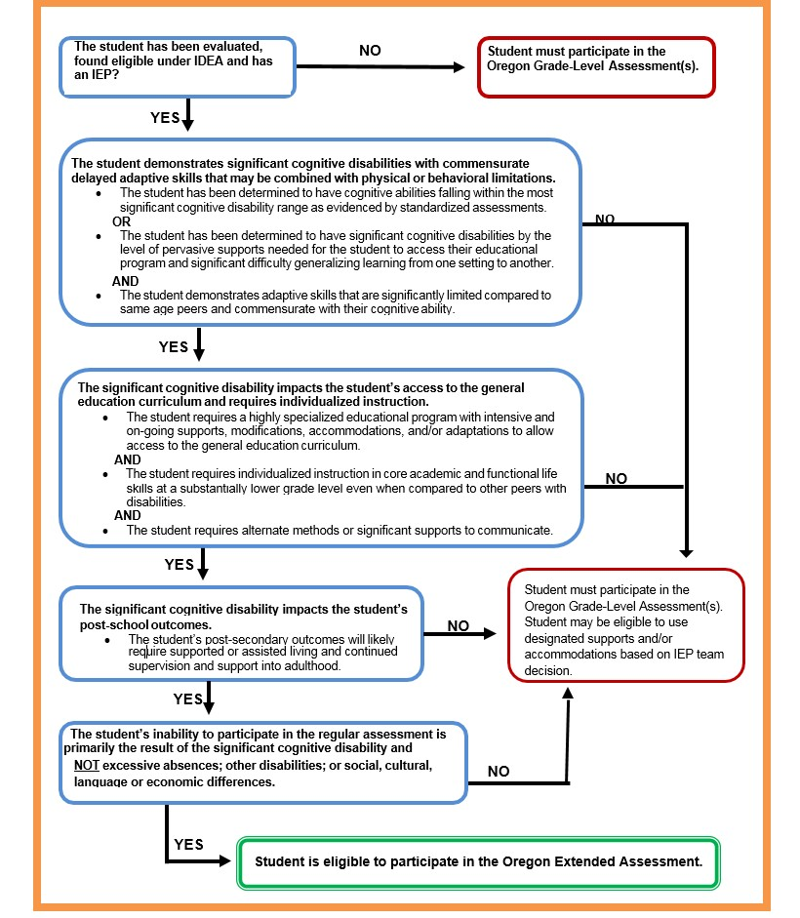
Assessment Decision Making Tool

Links to Resources
Pre-ETS: Age-Appropriate Transition Assessments
Traitify Career Discovery Test
Pictorial Interest Inventory
My Next Move Interest Profiler

Resources from Transition Community Network
Transition Assessment Student Interview
Know the Student Age Appropriate Transition Assessments
Age Appropriate Transition Assessment Toolkit

Other Resources
Assessment & Accountability Update (e-newsletter) sign-up at http://listsmart.osl.state.or.us/mailman/listinfo/ayprcupdates

