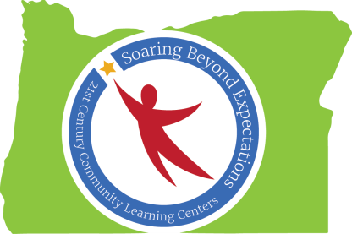

Peer-to-Peer Learning Conversation
Notes from May 19, 2015
Strategies for Implementing CTE in our Programs

Participants:
Teri Kimberling: Lincoln County SD - Taft Elementary w/Oceanlake Elementary Site Coordinator
Mike Loretz – Oregon City School District Project Director
Sarah Creek – Three Rivers/Josephine County Site Coordinator
Peter Lauf – Career & Technical Outreach Coordinator, Lane ESD

Facilitators: Candi Scott, Roxanna Marvin, and Gary Glasenapp, The Research Institute @ WOU

21st CCLC participants were sent a link to a presentation by Peter Lauf, the Career and Technical Outreach Coordinator for Lane ESD. Peter described the steps his district went through in implementing a CTE program. The Youtube presentation was titled "Trades Academy Youth Training Overview" and can be accessed at http://youtu.be/h6_M6uh2g8k.

Peter described a rigorous application process including interviewing interested students as to why they were interested in participating, which trade they wanted to pursue, and what characteristics would lead them to be successful in this endeavor. The interview panel included representatives from their respective fields.

What successes are you having implementing CTE into your programs?
It has been helpful to use additional funds (School Improvement Grants, etc.) to support and expand programs.

Retaining Business Partners
Businesses may become disillusioned because of “difficult” placements, students who do not meet reasonable expectations, or have poor attitudes.
In order to manage placements, it has been helpful to have an assigned person to:
- “bird dog” interns to do what they have committed to do. This requires a structure for monitoring students and businesses. It also requires good communication between the CTE program, business partners, and students.
- work with businesses to find jobs and internships and to keep business partners involved.

What are the challenges implementing CTE into your programs, and what are some strategies to address those challenges?
Lack of Student Skills
In addition to lacking job skills, students often lack motivation and work ethic:
- Programs need to first work with students on life skills such as being punctual, being responsible, and focusing on the task at hand instead of texting friends on their cell phone, etc.
- Many of these skills can be taught early on, during elementary and middle school years

Prospective Students
Students need to know what to expect when participating in a CTE program.
The competition to get into an apprenticeship is stiff, and students may be competing with adults. It is important to stress the benefits:
- Apprenticeship can lead to a job with good pay
- CTE experience(and volunteering) look good on a resume
Students need to clearly articulate why they want to participate – “I love to work with my hands….”

Recruiting Business Partners
As a result of high unemployment found in many technical fields, students may be competing with adults with job experience for part time jobs.
Though the economy is improving, it is important to show employers the benefits of participation:
- They will be helping to develop a viable work force
- Public outreach and getting the word out about the company

Ideas for Future Peer to Peer Conversations:
- Finding quality staff to offer enrichment/CTE/etc.
- Fundraising
- Family Engagement
- Sustainability (creative)
- Volunteer training
- Community outreach
- Building relationships

If you have any further questions, you can always call Candi at 503-838-9204 or email her at scottc@wou.edu

