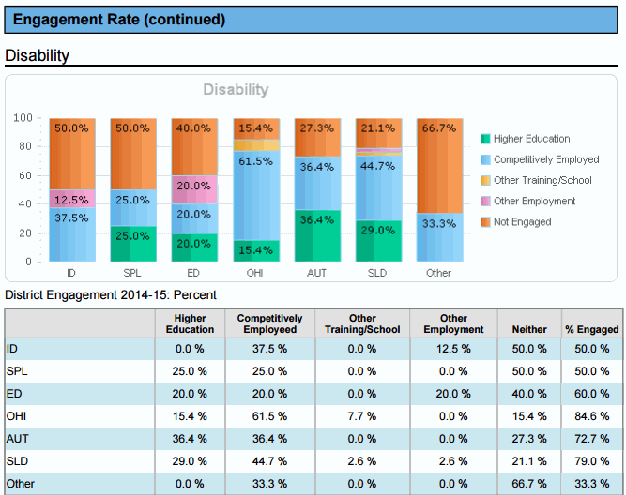
District Data Summary Table

Where to start?
- Create a short summary table of the most recent district performance, noting the change from the previous year. See example below and on page 11.
- Create charts at the building level if there is more than one high school in the district.
- Assemble a team of stakeholders involved in transition planning and services in the district to discuss the findings. Be sure someone familiar with the district data reporting is included on the team.

What to look for?
- Highlight the performance that stands out for your district—either because it shows positive outcomes or less than positive outcomes.
- Compare district results to state results—look for patterns.
- Gather information on possible changes that took place in the district that might have influenced results, such as change in the program, district activities, staffing, and other relevant events.

Next steps
- Discuss the areas to examine more closely.
- For PSO results, look at the available data reports on the PSO application to see if particular subgroups show noticeable differences.
- Request additional graduation, dropout and the transition standards results for more details on subgroup performance.
- Discuss district policies and practices to help understand what the data are showing
- Prioritize district needs and begin plan to improve results
- Consider using the STEPSS tool to structure the process (contact sally.simich@state.or.us for more information)

Example—most current district data | District | District Trend | State
Graduation Rate (4 year) | ___% | (state increase 14%)¹ | 51%
Graduation Rate (5 year) | ___% | (state increase 12%)¹ | 56%
Dropout Rate | ___% | (state no change%) | 6%
Students with quality IEP’s as measured by compliance on all 8 transition standards | ___% | (state dropped 7%) | 75%
Students in post-secondary school 1 year out | ___% | (state no change) | 24%
Students competitively employed one year out + in post-secondary school 1 year out | ___% | (state decrease .5%) | 54%
Total engagement | ___% | (state no change) | 70%
¹ Modified diplomas included as graduates led to increases in graduation rate

